Node JS Microservices:

By Amir Mustafa. D.O.S – 06/08/2022

Private and Confidential

Type: Backend Technology

[amirengg15@gmail.com](mailto:amirengg15@gmail.com) +91-8170954991 [LinkedIn](https://www.linkedin.com/in/amirmustafa1/) [Twitter](https://twitter.com/amir__mustafa) [GitHub](https://github.com/AmirMustafa) [YouTube](https://www.youtube.com/channel/UCiRv7SECTSF3-tXQM1IoMTw)

Introduction:

🡪 Microservices are the common patterns in modern software architecture.

🡪 With platform like Kubernetes, cloud-foundary

🡪 Having knowledge of microservice is key for any software development.

🡪 We will be using Node.js

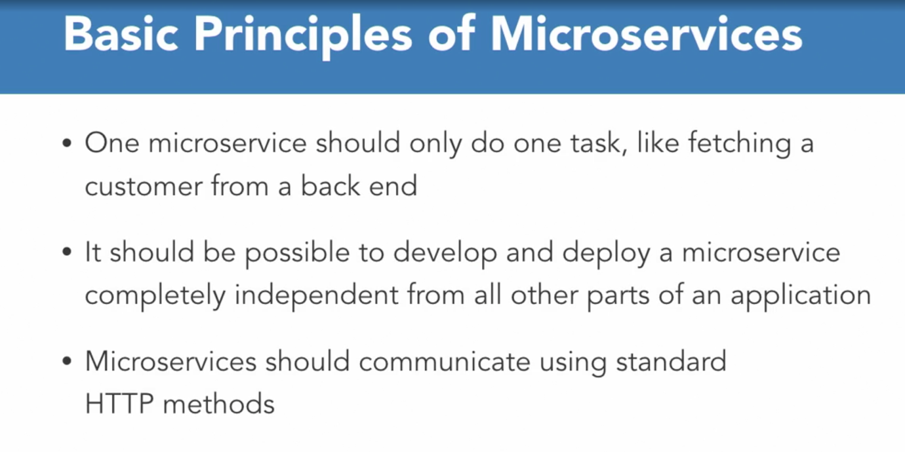

🡪 Here we will convert existing Monolithic app into microservices.

🡪 The microservice can be used as the good starting point for our microservice project.

🡪 We should have basic understanding of :

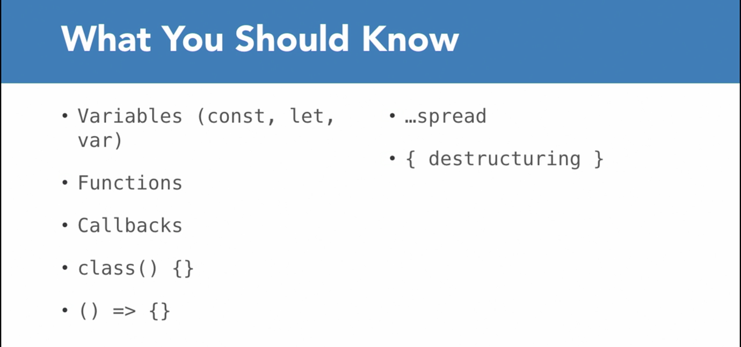

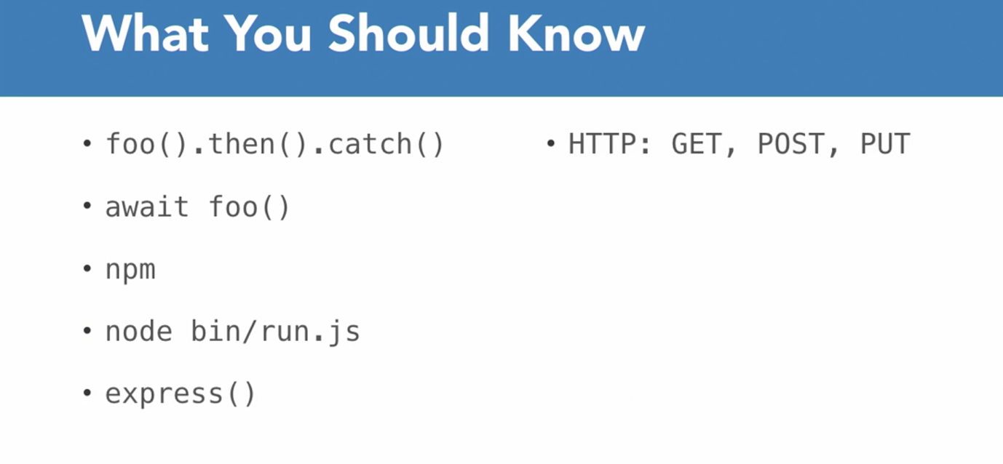

History of Software Architecture:

🡪 Previously from last decades history of architecture was monolithic i.e. only one single application.

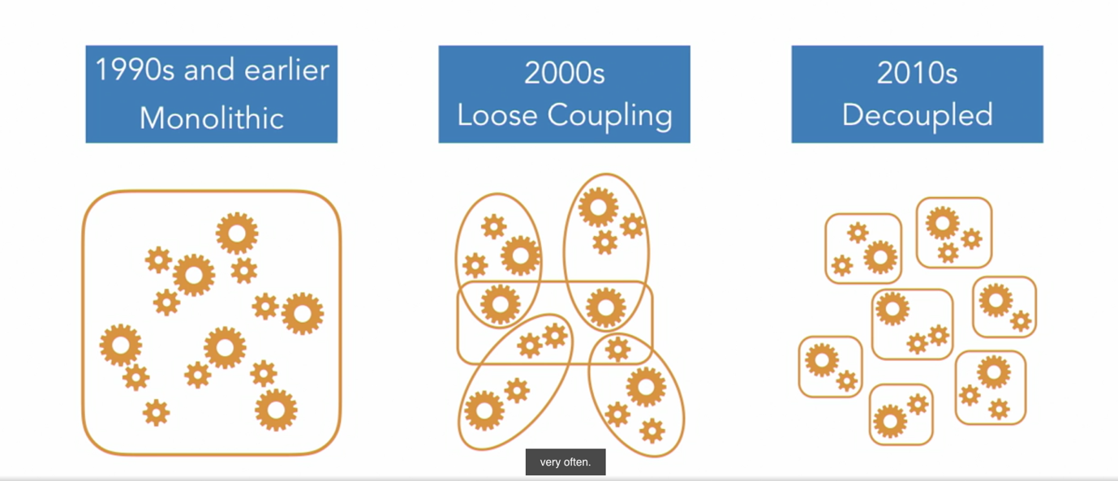

🡪 So we change anything in part of the application. This might affect in other parts of application.

🡪 This means developer have to have a model of the while application in mind while doing changes.

🡪 When new developer comes to work in the application, they should know how every feature of app is connect to another.

🡪 In recent time, application is sliced into logical pieces called services. It exchanges data over networks called SOA (Service Oriented Architecture).

🡪 The communication between components was mostly done via XML. This was also little complicated or incorrectly used (i.e. tightly coupled).

🡪 Around 2010, term microsevice was introduced.

🡪 There is no standard, the aim was simplicity.

Eg. if we use shopping system as an example:

It have an independent frontend that fetches data from various microservices

One service might return list of items,

while the other may provide access to the shopping cart for a given user.

Microservices:

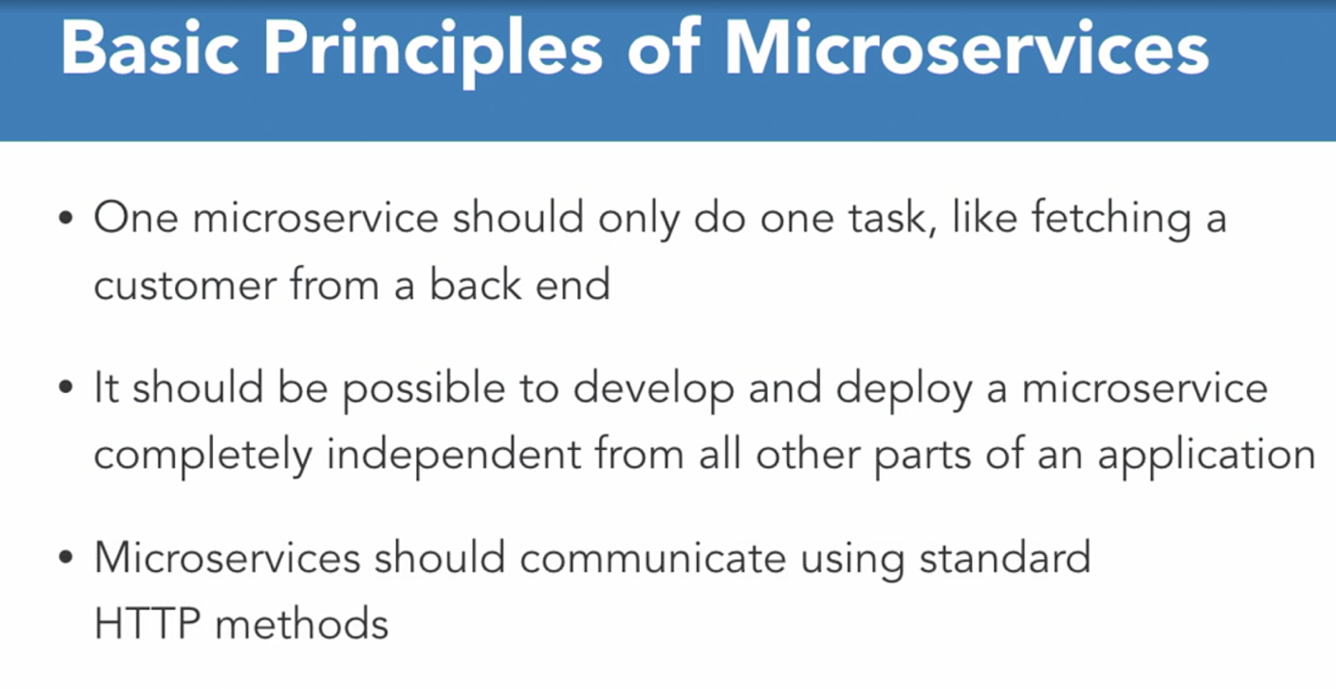

Benefits of Using Microservices:

🡪 We were working in an application that has below microservice architecture:

1. application in one server, (JavaScript)
2. AWS glue job that triggers (Python)
3. AWS lambda job that send data from one S3 bucket to application S3 bucket (Python)

🡪 Every microservice can be written in their best possible language

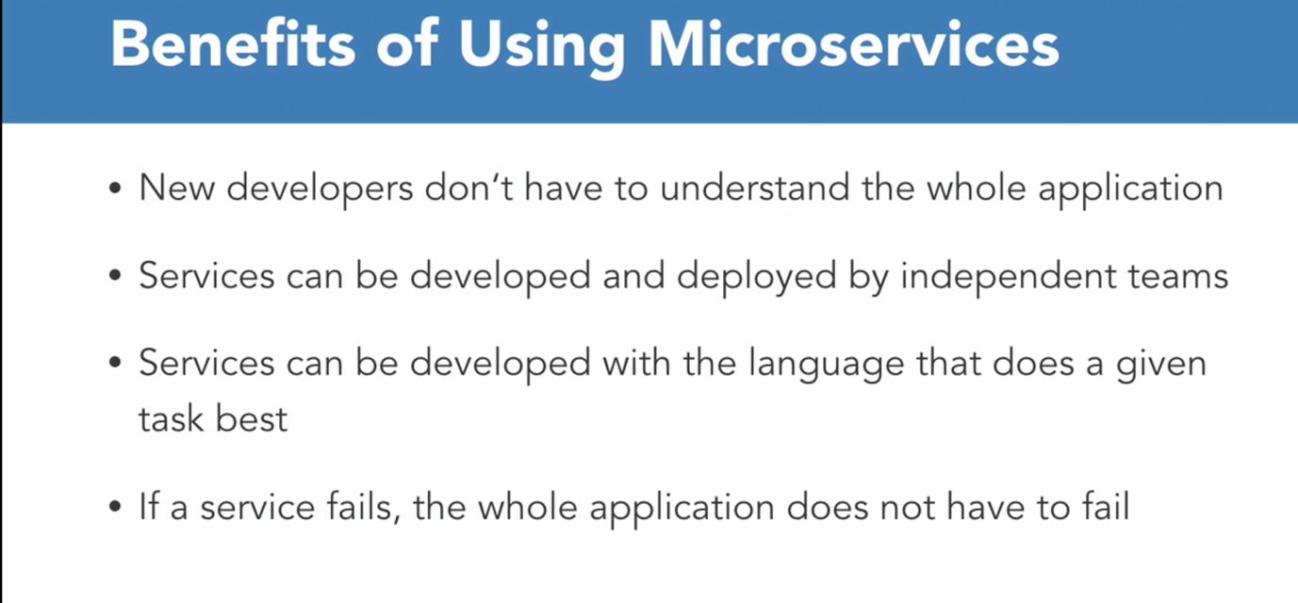

Drawbacks of using Microservices:

With advantage there also comes disadvantage/drawbacks:

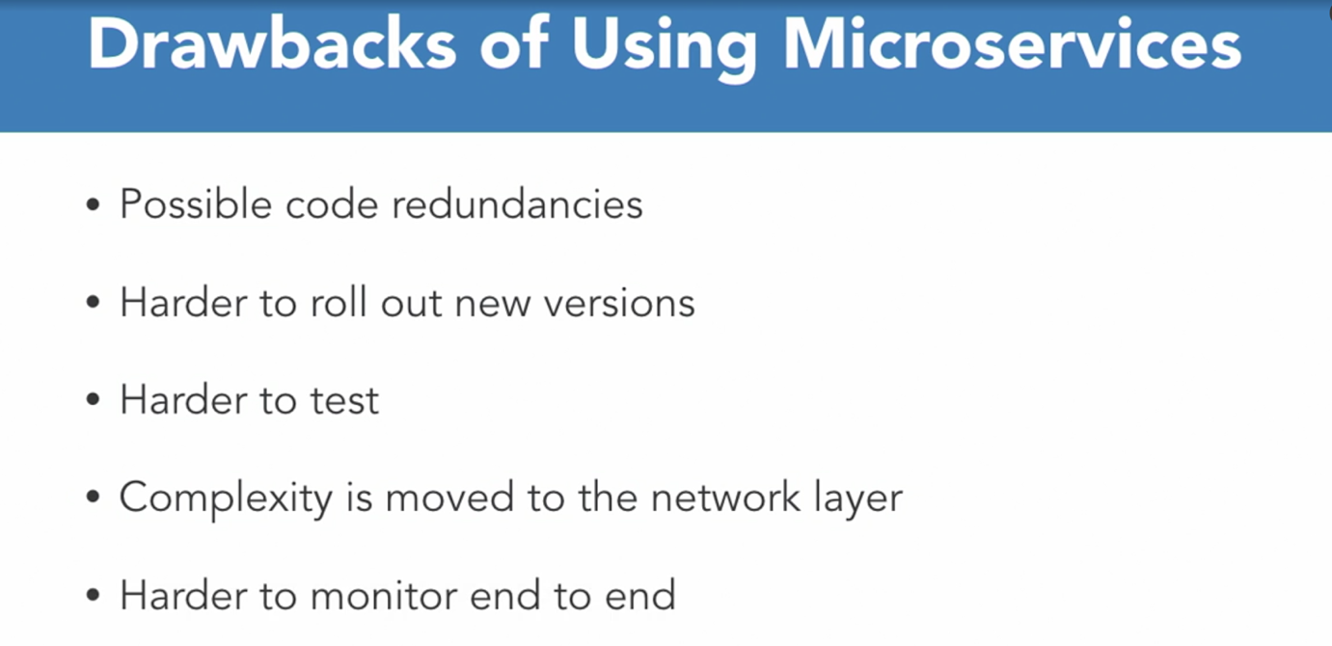

🡪 We will use best possible practice so that if one functionality degrades other keeps on moving

What we will build?

🡪 We have a monolithic Node.js application that was not built keeping Microservices in mind.

🡪 We will convert Conference app - monolithic to microservices

Part 1: Main Page: Speakers + Feedback



Speakers:



Feedback:

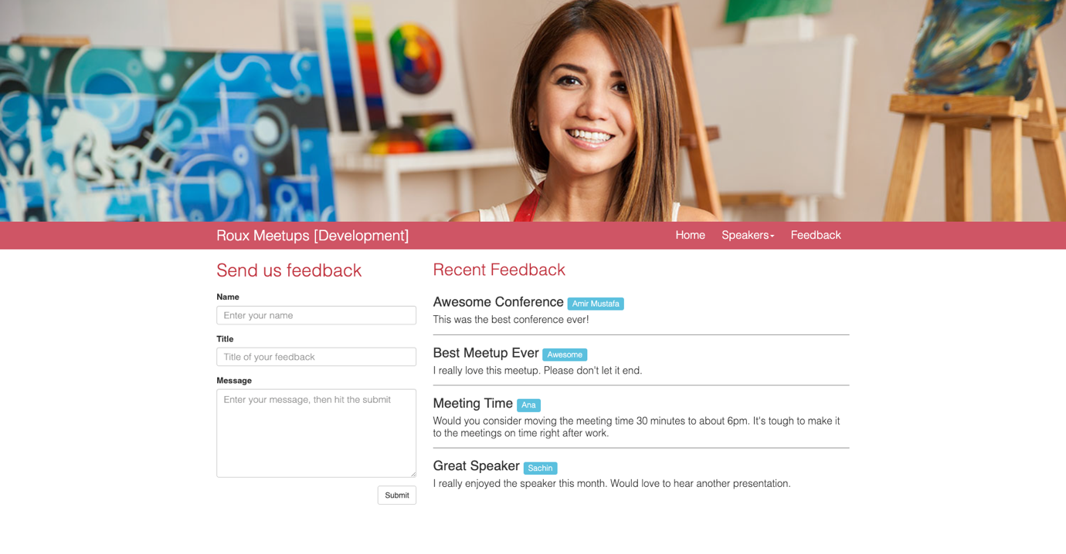

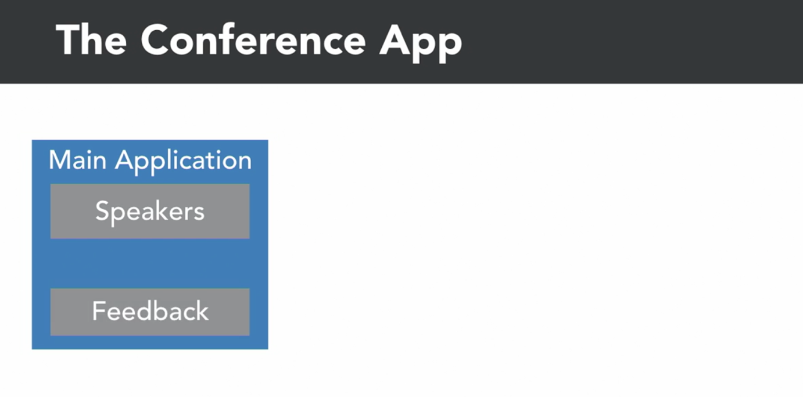

🡪 We will move out functionality of Speakers and Feedback functionality into Microservices

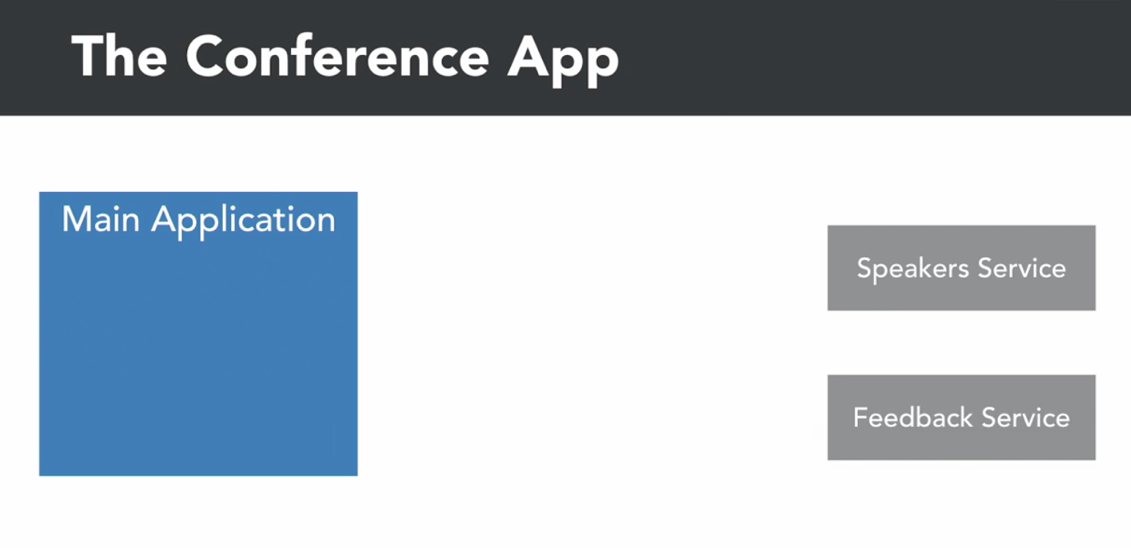

🡪 In between we will service registry that we will know where to find those services in our infrastructure and that will also provide some load balancing.

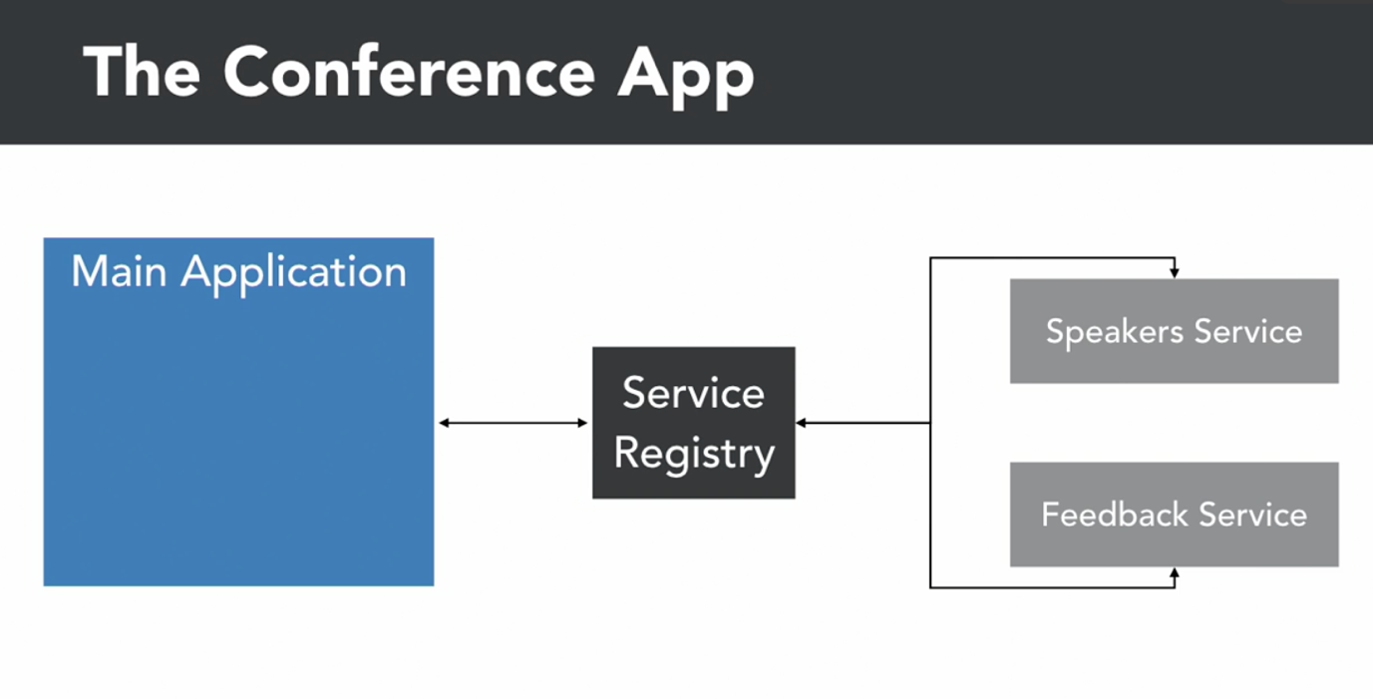

🡪 Additionally we will also provide communication layer, that will provide some ressilience against outages

🡪 This will be achieved by circuit breaking and caching.

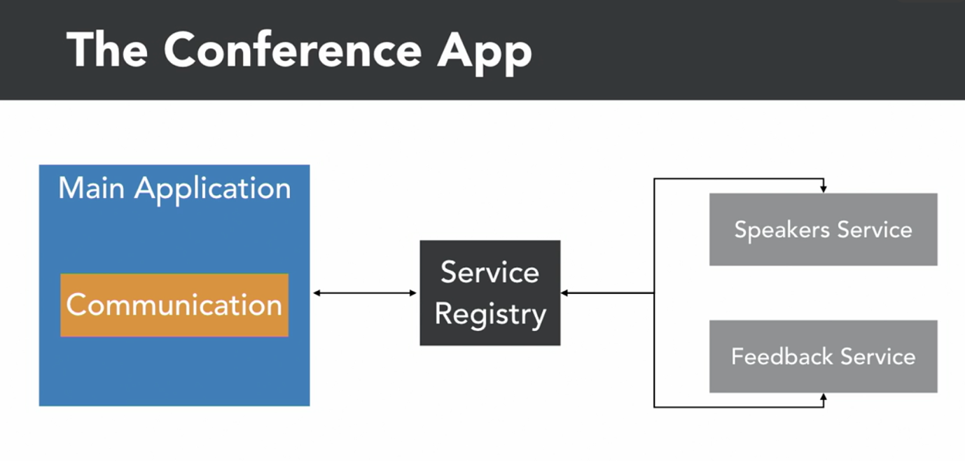

🡪 We will add additional layer of abstraction using queue to send feedback through it instead of posting data directly to the respective services.

Understanding Service Discovery:

🡪 Microservice architecture follow a pattern that services can be created and also taken down at any time.

🡪 When we scale up or down there is always unknown no. of instances running of each service and each instance run on different IP endpoint

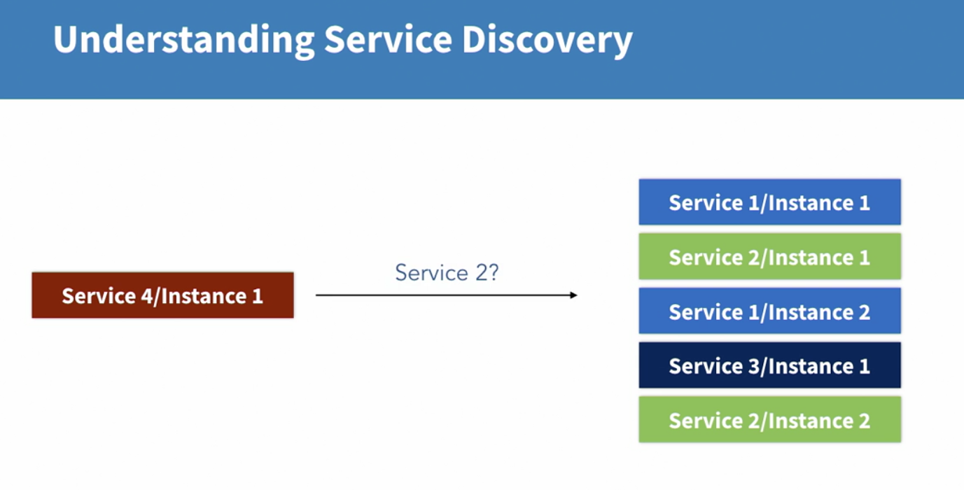

🡪 This means from the perspective of consuming application or a service – there is a no way to find the endpoint of the application or service we want to talk to.

🡪 Here comes Discovery – It keep tracks and statistics of services exists and provides the information it needed to route requests to.

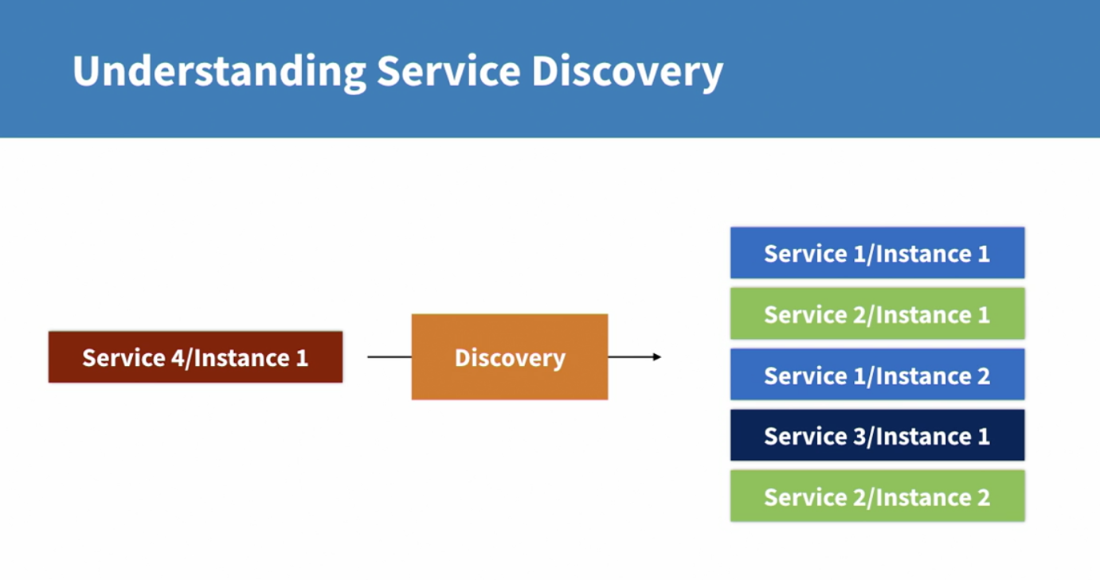

🡪 Today, there are two common way to achieve that:

1. Service Mesh (Infrastructure Level Component):

This is commonly used in containerized application when we use Kubernetes

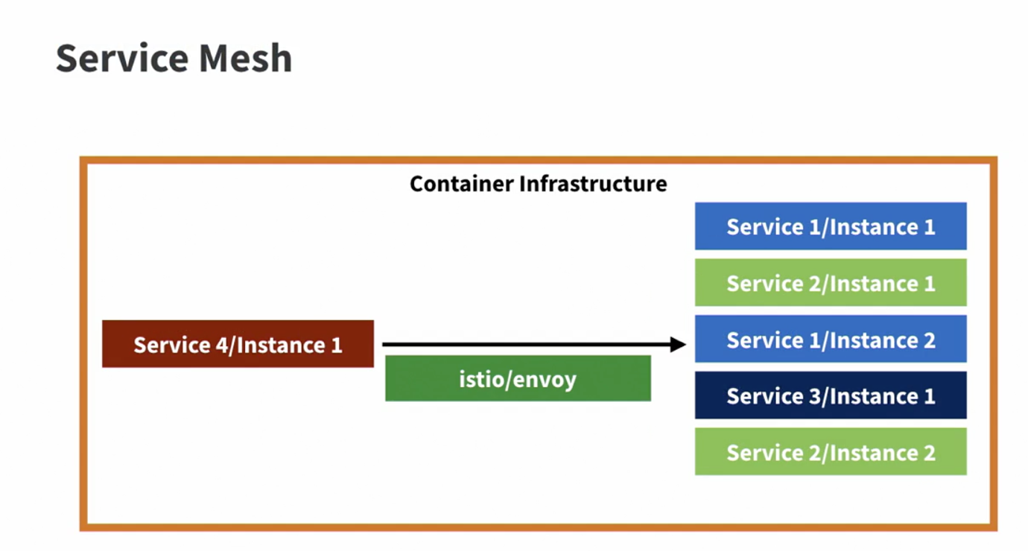

🡪 Here container works in software defined networks.

🡪 Here container engine can keep tracks of all the services and change network settings in a way that request is routed to the right endpoint

🡪 In Kubernetes – istio and envoy provide this functionality

2. Service Registry (Application Level Component):

If we don’t have control over the network and over the engine that spins up new services we cannot use infrastructure layer routing for us

🡪 In such scenarios service registry is the pattern of choice.

🡪 When new service comes to life it should only know where to find service registry

🡪 This can be provided through network layer and DNS.

🡪 It will then register itself to the registry.

🡪 If we now want to know where our service can be found we simply have to query the registry for the given service 🡪 It will return needed endpoint information

🡪 If there will be several instances of one service, the registry will not always provides the endpoint – will distribute randomly

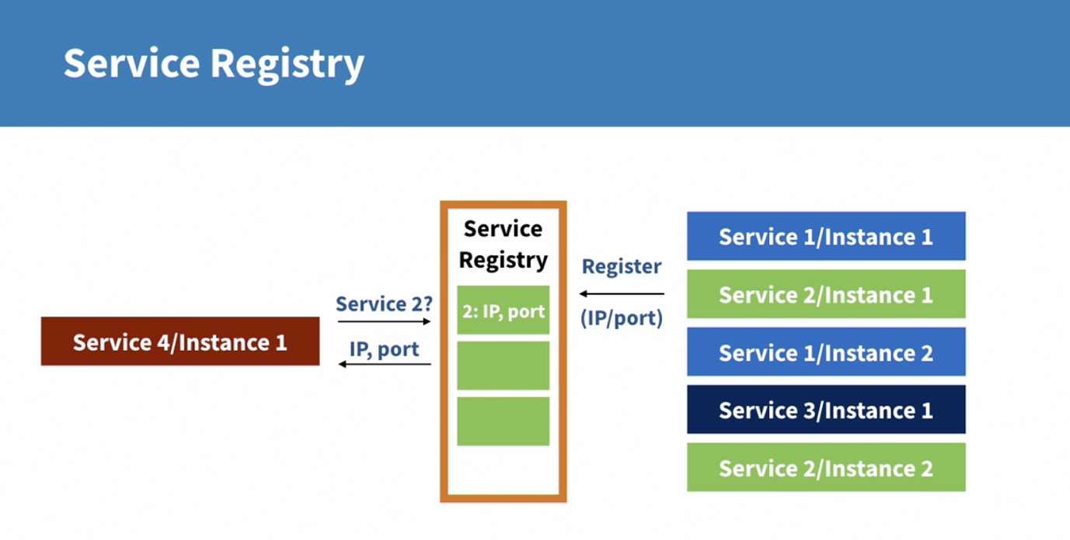

2. Creating a Service Registry:

1. Setting up the registry:

🡪 We have a basic starting foundation of service registry in express framework.

service-registry/bin/run

🡪 This file has server create and config include in server

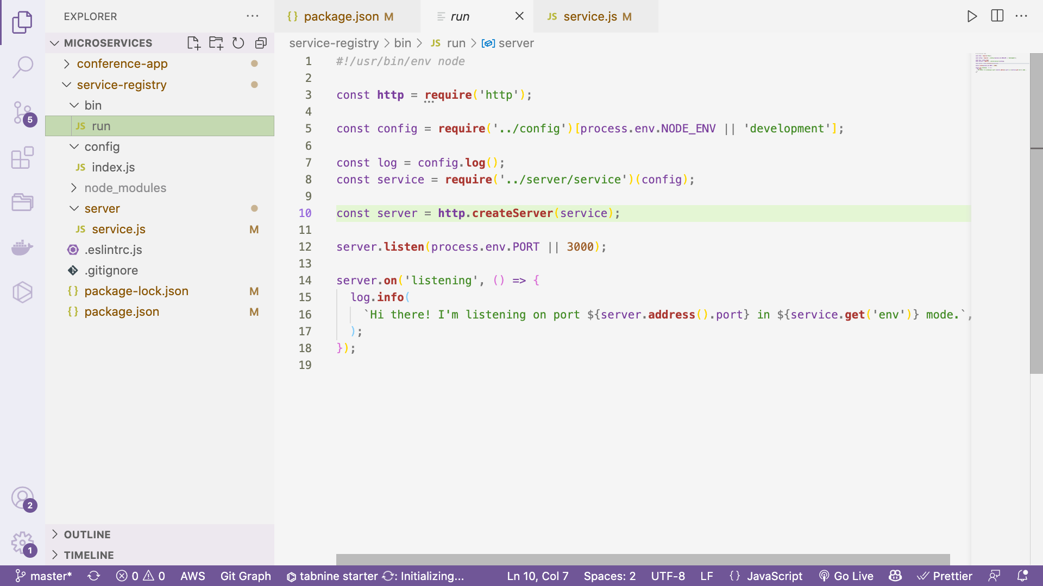

service-registry/config/index.js

🡪 Here we are basically using bunyan as the logging engine based on the environment – development, production, test

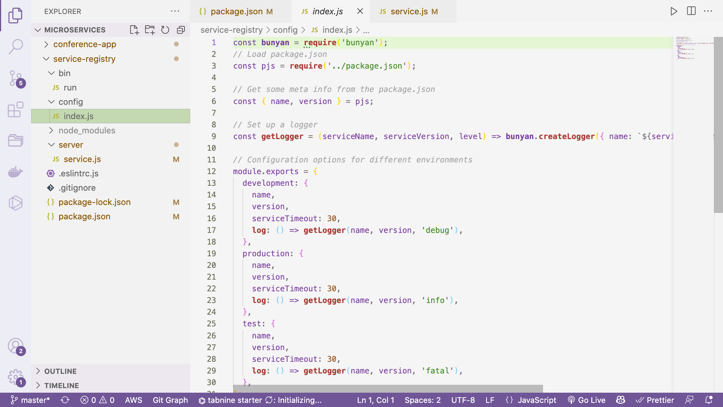

service-registry/server/service.js

This code contains express app entry point

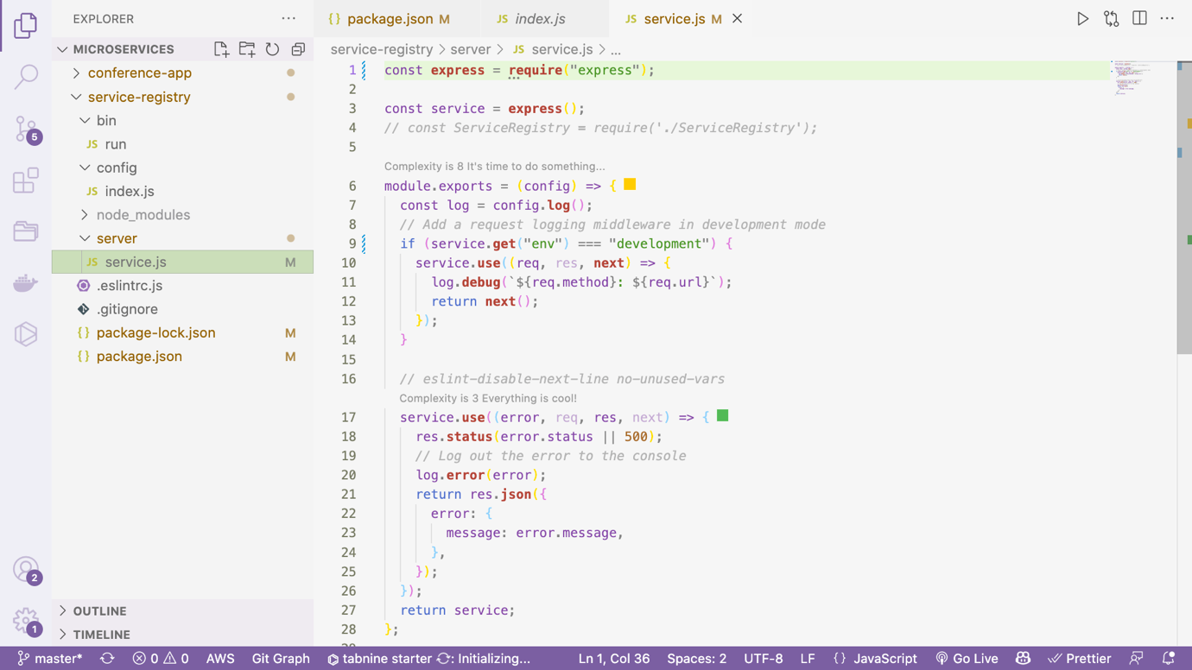

STEP 1: The first thing we need in the service registry is action point

In RESTful service it is routes

First we need a route that a service needs to register itself

🡪 The service can be characterized by the name, version and port it can be found in.

STEP 2: Create a ServiceRegistry class in server/lib/ServiceRegistry.js

🡪 Here we create class that can checks services created and newly created services

🡪 It accepts service name, port, IP and version

service-registry/server/lib/ServiceRegistry.js

class **ServiceRegistry** {

constructor(log) {

this.log = log;

this.services = {};

this.timestamp = 30;

}

**register**(name, version, ip, port) {

const key = name + version + ip + port;

if (!this.services[key]) {

this.services[key] = {};

this.services[key].timestamp = Math.**floor**(**Date**.**now**() / 1000); *// UNIX timestamp in seconds*

this.services[key].name = name;

this.services[key].version = version;

this.services[key].ip = ip;

this.services[key].port = port;

this.log.**debug**(`Added service ${name}, version ${version} at ${ip}`);

return key;

}

this.services[key].timestamp = Math.**floor**(**Date**.**now**() / 1000);

this.log.**debug**(`Updated service ${name}, version ${version} at ${ip}`);

return key;

}

}

**module**.**exports** = **ServiceRegistry**;

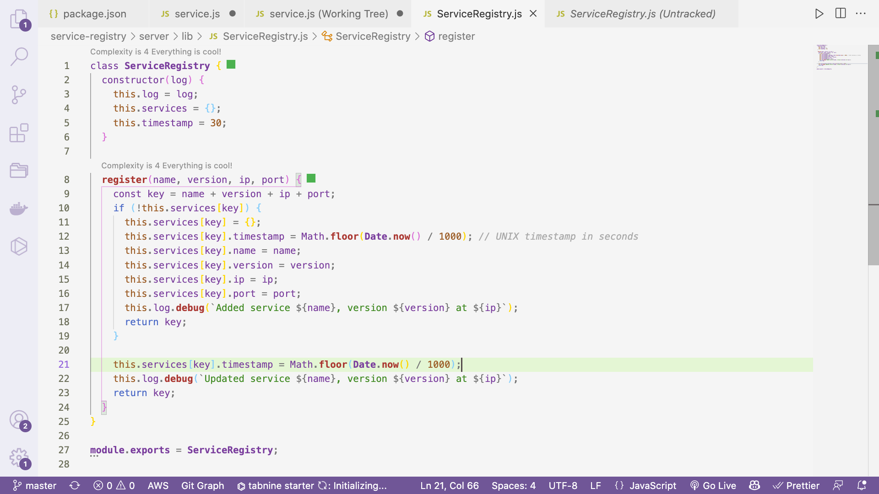

STEP 3: Create instance of created class:

Here we add Service Registry instance

const **express** = **require**("express");

const **ServiceRegistry** = **require**("./lib/ServiceRegistry");

const service = **express**();

module.exports = (config) => {

const log = config.**log**();

const serviceRegistry = new **ServiceRegistry**(log);

*// Add a request logging middleware in development mode*

if (service.**get**("env") === "development") {

service.**use**((req, res, **next**) => {

log.**debug**(`${req.method}: ${req.url}`);

return **next**();

});

}

*// Registering a service*

service.**put**(

"/register/:servicename/:serviceversion/:serviceport",

(req, res) => {

const { servicename, serviceversion, serviceport } = req.params;

const serviceip = req.connection.remoteAddress.**includes**("::")

? `[${req.connection.remoteAddress}]`

: req.connection.remoteAddress;

const serviceKey = serviceRegistry.**register**(

servicename,

serviceversion,

serviceip,

serviceport

);

return res.**json**({ result: serviceKey });

}

);

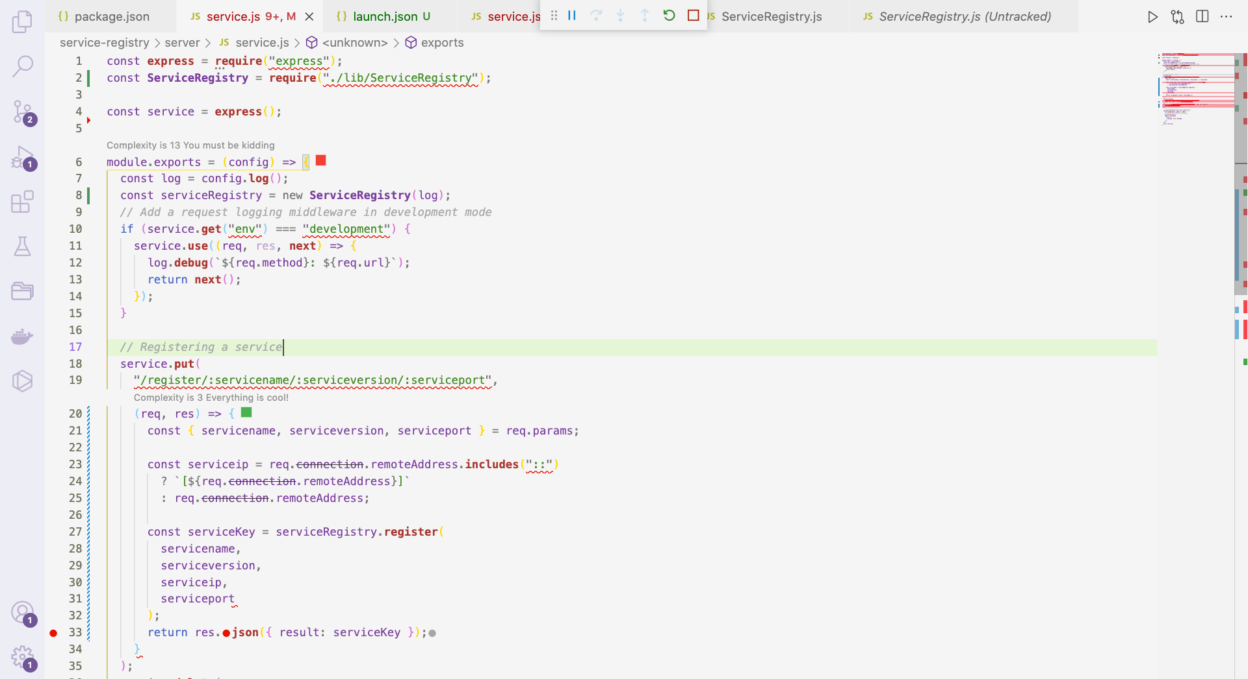

🡪 In addition to this we can add debugger from VS code

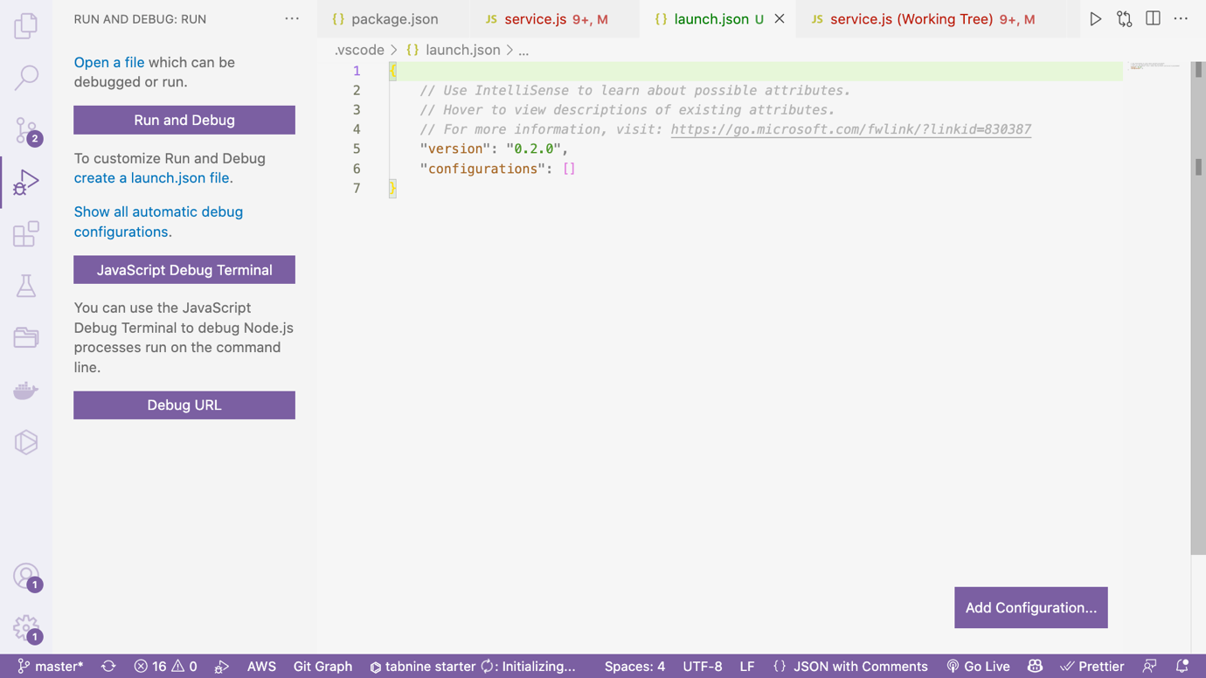

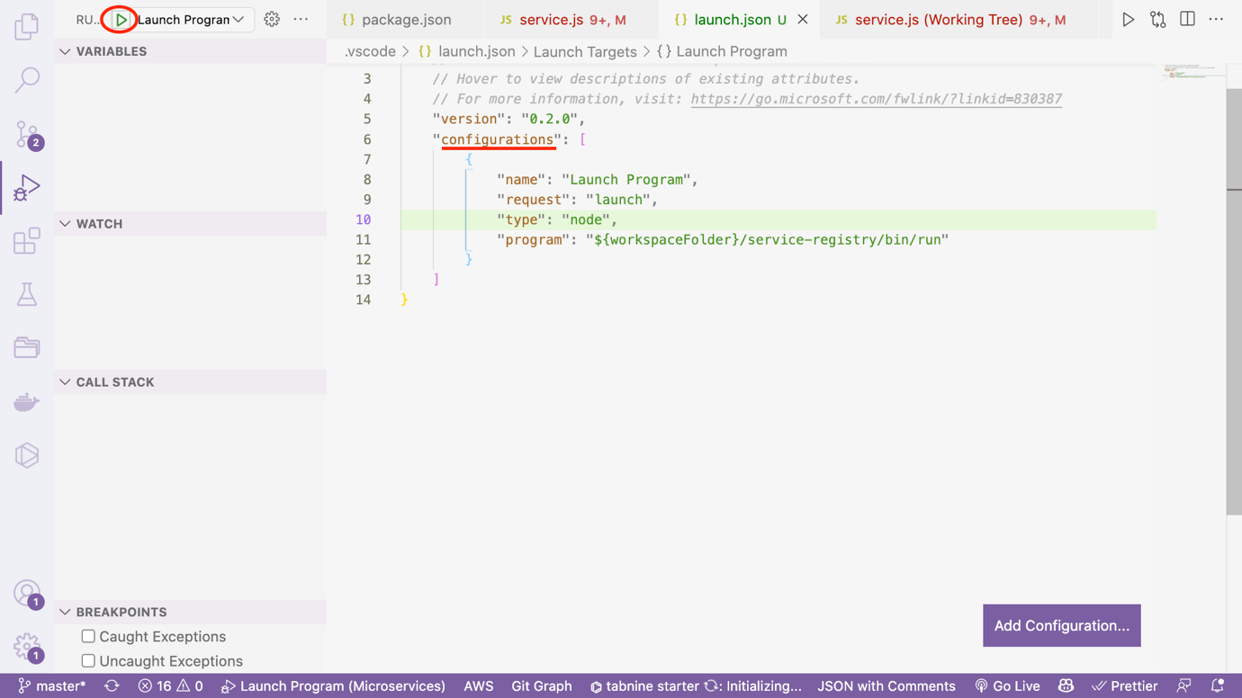

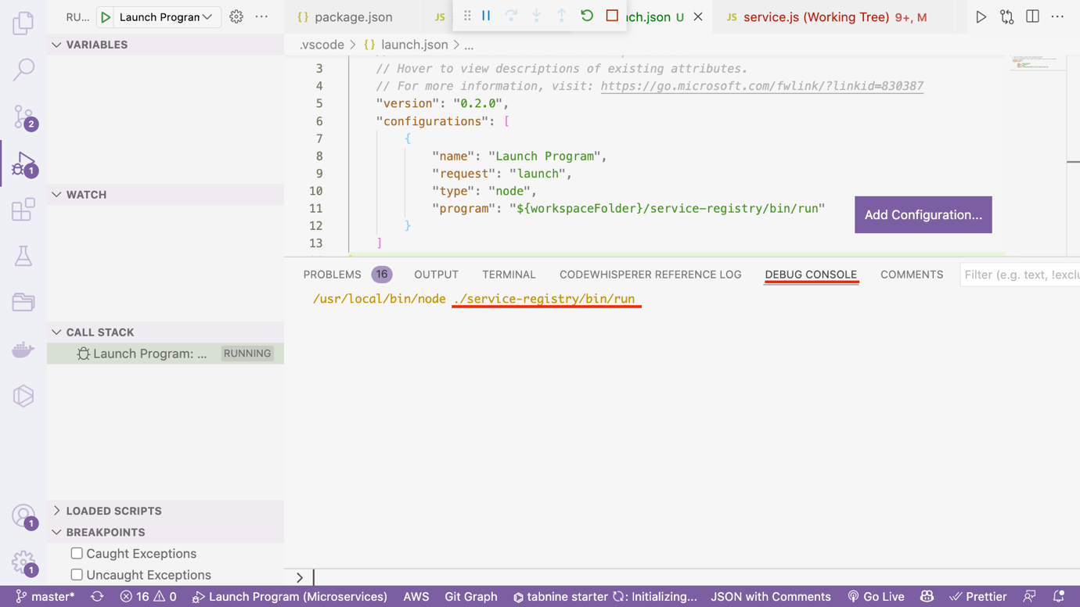

Launch.json

Path: .vscode/launch.json

{

*// Use IntelliSense to learn about possible attributes.*

*// Hover to view descriptions of existing attributes.*

*// For more information, visit: https://go.microsoft.com/fwlink/?linkid=830387*

"version": "0.2.0",

"configurations": [

{

"name": "Launch Program",

"request": "launch",

"type": "node",

"program": "${workspaceFolder}/service-registry/bin/run"

}

]

}

🡪 Let us now open Postman

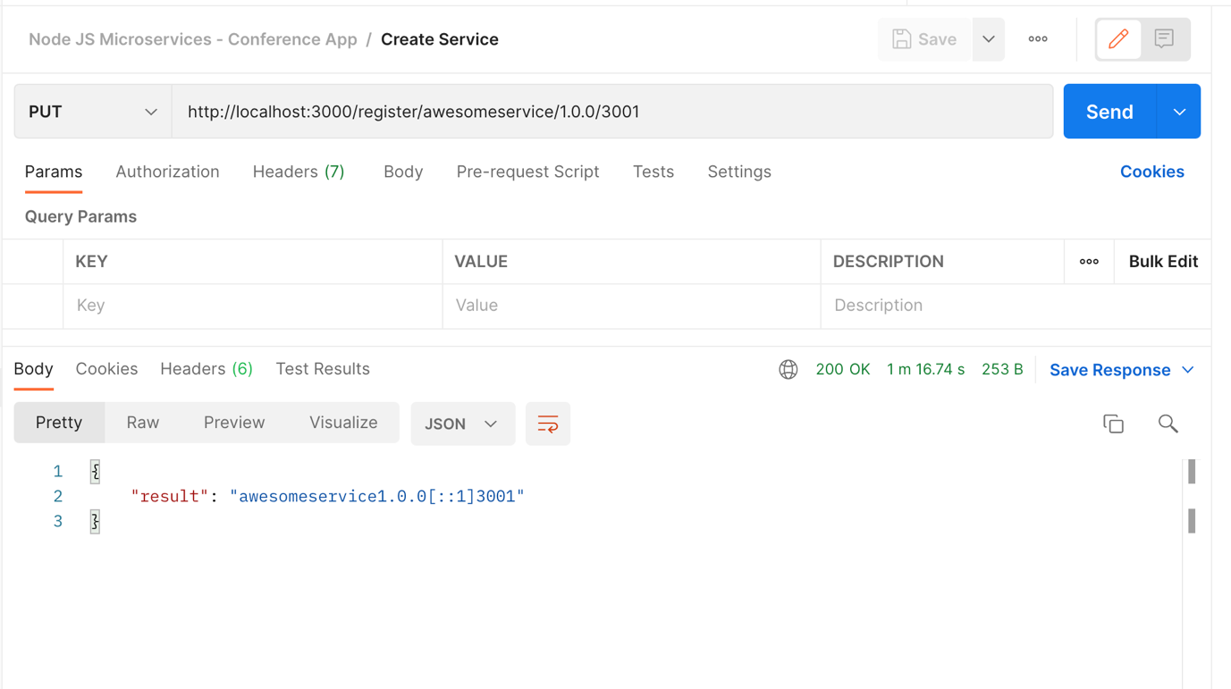

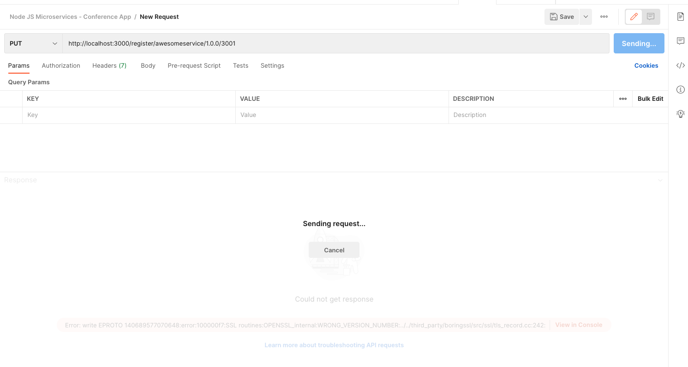

🡪 Cursor stops in breakpoint

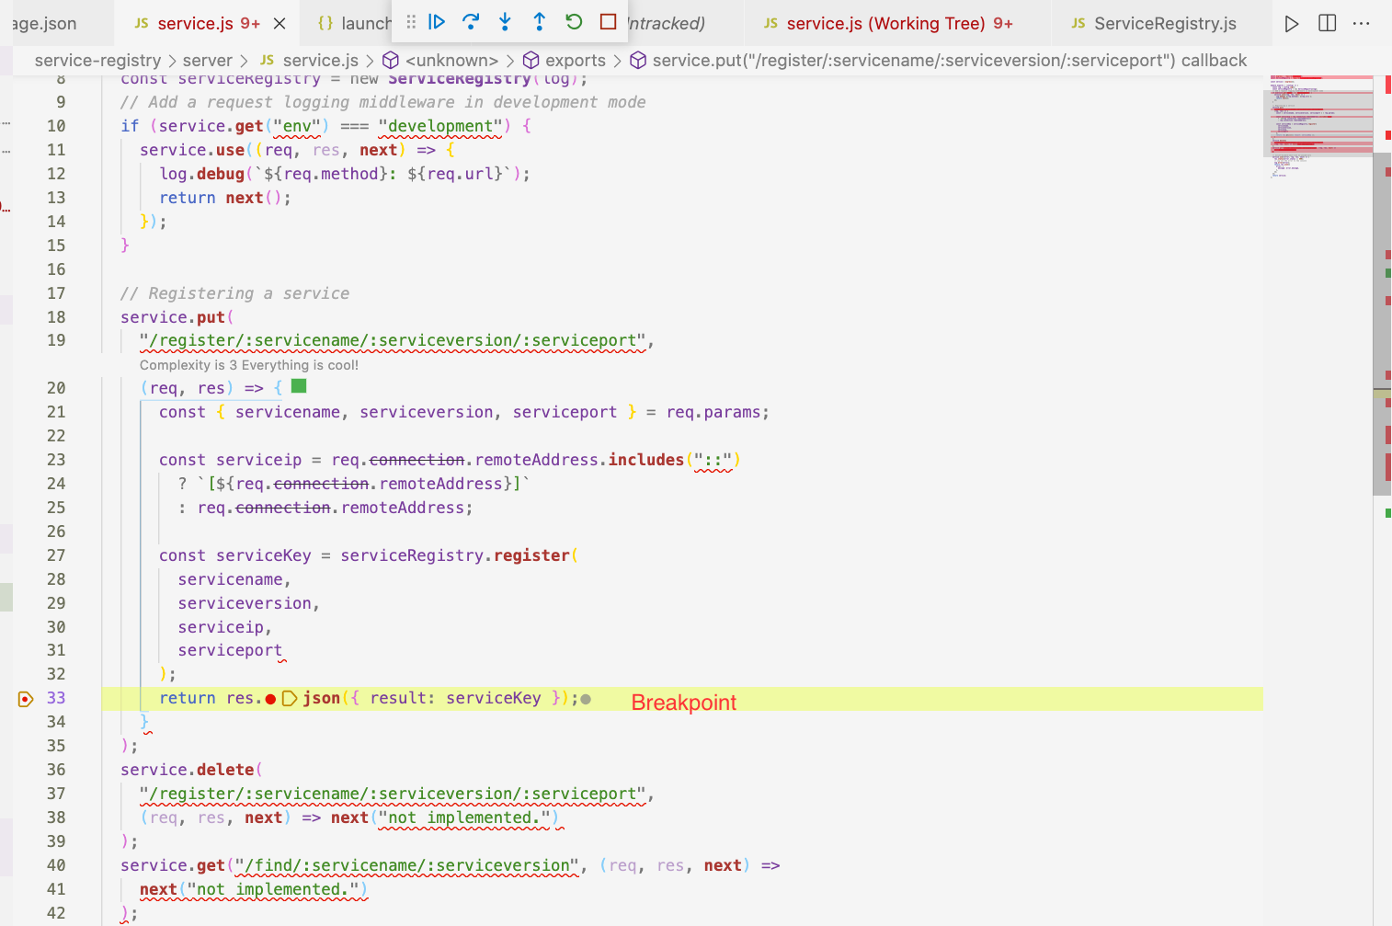

🡪 We see list of variable in left side received 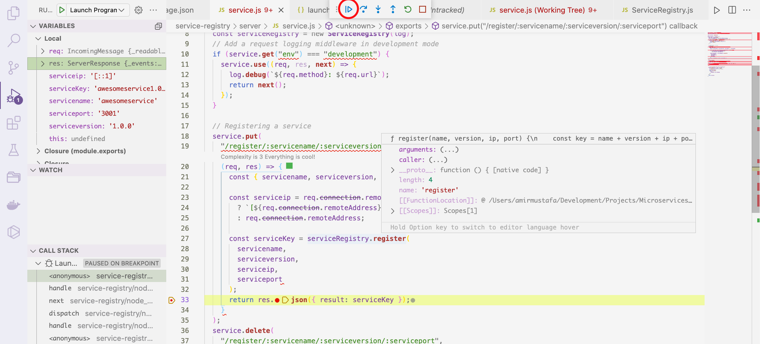

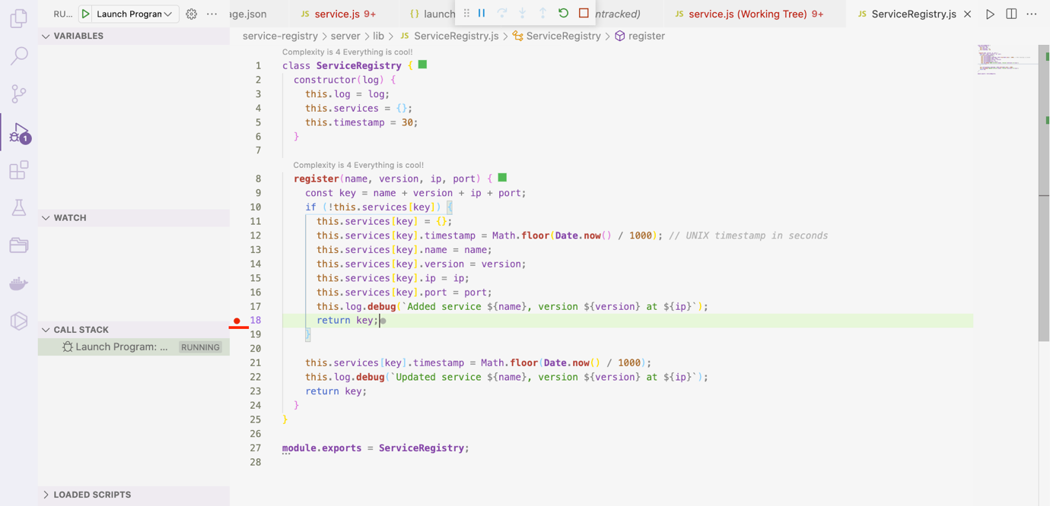

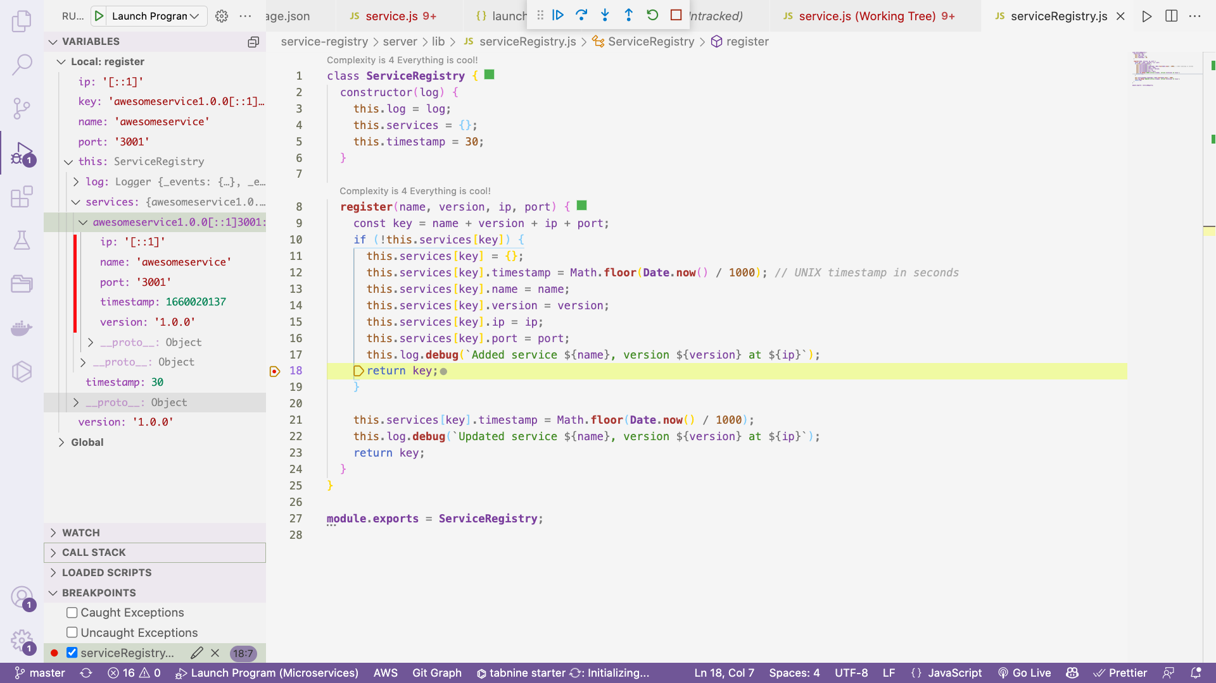



2. Unregister Service:

🡪 This is for deleting the created service

service-registry/server/lib/ServiceRegistry.js

**unregister**(name, version, ip, port) {

const key = name + version + ip + port;

if (this.services[key]) {

delete this.services[key];

this.log.**debug**(

`Unregistered service ${name}, version ${version} at ${ip}`

);

return key;

}

}

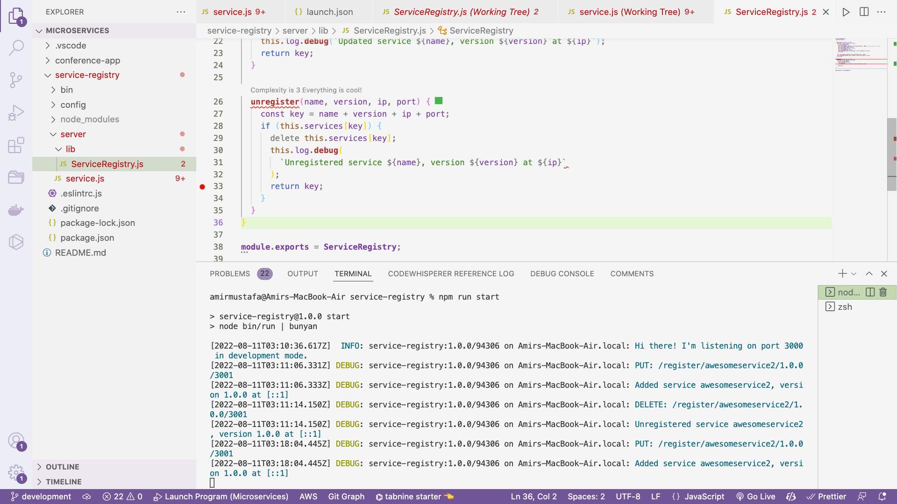

Invoking unregister

service-registry/server/lib/ServiceRegistry.js

*// Unregistering a service*

service.**delete**(

"/register/:servicename/:serviceversion/:serviceport",

(req, res) => {

const { servicename, serviceversion, serviceport } = req.params;

const serviceip = req.connection.remoteAddress.**includes**("::")

? `[${req.connection.remoteAddress}]`

: req.connection.remoteAddress;

const servicekey = serviceRegistry.**unregister**(

servicename,

serviceversion,

serviceip,

serviceport

);

return res.**json**({ result: servicekey });

}

);

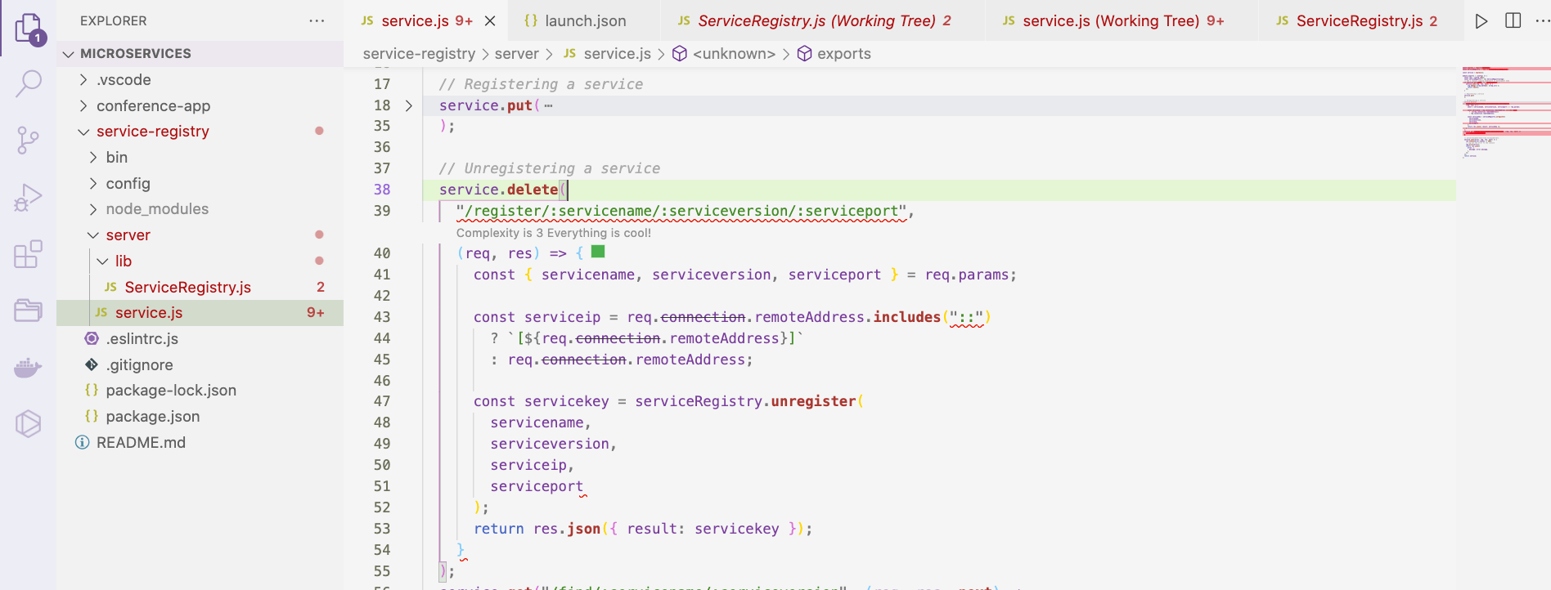

Postman

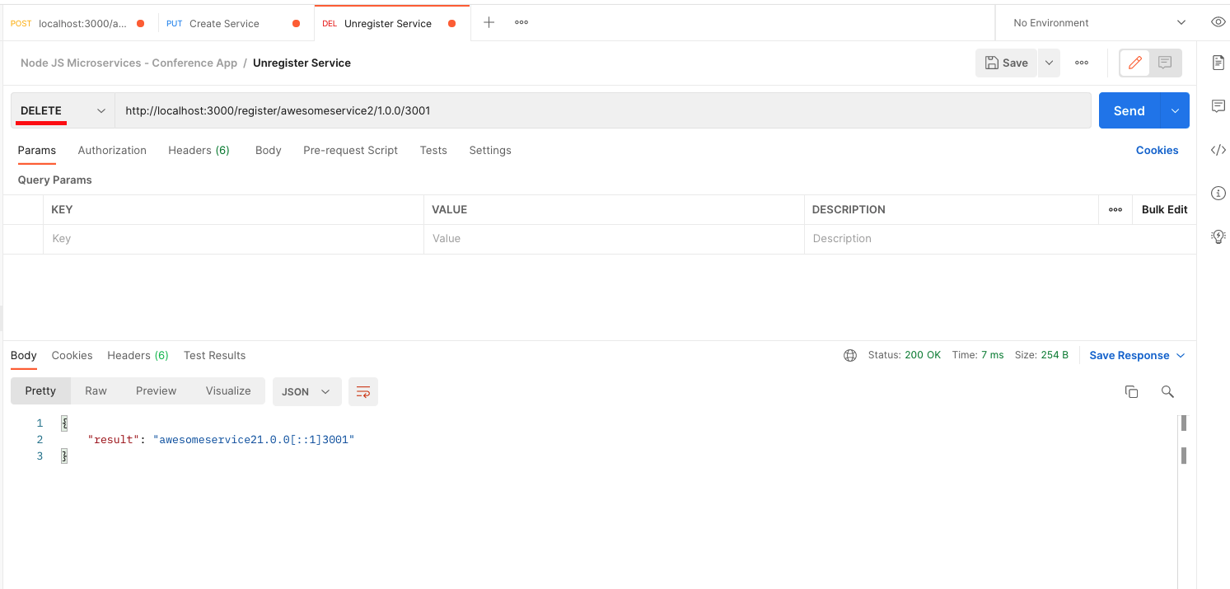

Getting and Versioning of Services:

🡪 This is very useful when we there are multiple versions of services and fetch right one (semver.org)

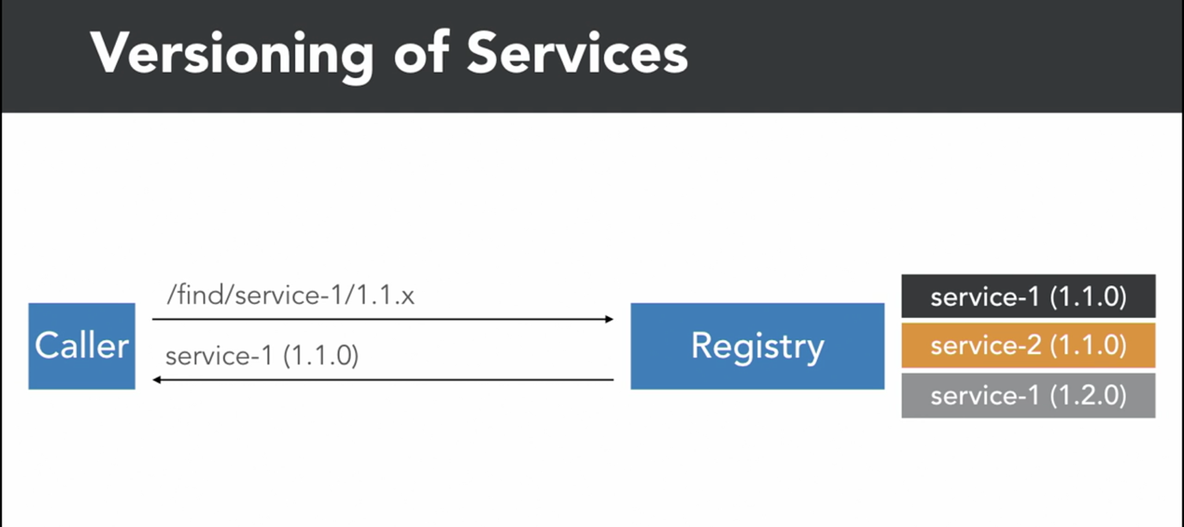

Load Balancing:

When we call by major version it can give irrespective of minor version based on code

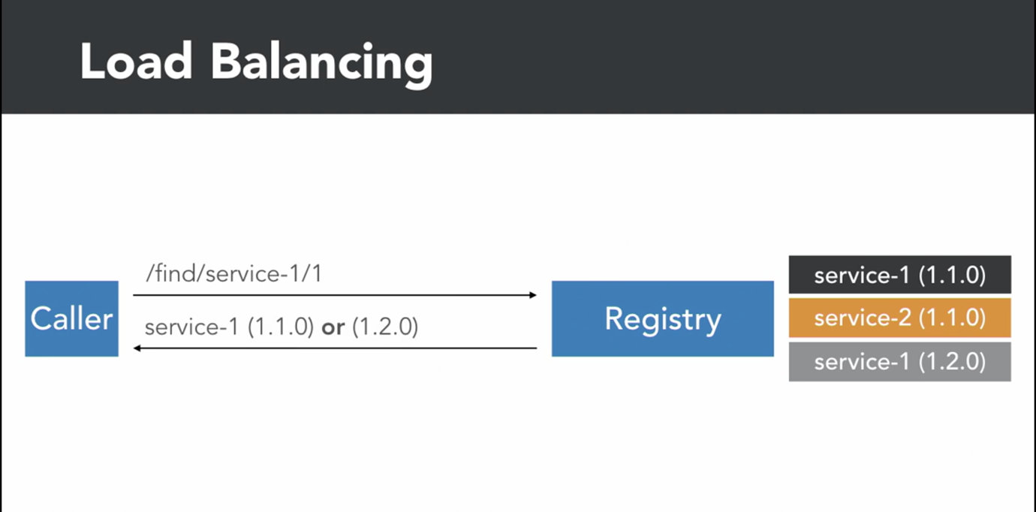

For this we will use package

npm install semver –save

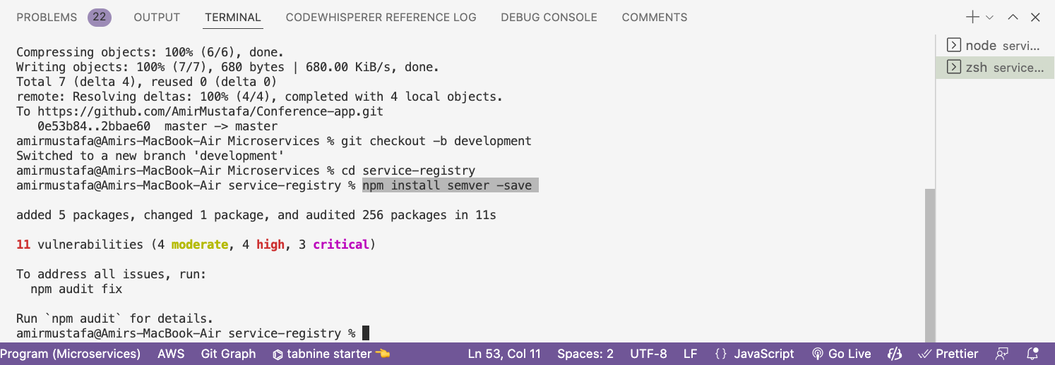

Semver: A version checking library. This is handy with comparing versions and many more.

<https://www.npmjs.com/package/semver>

Path: service-registry/server/lib/ServiceRegistry.js

class **ServiceRegistry** {

constructor(log) {

this.log = log;

this.services = {};

this.timestamp = 30;

}

**get**(name, version) {

*// return Object.values(this.services); // gives list of services*

const candidates = **Object**.**values**(this.services).**filter**(

(service) =>

service.name?.**toString**()?.**toLowerCase**()?.**trim**() ===

name?.**toString**()?.**toLowerCase**()?.**trim**() &&

semver.**satisfies**(service.version, version)

);

*// Math.floor(Math.random() * 3); // this is used to get random 1 no. till 3 i.e. length of array*

return candidates[Math.**floor**(Math.**random**() * candidates.length)];

}

Path: service-registry/server/service.js

const **ServiceRegistry** = **require**("./lib/ServiceRegistry");

service.**get**("/find/:servicename/:serviceversion", (req, res) => {

const { servicename, serviceversion } = req.params;

const svc = serviceRegistry.**get**(servicename, serviceversion);

if (!svc) {

return res

.**status**(404)

.**json**({ result: `Service ${servicename} not found ` });

}

return res.**json**(svc);

});

How this will help in load balancing:

🡪 Suppose we create lots of service with multiple versions

Eg1:

Create service request

<http://localhost:3000/register/awesomeservice/2.0.2/3002>

<http://localhost:3000/register/awesomeservice/1.2.0/3001>

<http://localhost:3000/register/awesomeservice/1.0.0/3000>

NOTE: Multiple version is connected to different ports

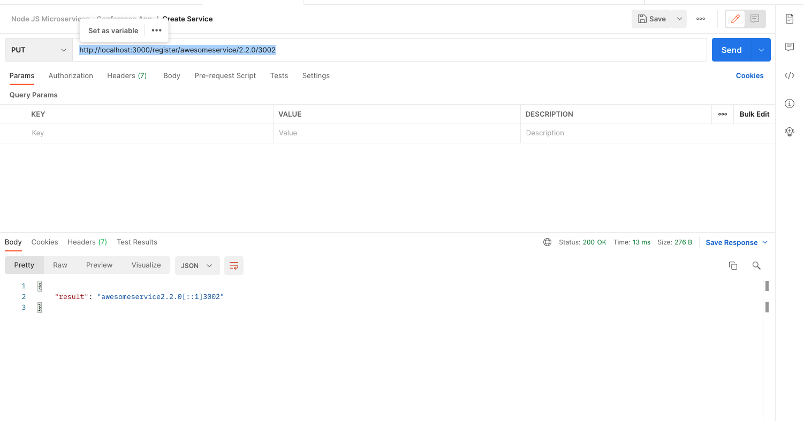

🡪

http://localhost:3000/find/awesomeservice/1

This will fetch either of second or third in every hit randomly

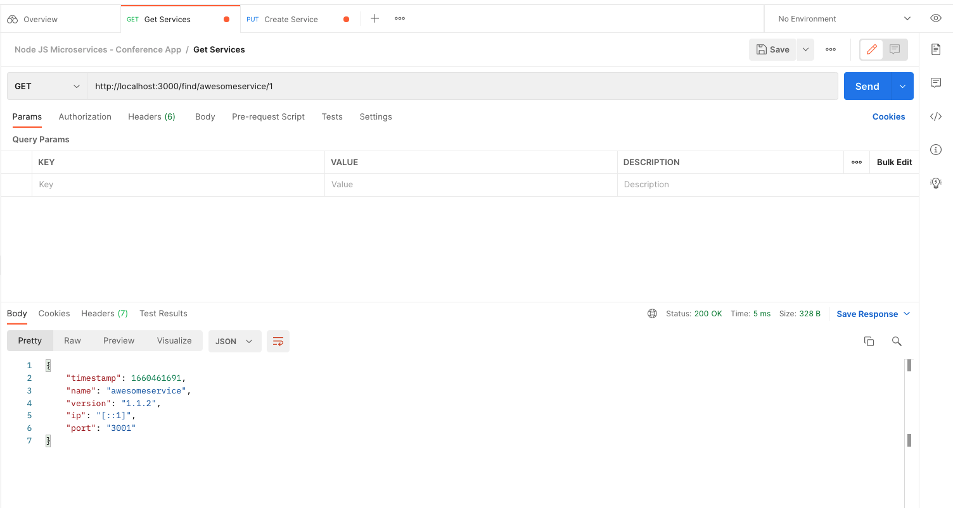

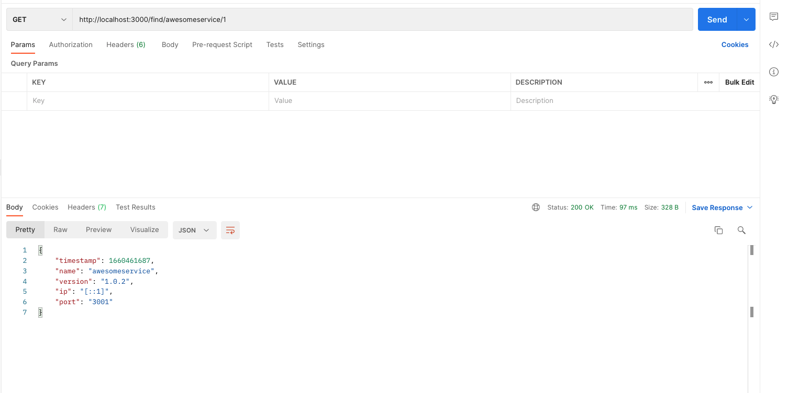

🡪 When we will hit with version 2 will get below first service version data

http://localhost:3000/find/awesomeservice/2

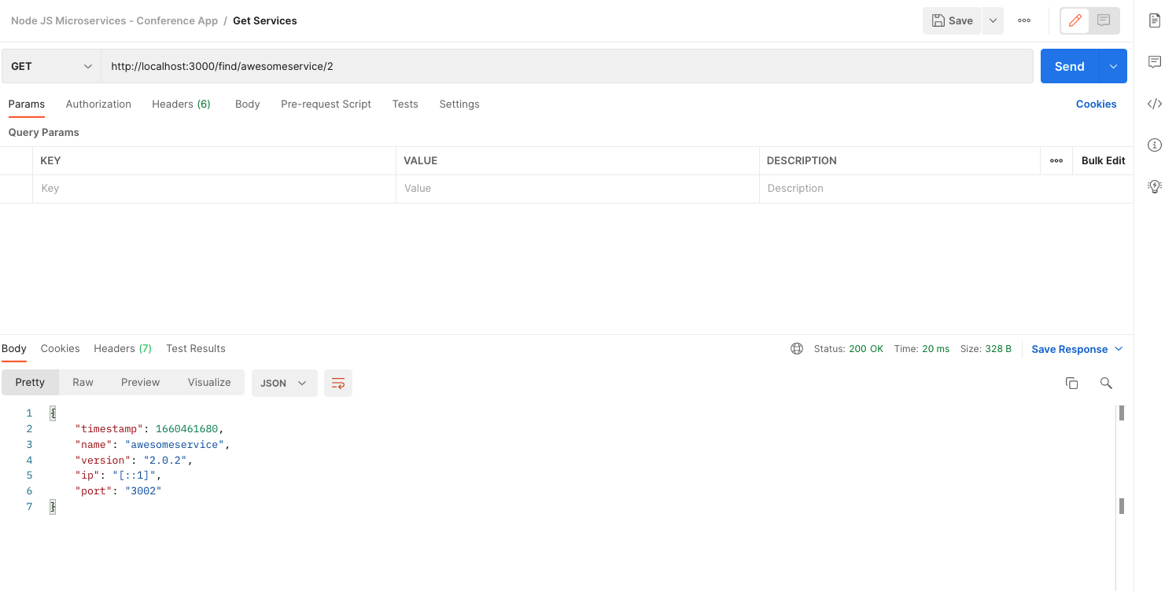

🡪 Of course we can specify specific version to get exact match

http://localhost:3000/find/awesomeservice/1.2.0

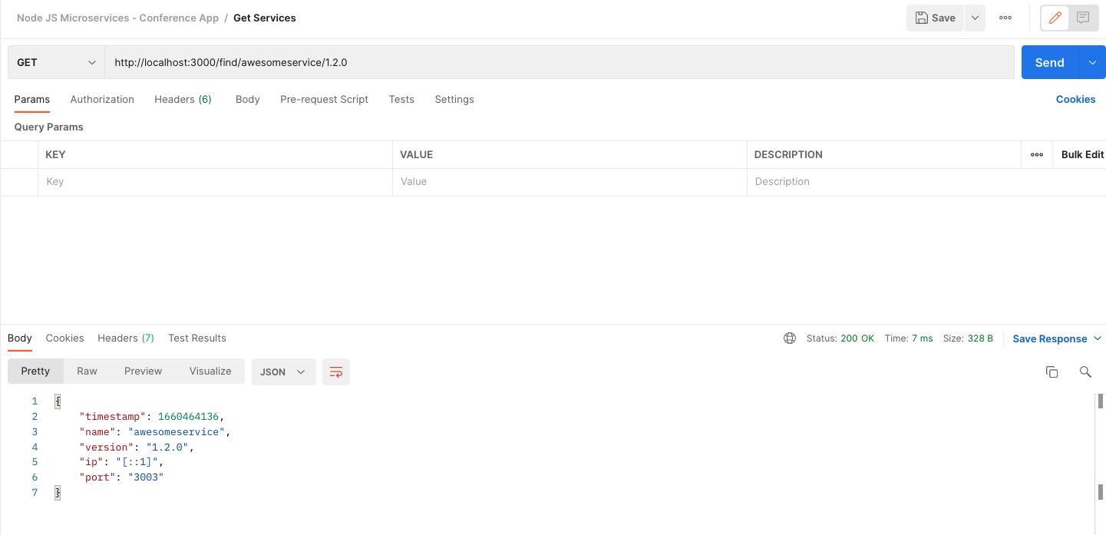

Removing Expired Services:

🡪 We can give facility for removing expired services after certain time

const semver = **require**("semver");

class **ServiceRegistry** {

constructor(log) {

this.log = log;

this.services = {};

this.timeout = 15;

}

**get**(name, version) {

*// return Object.values(this.services); // gives list of services*

this.**cleanUp**();

const candidates = **Object**.**values**(this.services).**filter**(

(service) =>

service.name?.**toString**()?.**toLowerCase**()?.**trim**() ===

name?.**toString**()?.**toLowerCase**()?.**trim**() &&

semver.**satisfies**(service.version, version)

);

*// Math.floor(Math.random() * 3); // this is used to get random 1 no. till 3 i.e. length of array*

return candidates[Math.**floor**(Math.**random**() * candidates.length)];

}

**register**(name, version, ip, port) {

this.**cleanUp**();

const key = name + version + ip + port;

if (!this.services[key]) {

this.services[key] = {};

this.services[key].timestamp = Math.**floor**(**Date**.**now**() / 1000); *// UNIX timestamp in seconds*

this.services[key].name = name;

this.services[key].version = version;

this.services[key].ip = ip;

this.services[key].port = port;

this.log.**debug**(`Added service ${name}, version ${version} at ${ip}`);

return key;

}

this.services[key].timestamp = Math.**floor**(**Date**.**now**() / 1000);

this.log.**debug**(`Updated service ${name}, version ${version} at ${ip}`);

return key;

}

**unregister**(name, version, ip, port) {

const key = name + version + ip + port;

delete this.services[key];

this.log.**debug**(`Unregistered service ${name}, version ${version} at ${ip}`);

return key;

}

**cleanUp**() {

const now = Math.**floor**(**Date**.**now**() / 1000);

**Object**.**keys**(this.services).**forEach**((key) => {

if (this.services[key].timestamp + this.timeout < now) {

delete this.services[key];

this.log.**debug**(`Removed service ${key}`);

}

});

}

}

**module**.**exports** = **ServiceRegistry**;

🡪 So now when we create a service

PUT <http://localhost:3000/register/awesomeservice/1.5.0/3005>

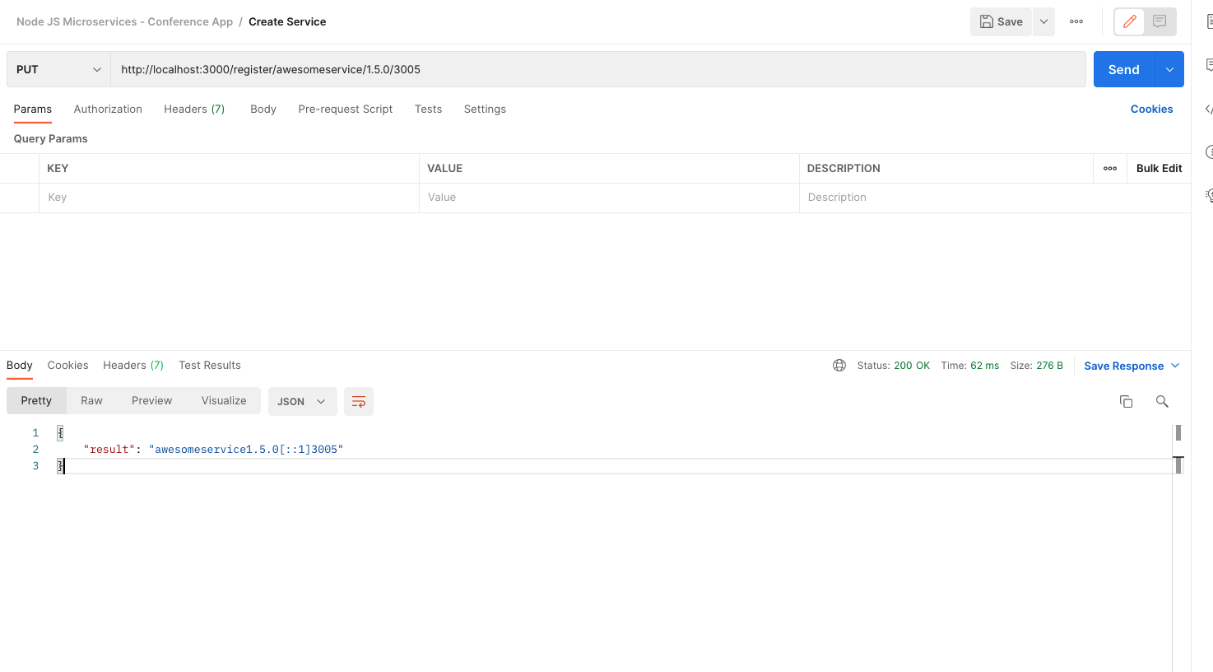

🡪 We have given timeout as 15 seconds in Service Registry constructer.

this.timeout = 15;

🡪 When we try to fetch this service. It will stay only till timeout period i.e. 15 seconds

🡪 After that service not found will come

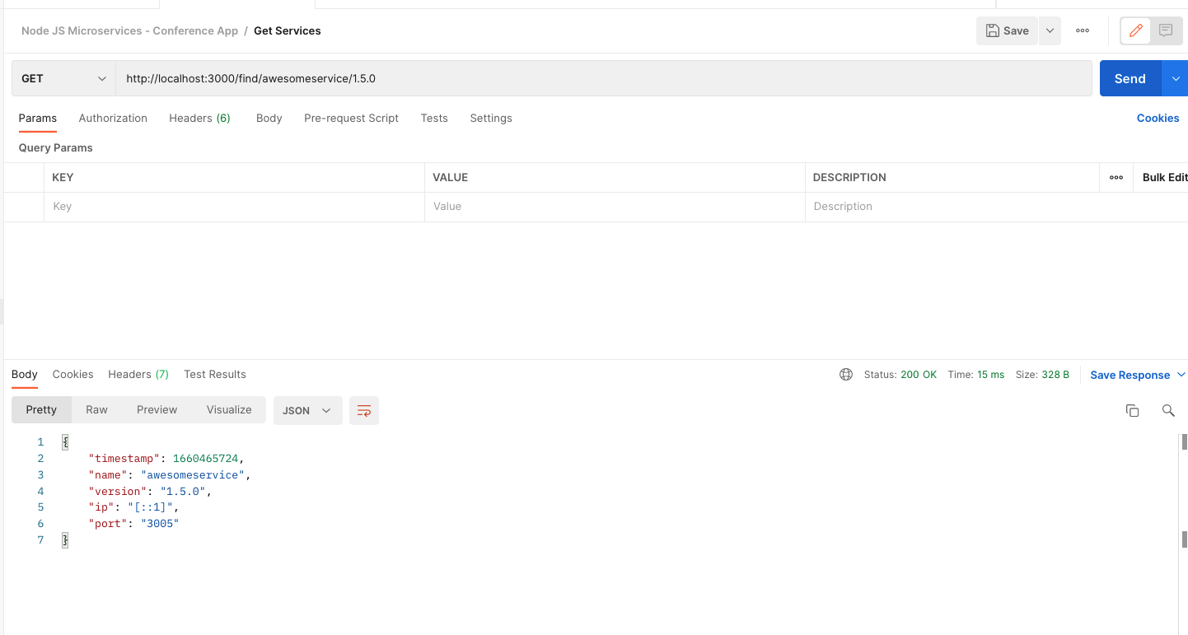

After 15 seconds:

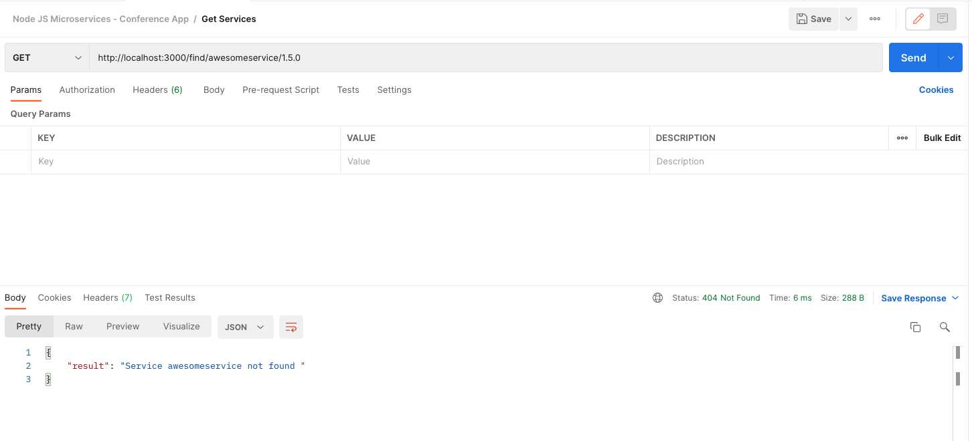

🡪 We have now built all functionality for Service registry – register, unregister, load balancing, get, delete, remove expired services

Splitting up Monolithic into Microservice Application:

🡪 We have one monolithic application that has two important functionalities –

speakers and feedback



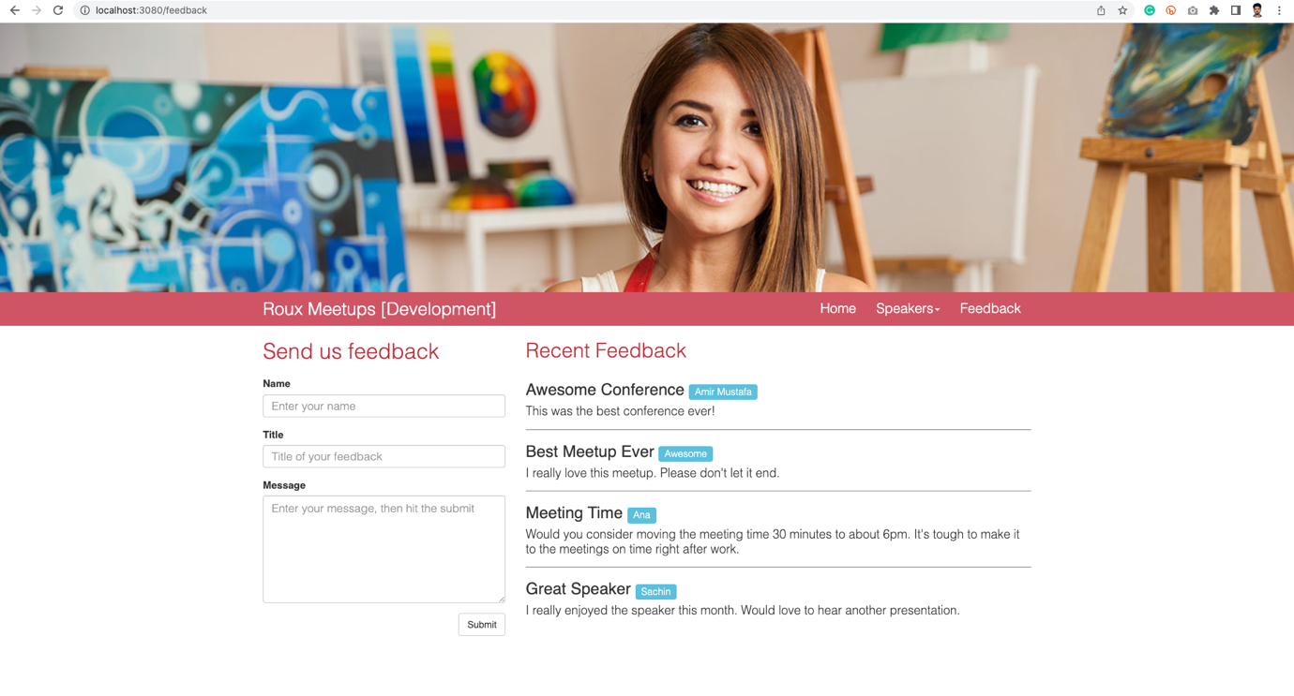

🡪 Firstly we should add a new microservice. This is basically a brand new express app.

* We will now slowly remove speakers service code data from monolithic app and use in our new micro service

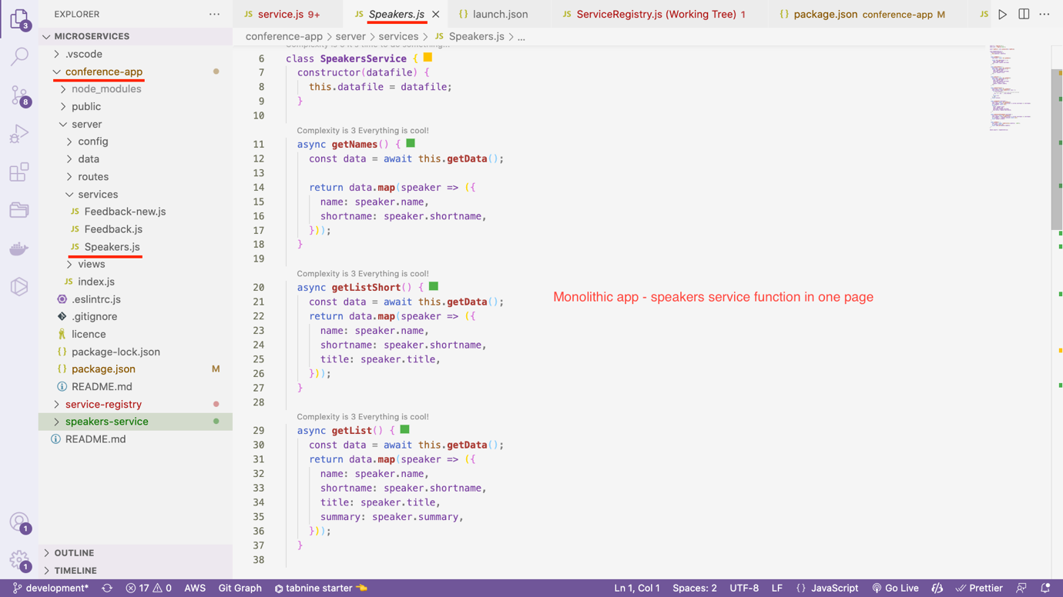

🡪 So currently inside conference-app, all methods of speakers service is there.

🡪 When the application grows, this method is not feasible – as the list grows will need more bandwidth.

Path - conference-app/server/services/Speakers.js

const **fs** = **require**('fs');

const **util** = **require**('util');

const **readFile** = **util**.**promisify**(**fs**.**readFile**);

class **SpeakersService** {

constructor(datafile) {

this.datafile = datafile;

}

async **getNames**() {

const data = await this.**getData**();

return data.**map**(speaker => ({

name: speaker.name,

shortname: speaker.shortname,

}));

}

async **getListShort**() {

const data = await this.**getData**();

return data.**map**(speaker => ({

name: speaker.name,

shortname: speaker.shortname,

title: speaker.title,

}));

}

async **getList**() {

const data = await this.**getData**();

return data.**map**(speaker => ({

name: speaker.name,

shortname: speaker.shortname,

title: speaker.title,

summary: speaker.summary,

}));

}

async **getAllArtwork**() {

const data = await this.**getData**();

const artwork = data.**reduce**((acc, elm) => {

if (elm.artwork) {

*// eslint-disable-next-line no-param-reassign*

acc = [...acc, ...elm.artwork];

}

return acc;

}, []);

return artwork;

}

async **getSpeaker**(shortname) {

const data = await this.**getData**();

const speaker = data.**find**(current => current.shortname === shortname);

if (!speaker) return null;

return {

title: speaker.title,

name: speaker.name,

shortname: speaker.shortname,

description: speaker.description,

};

}

async **getArtworkForSpeaker**(shortname) {

const data = await this.**getData**();

const speaker = data.**find**(current => current.shortname === shortname);

if (!speaker || !speaker.artwork) return null;

return speaker.artwork;

}

async **getData**() {

const data = await **readFile**(this.datafile, 'utf8');

if (!data) return [];

return JSON.**parse**(data).speakers;

}

}

**module**.exports = SpeakersService;

🡪 Speakers service runs in PORT=3001

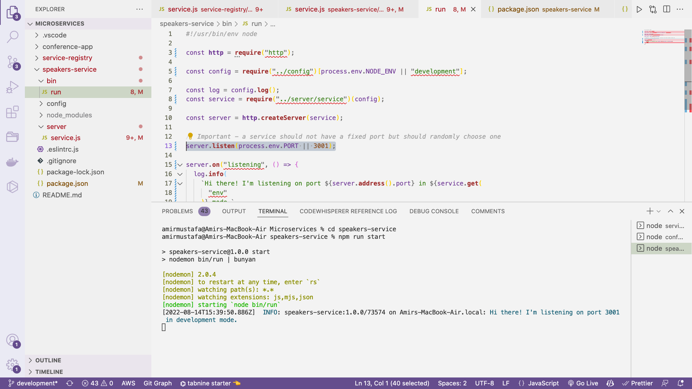

🡪 We have created some dummy routes inside service.js

Path = speakers-service/server/service.js

const **express** = **require**("express");

const service = **express**();

module.exports = (config) => {

const log = config.**log**();

*// Add a request logging middleware in development mode*

if (service.**get**("env") === "development") {

service.**use**((req, res, **next**) => {

log.**debug**(`${req.method}: ${req.url}`);

return **next**();

});

}

*// Adding all routes for speakers micro-service*

service.**get**("/list", (req, res, **next**) => {

return **next**("not implemented");

});

service.**get**("/list-short", (req, res, **next**) => {

return **next**("not implemented");

});

service.**get**("/names", (req, res, **next**) => {

return **next**("not implemented");

});

service.**get**("/speaker/:shortname", (req, res, **next**) => {

return **next**("not implemented");

});

service.**get**("/artwork/:shortname", (req, res, **next**) => {

return **next**("not implemented");

});

*// eslint-disable-next-line no-unused-vars*

service.**use**((error, req, res, next) => {

res.**status**(error.status || 500);

*// Log out the error to the console*

log.**error**(error);

return res.**json**({

error: {

message: error.message,

},

});

});

return service;

};

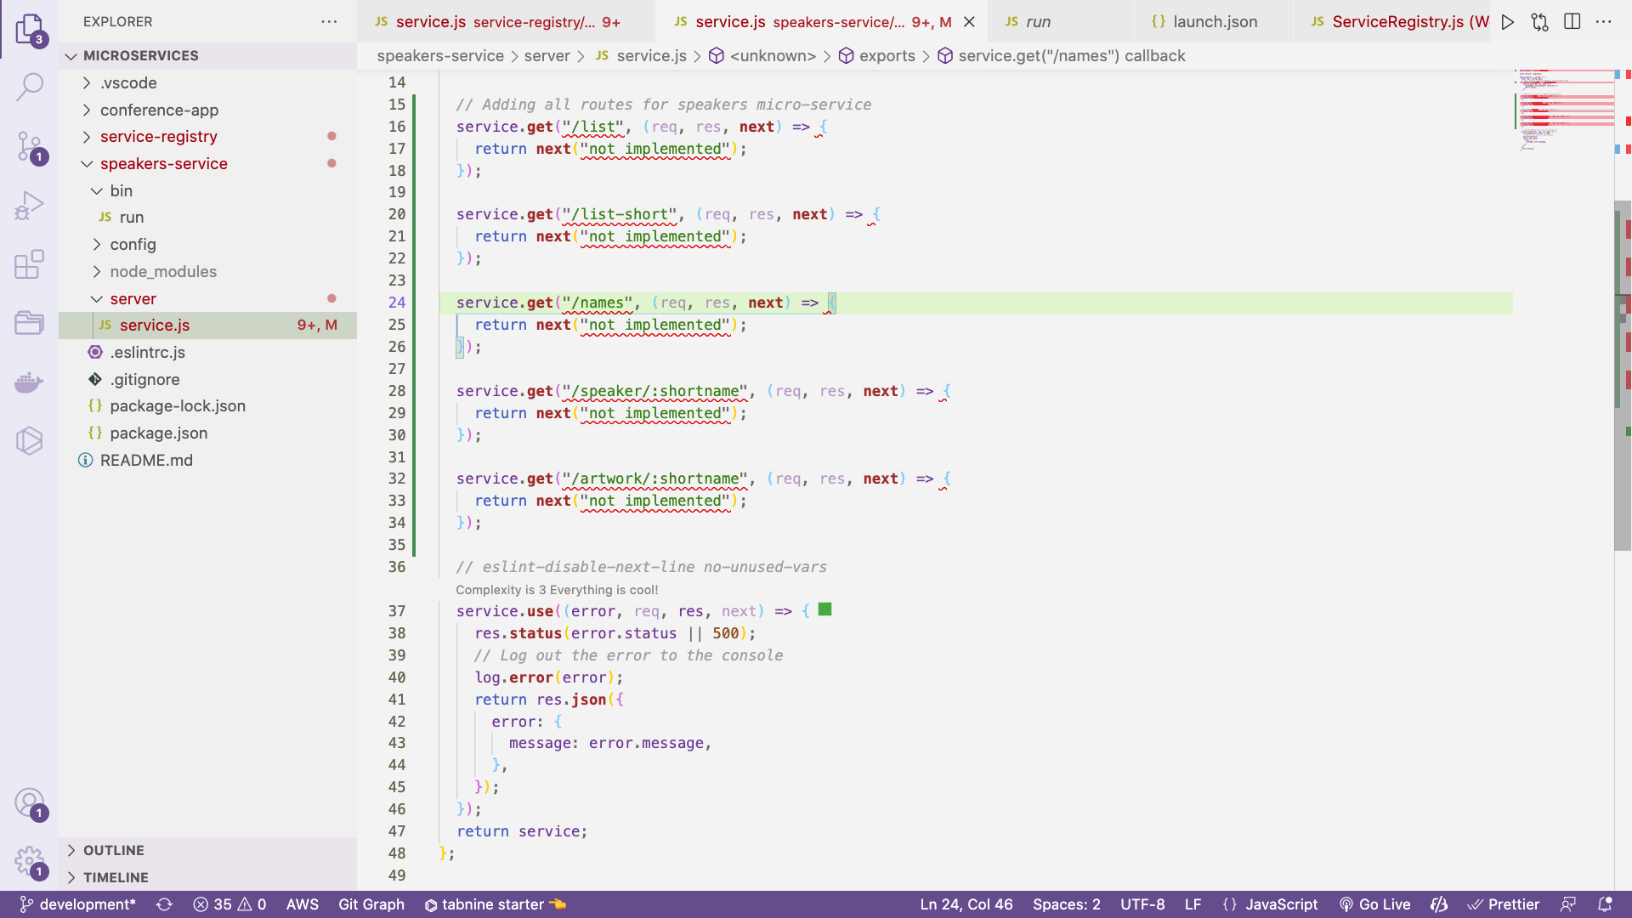

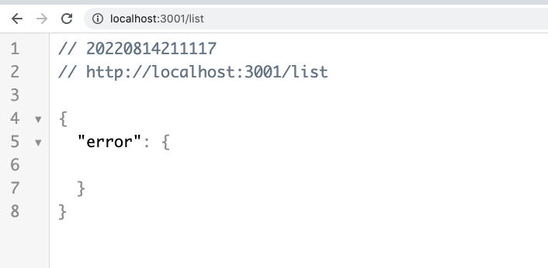

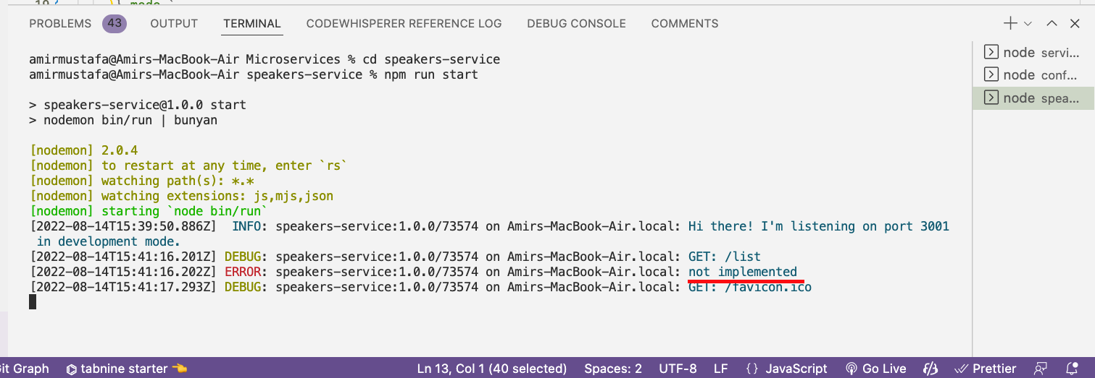

🡪 Till now we have created skeleton of speakers route – will add logics in it later

🡪 We will first register the speaker microservice.

Register Speaker Service

🡪 For this first we will install axios

npm install –save axios

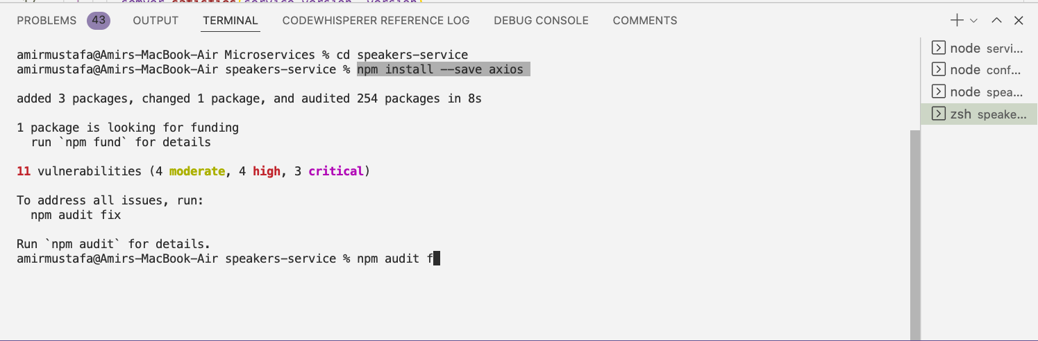

Path - speakers-service/bin/run

*#!/usr/bin/env node*

const **http** = **require**('http');

const axios = **require**('axios');

const config = **require**('../config')[process.env.NODE_ENV || 'development'];

const log = config.**log**();

const service = **require**('../server/service')(config);

const server = **http**.**createServer**(service);

server.**listen**(0); *// Choose free port*

*// server.listen(process.env.PORT || 3001);*

server.**on**('listening', () => {

const **registerService** = () => axios.**put**(

`http://localhost:3000/register/${config.name}/${config.version}/${server.**address**().port}`,

);

**registerService**();

**setInterval**(**registerService**, 20000); *// Reregister after every timeout i.e. 30 seconds*

log.**info**(

`Hi there! I'm listening on port ${server.**address**().port} in ${service.**get**(

'env',

)} mode.`,

);

});

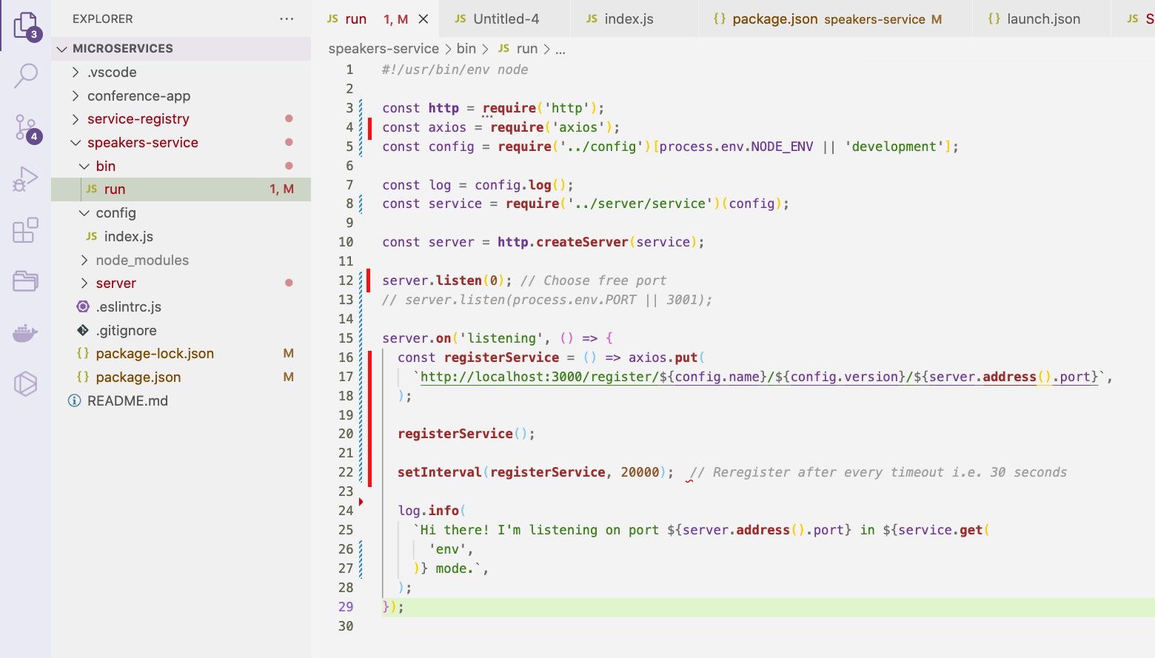

Unregister a service when stop:

🡪 We need to unregister service when terminated

🡪 In real-life scenario there will ways to start/stop the service, this also changes with the OS to OS.

🡪 Here we will see most common way to exit the service

NOTE: If service fails to unregister, we still have service timeout in place

🡪 Overhere the idea is we will add unregister route and call it when some error occurs in node

🡪 Mainly error in Node.js is handled when

process.**on**('uncaughtException', async () => {. // Unexpected ERROR

});

process.**on**('SIGTERM', async () => { // WHEN Some Error happens gradually

});

process.**on**('SIGINT', async () => { //

});

Path - speakers-service/bin/run

*#!/usr/bin/env node*

const **http** = **require**('http');

const axios = **require**('axios');

const config = **require**('../config')[process.env.NODE_ENV || 'development'];

const log = config.**log**();

const service = **require**('../server/service')(config);

const server = **http**.**createServer**(service);

server.**listen**(0); *// Choose free port*

*// server.listen(process.env.PORT || 3001);*

server.**on**('listening', () => {

*// Below requests are sent to service-registry microservice*

const **registerService** = () => axios.**put**(

`http://localhost:3000/register/${config.name}/${config.version}/${server.**address**().port}`,

);

const **unregisterService** = () => axios.**delete**(

`http://localhost:3000/register/${config.name}/${config.version}/${server.**address**().port}`,

);

*// Registering speakers-service service to service-registry microservice*

**registerService**();

const interval = **setInterval**(**registerService**, 20000); *// Reregister after every timeout i.e. 30 seconds*

const **cleanUp** = async () => {

**clearInterval**(interval);

await **unregisterService**();

};

*// Unregister a service when some error occured*

process.**on**('uncaughtException', async () => {

await **cleanUp**();

process.**exit**(1);

});

process.**on**('SIGTERM', async () => {

await **cleanUp**();

process.**exit**(1);

});

process.**on**('SIGINT', async () => {

await **cleanUp**();

process.**exit**(1);

});

log.**info**(

`Hi there! I'm listening on port ${server.**address**().port} in ${service.**get**(

'env',

)} mode.`,

);

});

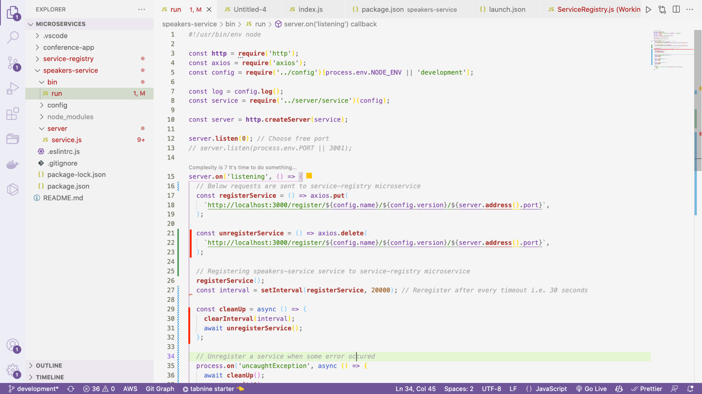

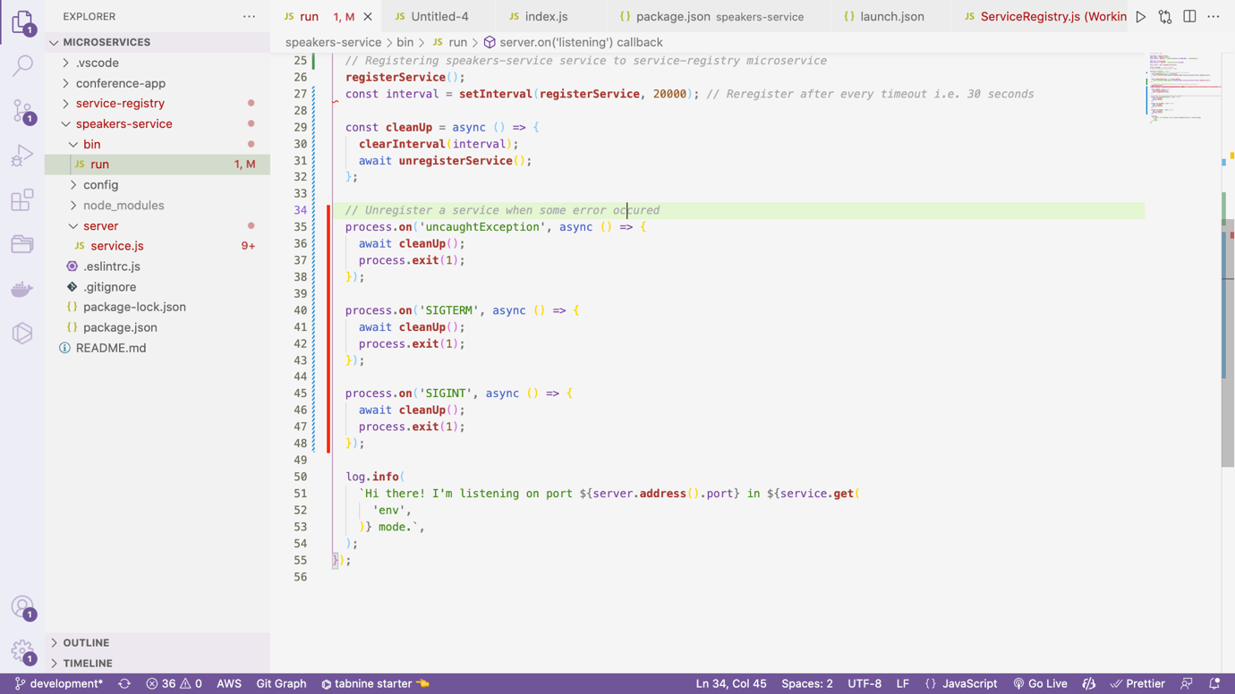

TRICK:

🡪 We will first restart the speakers-service microservice

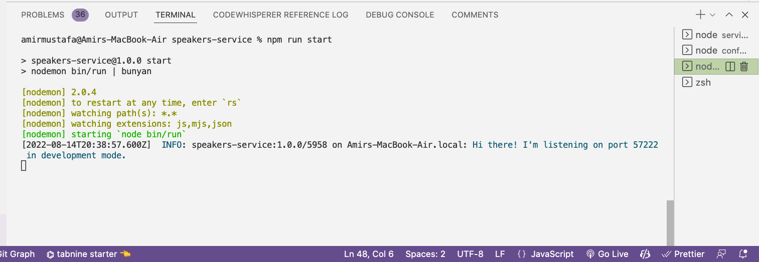

🡪 In the service-registry microservice register service log will come.

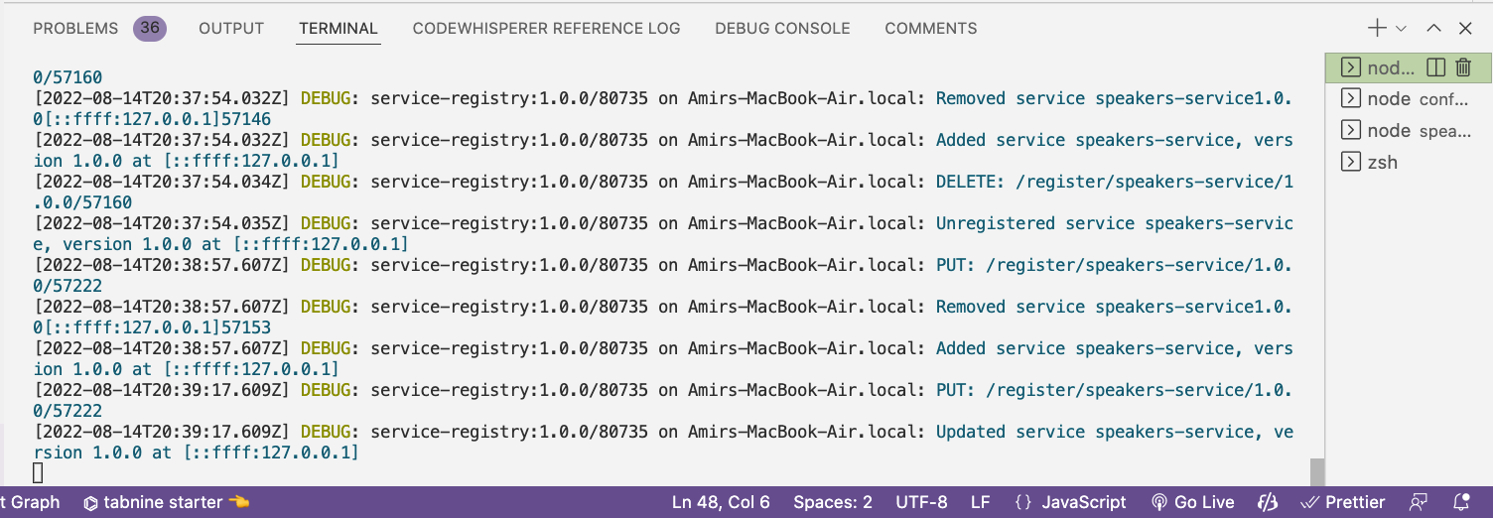

Here we get Added service speaker-service message, followed by update service message after every 30 seconds

🡪 To generate error case scenario, we will in the speakers-service do Ctrl + C (i.e. terminate the speakers microservice)

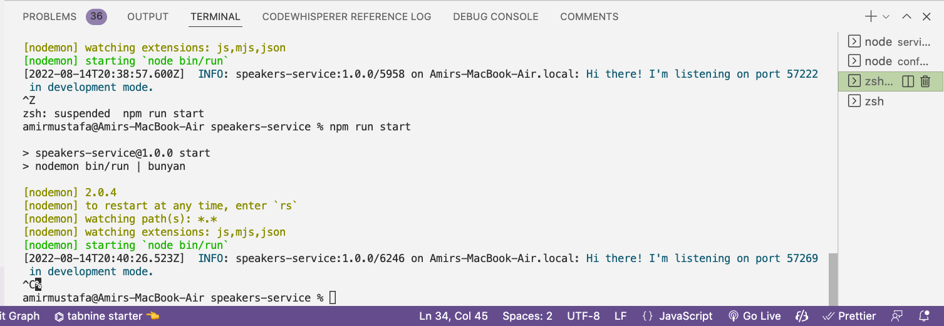

🡪 We now get unregister speaker service message logs in the service-registry service terminal

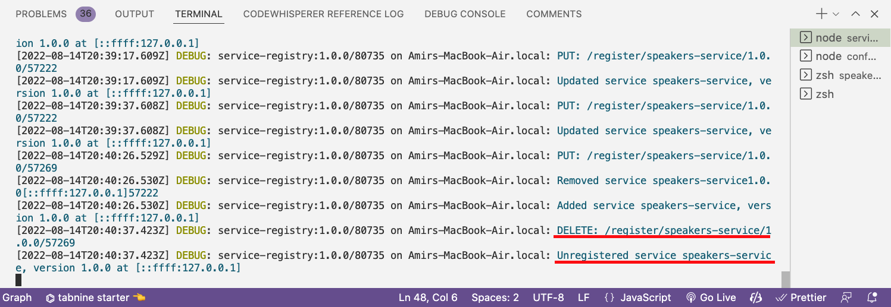

🡪 The second way we can generate the error is:

Addign setTimeout method

**setTimeout**(() => {

throw new **Error**('Something went wrong!');

}, 10000);

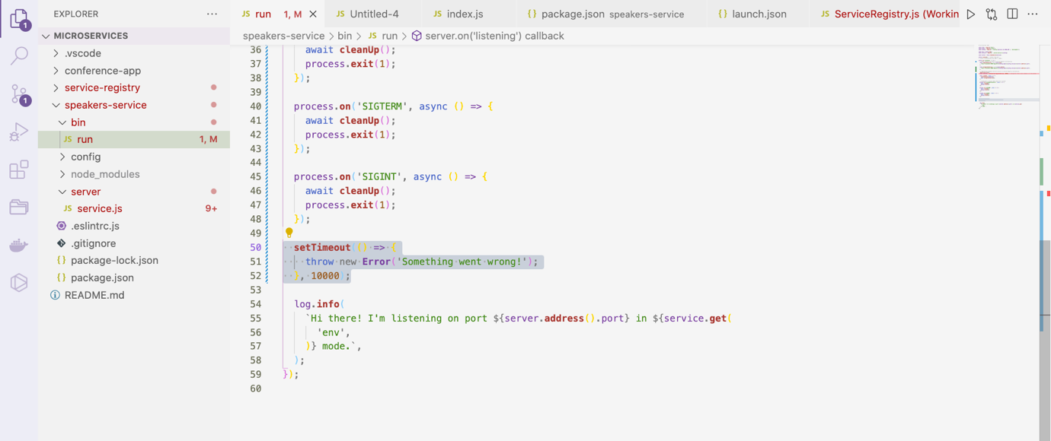

🡪 If we restart speakers microservice, after 10 seconds an unregister logs prints in the service registry

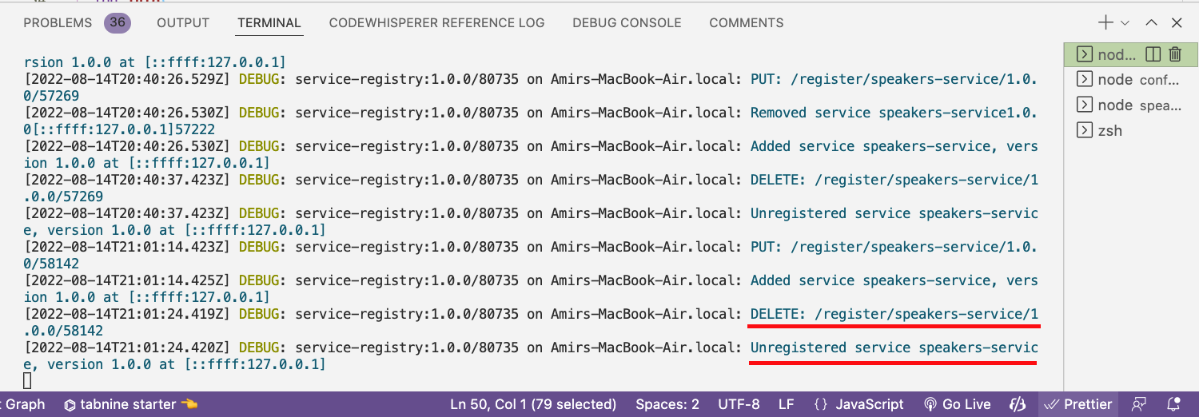

NOTE:

Based on OS or error cases we need to handle different error cases.

Adding Service Logic:

🡪 We are now heading towards application logic i.e. moving from monolithic to its microservice.

🡪 When we open conference app (monolithic app) inside

speakers-service/server/lib/Speakers.js

we have all logic

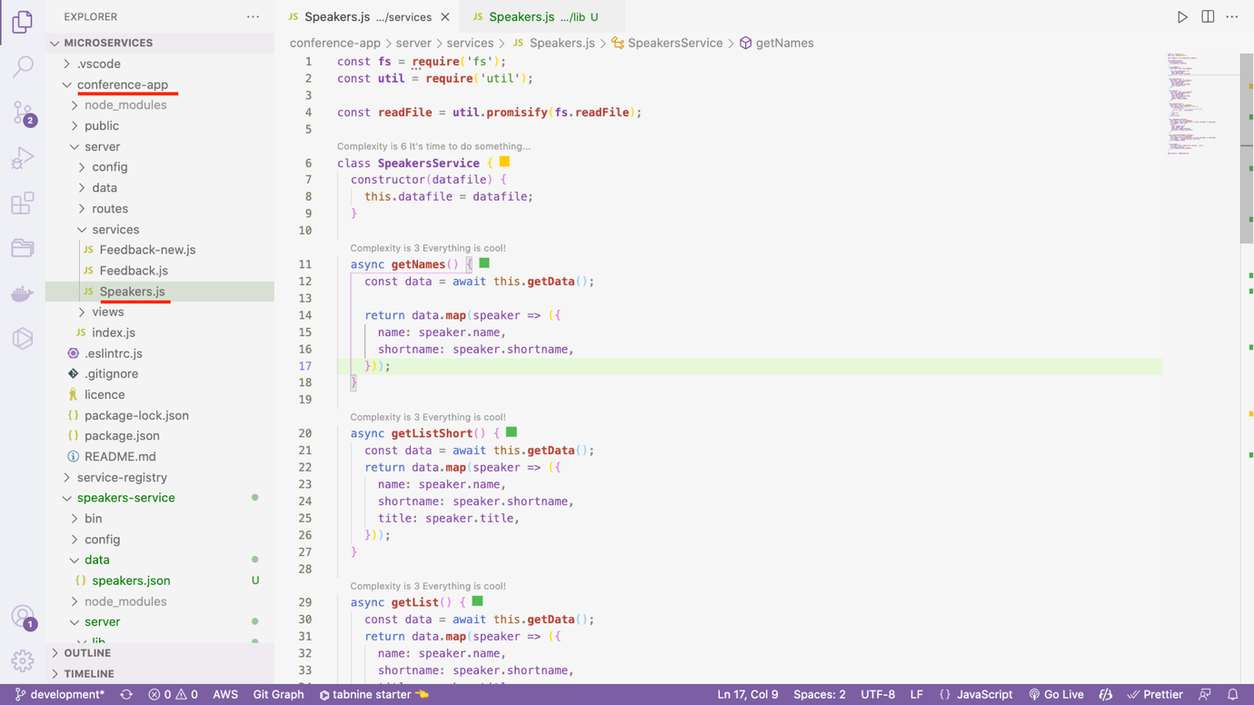

🡪 We have created speakers microservice to move logic there and load to the mail app will be less.

🡪 Let copy services/Speakers.js and data directory in speakers microservice

🡪 Pasted in speakers-service/server/lib/Speakers.js. (created new directory lib and pasted)

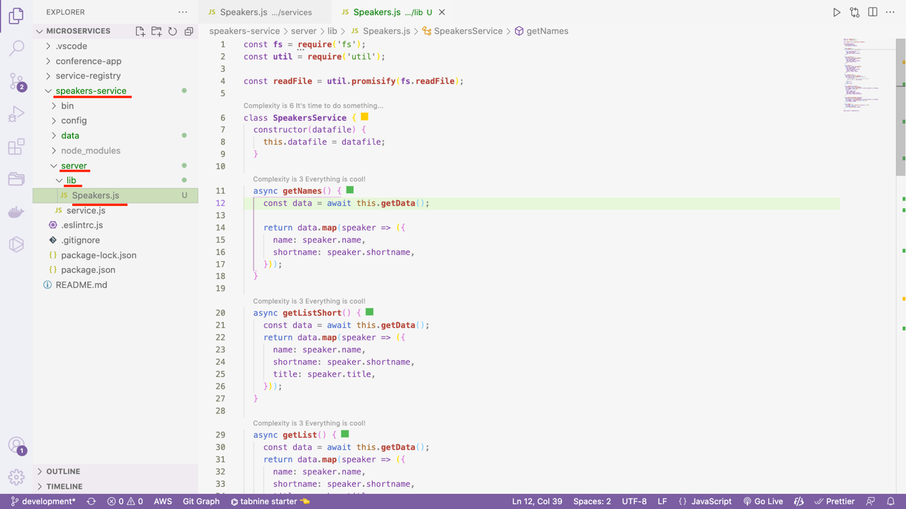

🡪 If we observe Speakers.js file, data variable used, so we need to copy data directory from conference app (Monolithic – main app)

async **getNames**() {

const data = await this.**getData**();

return data.**map**(speaker => ({

name: speaker.name,

shortname: speaker.shortname,

}));

}

Copy: Conference - conference-app/server/data/speakers.json to

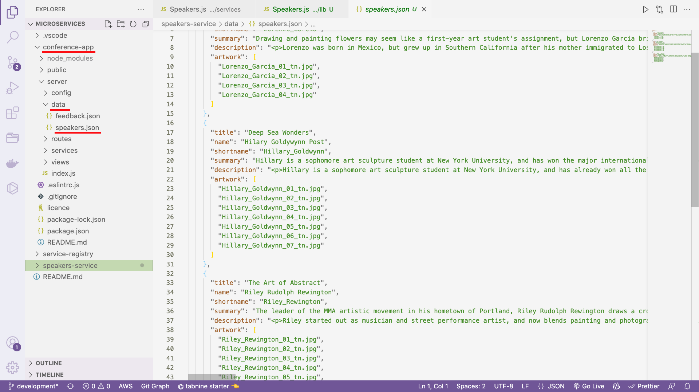

Paste: Speakers microservice - speakers-service/server/lib/Speakers.js

🡪 We have pasted data in root directory

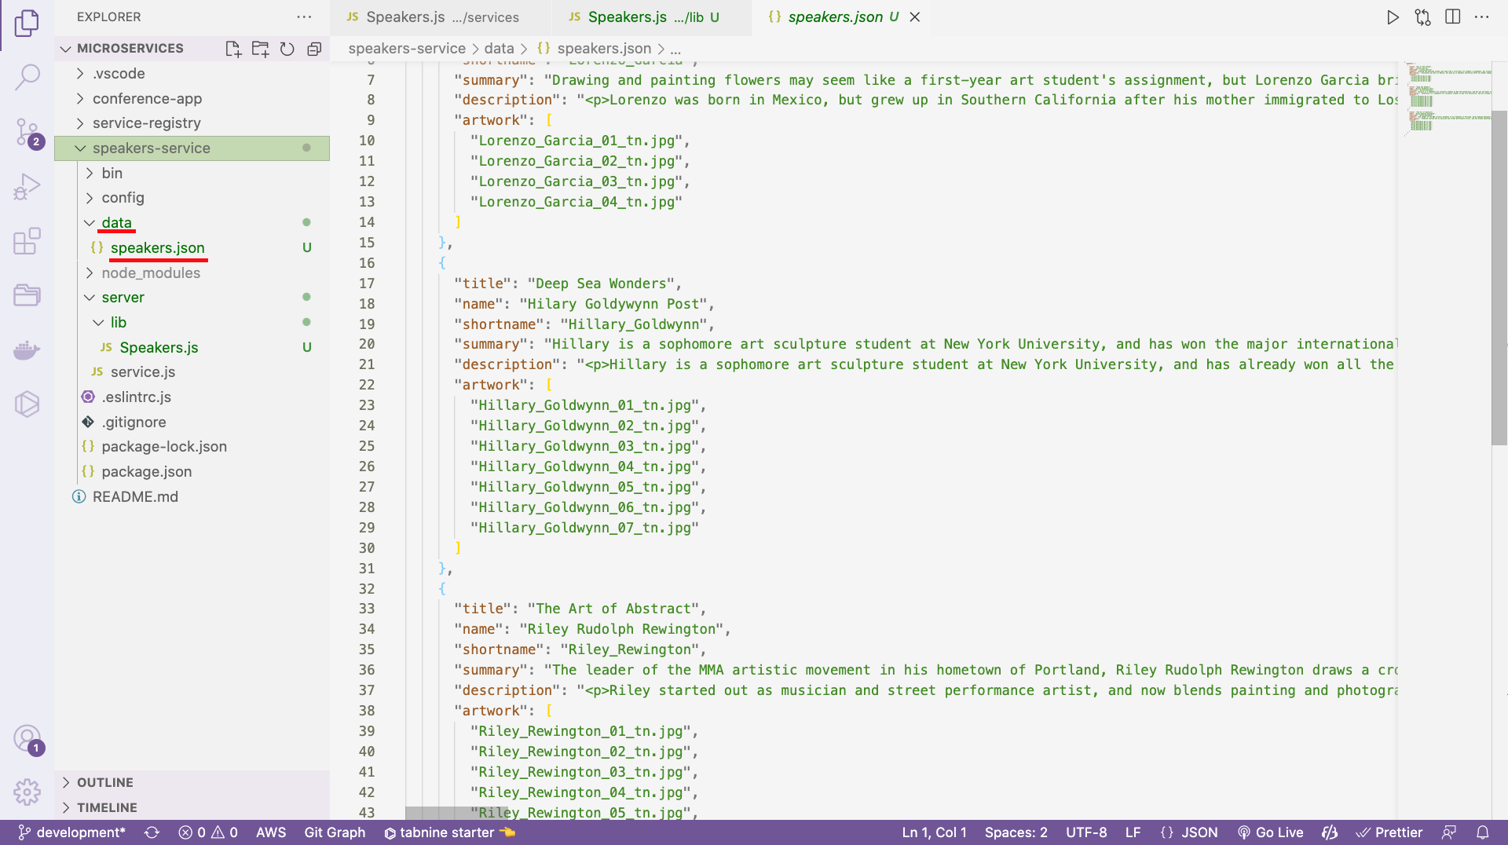

🡪 If we observe constructor – datafile is passed, we need to get that data as well

class **SpeakersService** {

constructor(datafile) {

this.datafile = datafile;

}

🡪 Inside constructor, we pass config.data.speaker, so let check what is inside config

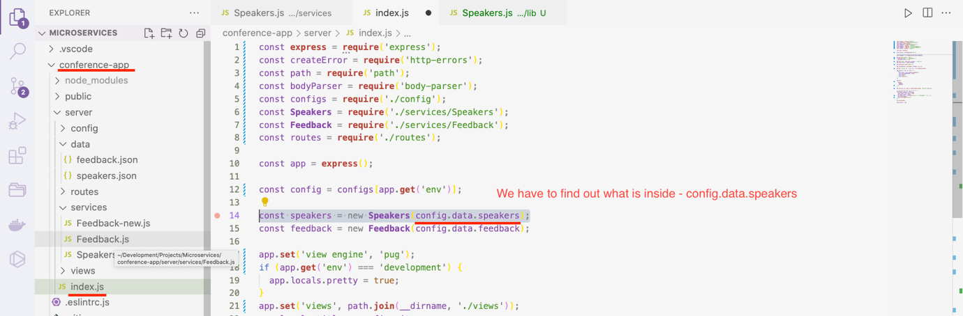

🡪 It is path to the speaker’s data. Let is copy this in speaker’s microservice

data: {

speakers: path.**join**(__dirname, '../data/speakers.json'),

feedback: path.**join**(__dirname, '../data/feedback.json'),

},

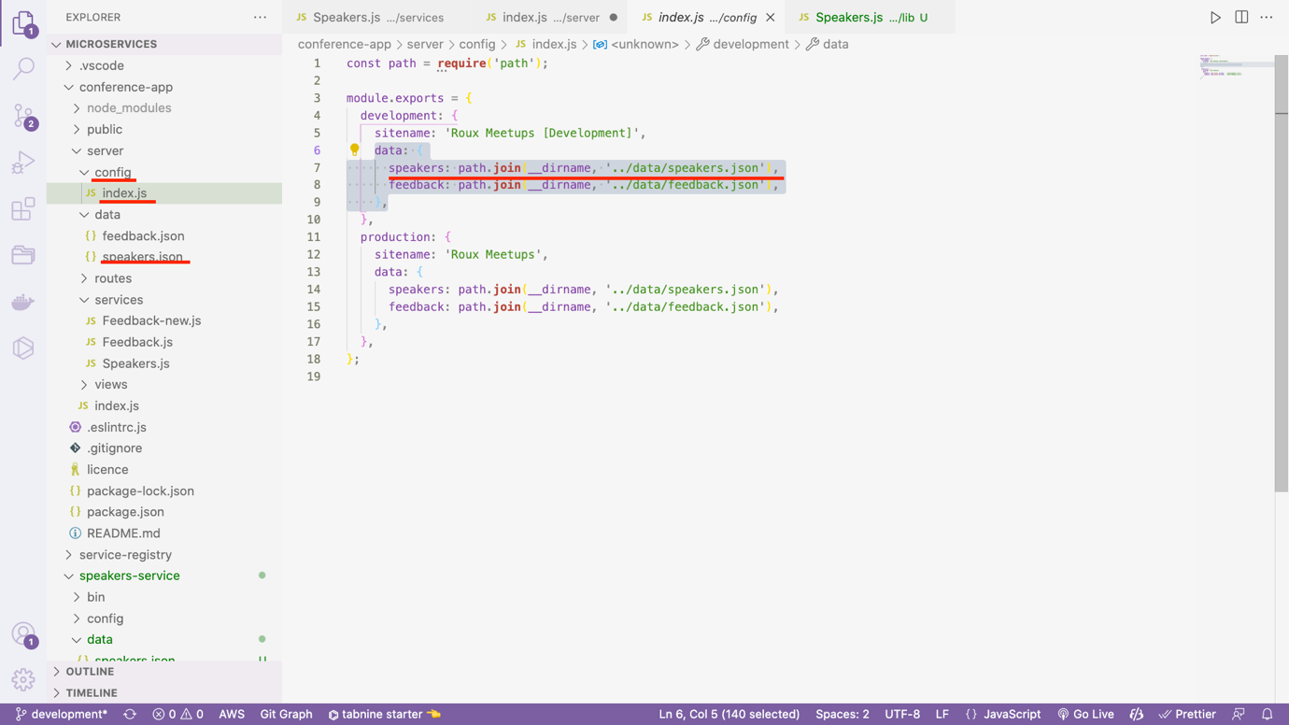

Path: speakers-service/config/index.js

const path = **require**('path');

const **bunyan** = **require**('bunyan');

*// Load package.json*

const pjs = **require**('../package.json');

*// Get some meta info from the package.json*

const { name, version } = pjs;

*// Set up a logger*

const **getLogger** = (serviceName, serviceVersion, level) => **bunyan**.**createLogger**({ name: `${serviceName}:${serviceVersion}`, level });

*// Configuration options for different environments*

module.exports = {

development: {

name,

version,

serviceTimeout: 30,

data: {

speakers: path.**join**(__dirname, '../data/speakers.json'),

},

**log**: () => **getLogger**(name, version, 'debug'),

},

production: {

name,

version,

serviceTimeout: 30,

data: {

speakers: path.**join**(__dirname, '../data/speakers.json'),

},

**log**: () => **getLogger**(name, version, 'info'),

},

test: {

name,

version,

serviceTimeout: 30,

data: {

speakers: path.**join**(__dirname, '../data/speakers.json'),

},

**log**: () => **getLogger**(name, version, 'fatal'),

},

};

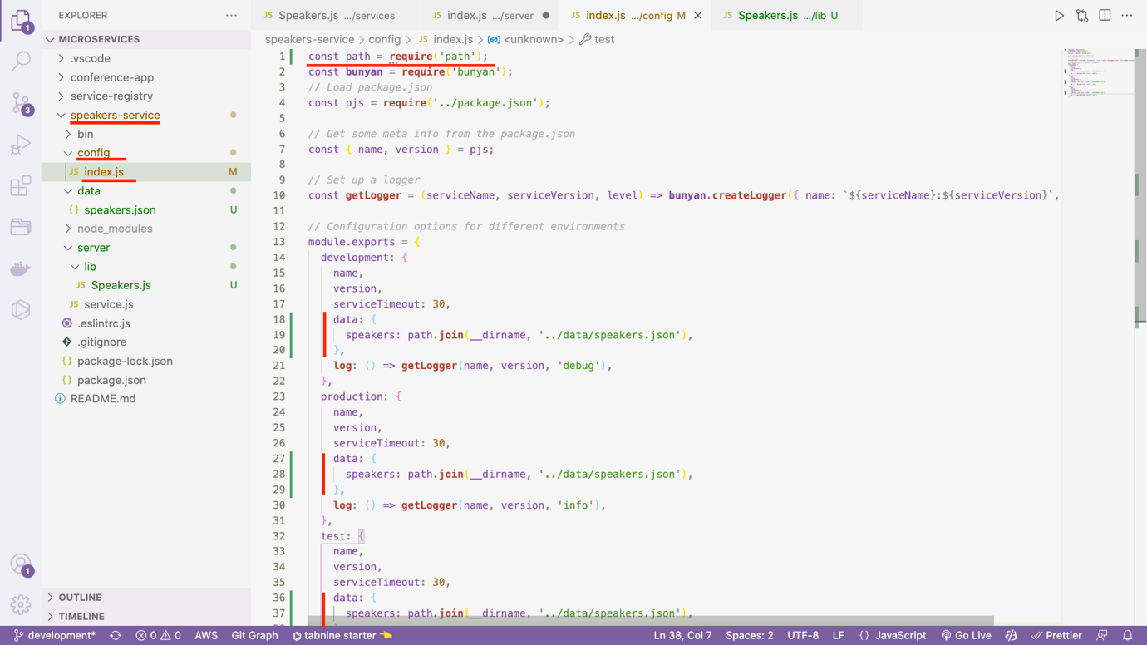

🡪 Now let is invoke this class in speakers microservice

Path - speakers-service/server/service.js

const **express** = **require**('express');

const service = **express**();

const **Speakers** = **require**('./lib/Speakers');

module.exports = (config) => {

const log = config.**log**();

const speakers = new **Speakers**(config.data.speakers);

Now basically we have to use method of class Speakers for all routes

🡪

const **express** = **require**('express');

const service = **express**();

const **Speakers** = **require**('./lib/Speakers');

module.exports = (config) => {

const log = config.**log**();

const speakers = new **Speakers**(config.data.speakers);

*// Add a request logging middleware in development mode*

if (service.**get**('env') === 'development') {

service.**use**((req, res, **next**) => {

log.**debug**(`${req.method}: ${req.url}`);

return **next**();

});

}

*// Adding all routes for speakers micro-service*

service.**get**('/list', async (req, res, **next**) => {

try {

return res.**json**(await speakers.**getList**());

} catch (err) {

return **next**(err);

}

});

service.**get**('/list-short', async (req, res, **next**) => {

try {

return res.**json**(await speakers.**getListShort**());

} catch (err) {

return **next**(err);

}

});

service.**get**('/names', async (req, res, **next**) => {

try {

return res.**json**(await speakers.**getNames**());

} catch (err) {

return **next**(err);

}

});

service.**get**('/artwork', async (req, res, **next**) => {

try {

return res.**json**(await speakers.**getAllArtwork**());

} catch (err) {

return **next**(err);

}

});

service.**get**('/speaker/:shortname', async (req, res, **next**) => {

try {

return res.**json**(await speakers.**getSpeaker**(req.params.shortname));

} catch (err) {

return **next**(err);

}

});

service.**get**('/artwork/:shortname', async (req, res, **next**) => {

try {

return res.**json**(await speakers.**getArtworkForSpeaker**(req.params.shortname));

} catch (err) {

return **next**(err);

}

});

*// eslint-disable-next-line no-unused-vars*

service.**use**((error, req, res, next) => {

res.**status**(error.status || 500);

*// Log out the error to the console*

log.**error**(error);

return res.**json**({

error: {

message: error.message,

},

});

});

return service;

};

🡪 Let us now restart the speakers microservice

🡪 Copy the port from log

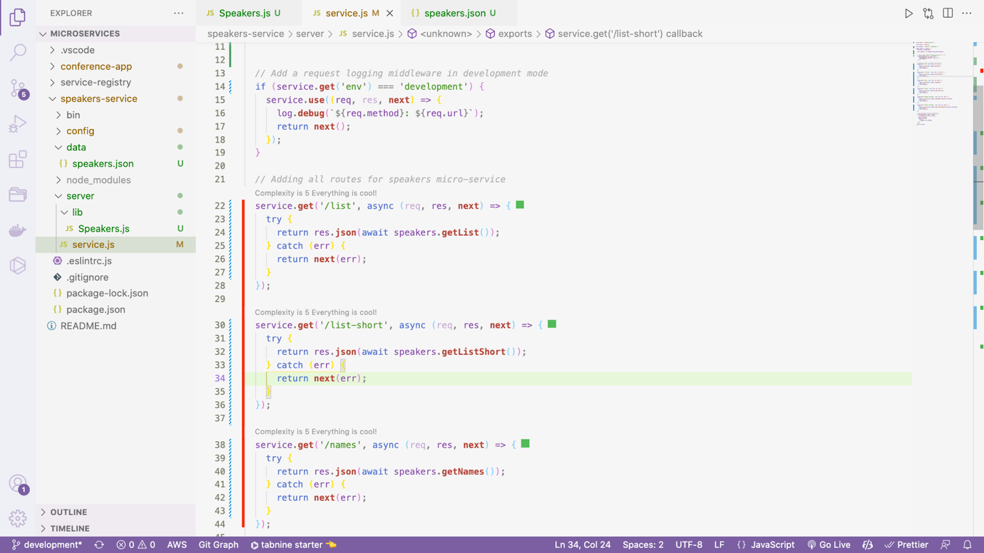

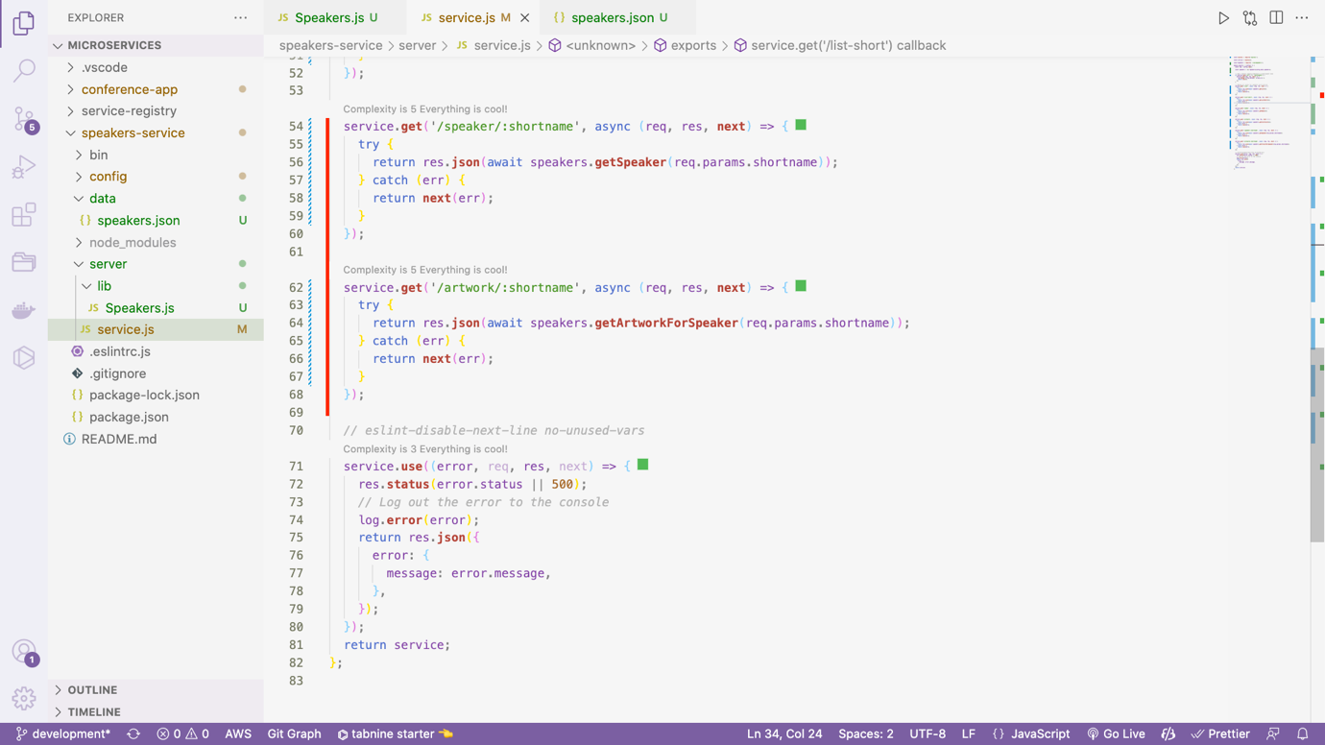

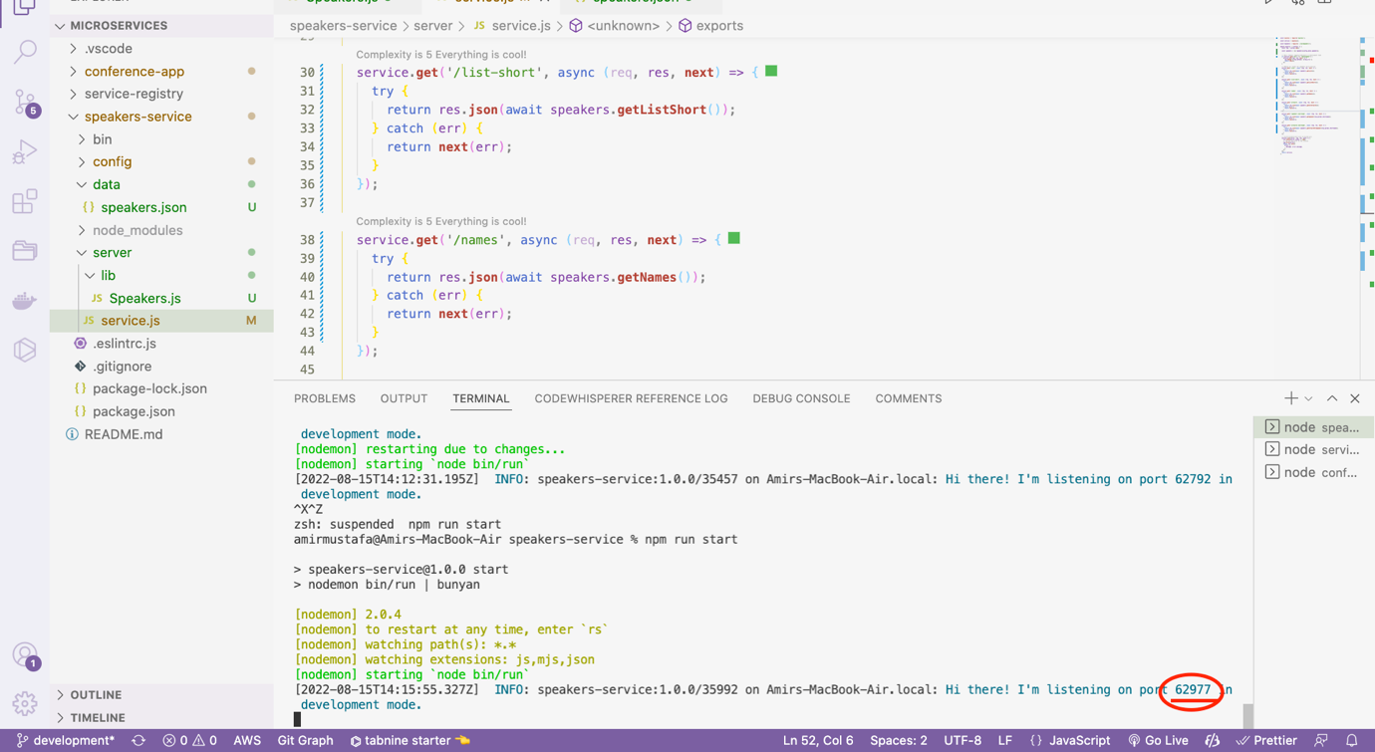

🡪 Now let us run these routes from browser

<http://localhost:62977/list>

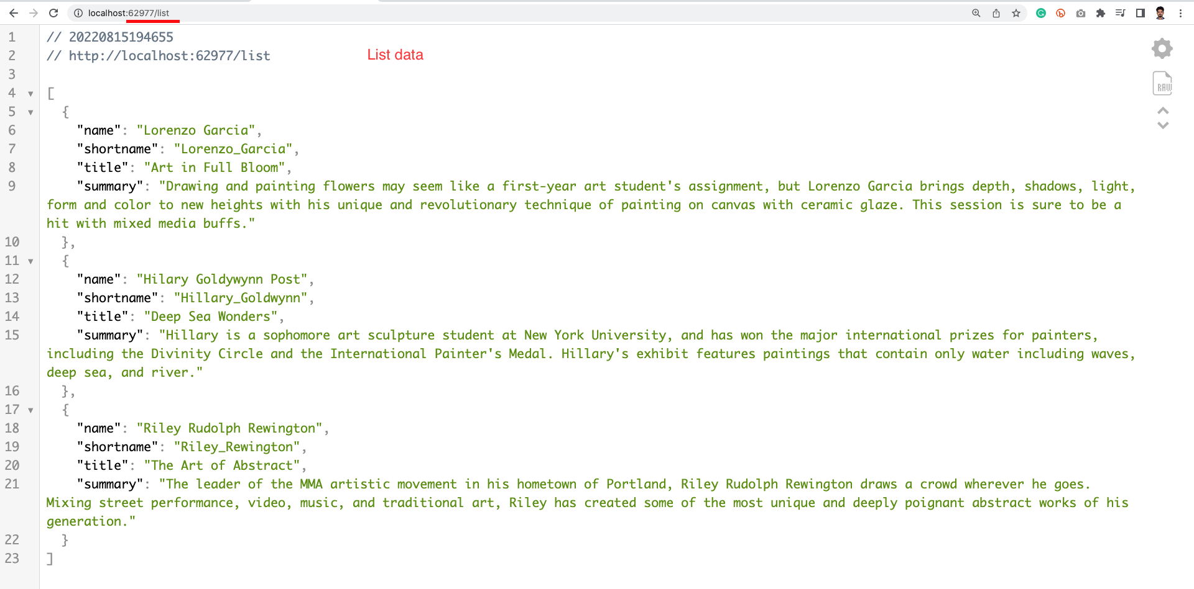

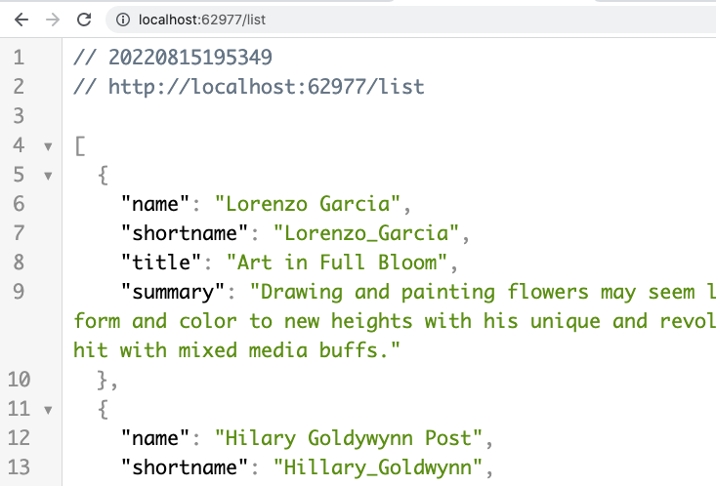

2. Names:

<http://localhost:62977/names>

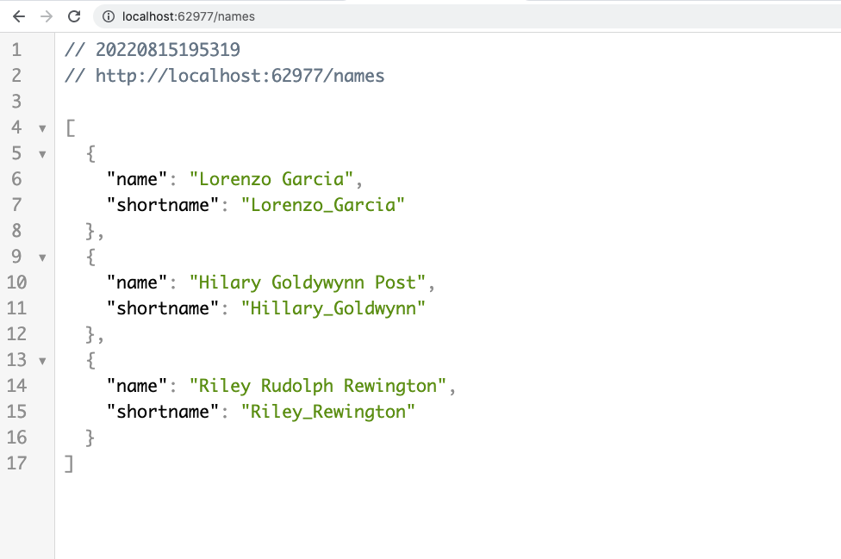

3. List Short:

<http://localhost:62977/list-short>

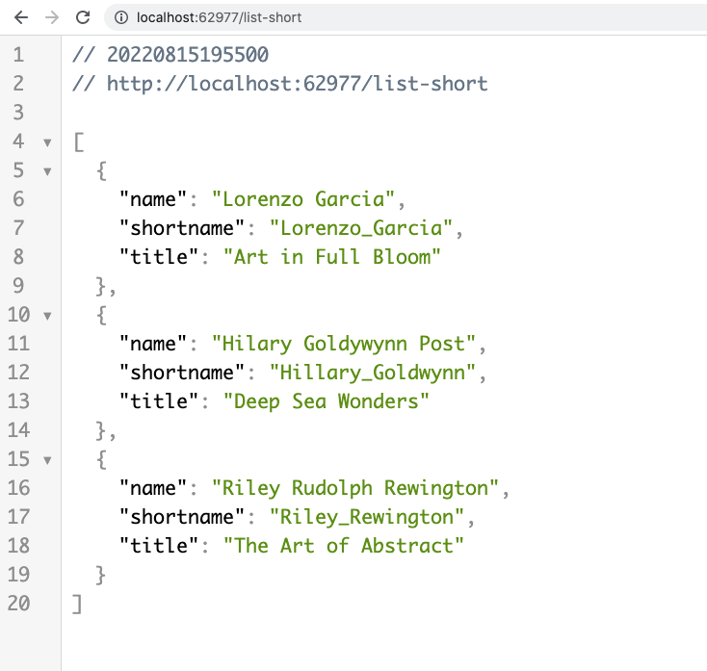

4. Speaker short name:

Let us copy the short name from above list and pass as params in below URL:

<http://localhost:62977/speaker/Riley_Rewington>

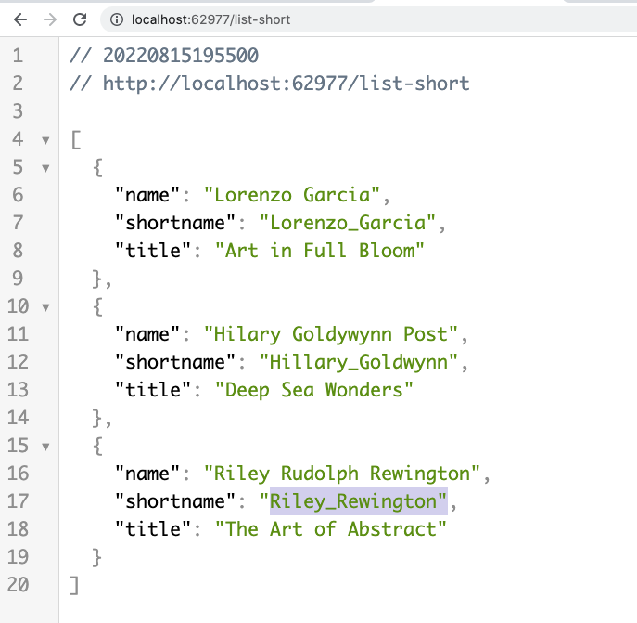

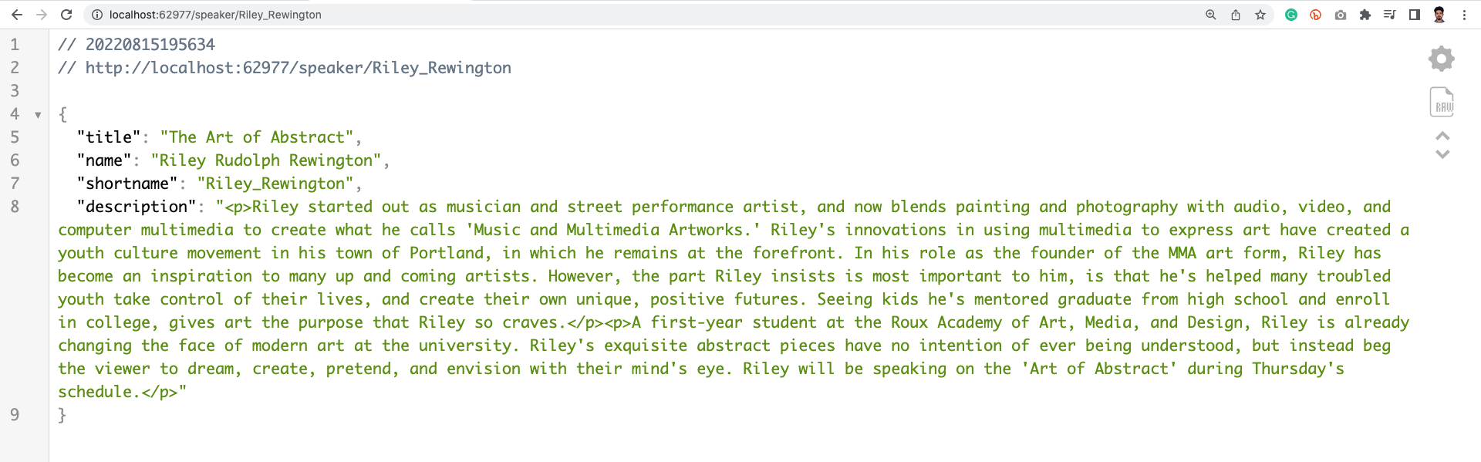

See overall changes here:

<https://github.com/AmirMustafa/Conference-app/commit/016552604422095076a949c3c4e21687805a711a>

Using Main App (conference) to call microservices:

STEP 1: npm install -save axios (in conference-app)

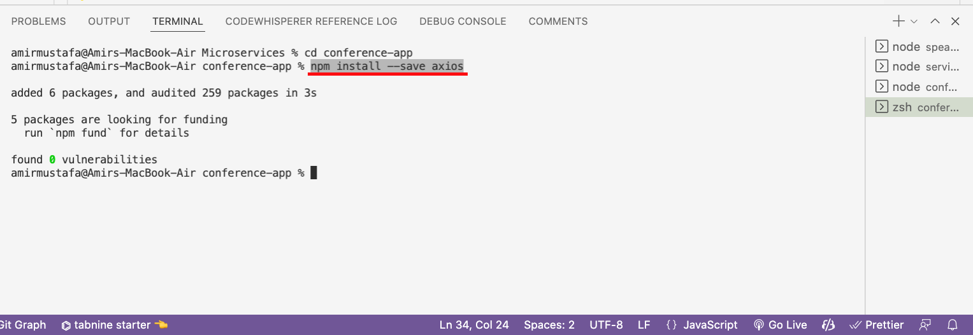

🡪 We will now use main app i.e. conference to fetch data from

Path: conference-app/server/services/Speakers.js

Commit ID: <https://github.com/AmirMustafa/Conference-app/commit/f3897d8149e79d496f1779c1d004eff9fad9dcb4>

*/* eslint-disable class-methods-use-this */*

const axios = **require**('axios');

class **SpeakersService** {

constructor(datafile) {

this.datafile = datafile;

}

async **getNames**() {

const { ip, port } = await this.**getService**('speakers-service');

return this.**callService**({

method: 'get',

url: `http://${ip}:${port}/names`,

});

}

async **getListShort**() {

const { ip, port } = await this.**getService**('speakers-service');

return this.**callService**({

method: 'get',

url: `http://${ip}:${port}/list-short`,

});

}

async **getList**() {

const { ip, port } = await this.**getService**('speakers-service');

return this.**callService**({

method: 'get',

url: `http://${ip}:${port}/list`,

});

}

async **getAllArtwork**() {

const { ip, port } = await this.**getService**('speakers-service');

return this.**callService**({

method: 'get',

url: `http://${ip}:${port}/artwork`,

});

}

async **getSpeaker**(shortname) {

const { ip, port } = await this.**getService**('speakers-service');

return this.**callService**({

method: 'get',

url: `http://${ip}:${port}/speaker/${shortname}`,

});

}

async **getArtworkForSpeaker**(shortname) {

const { ip, port } = await this.**getService**('speakers-service');

return this.**callService**({

method: 'get',

url: `http://${ip}:${port}/artwork/${shortname}`,

});

}

async **callService**(requestOptions) {

const response = await **axios**(requestOptions);

return response.data;

}

async **getService**(servicename) {

const response = await axios.**get**(`http://localhost:3000/find/${servicename}/1`);

return response.data;

}

}

**module**.**exports** = **SpeakersService**;

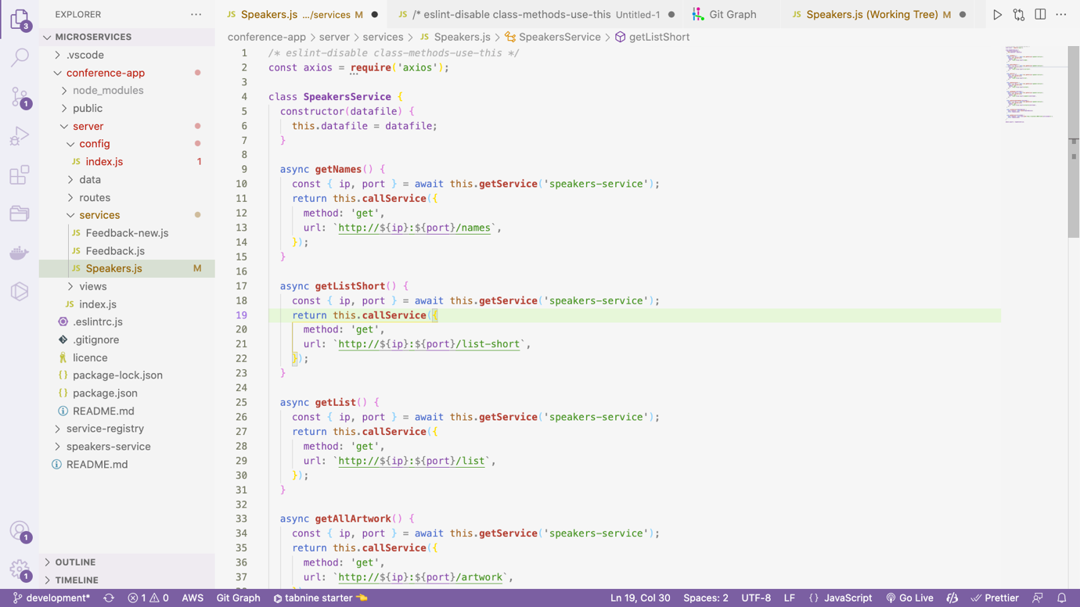

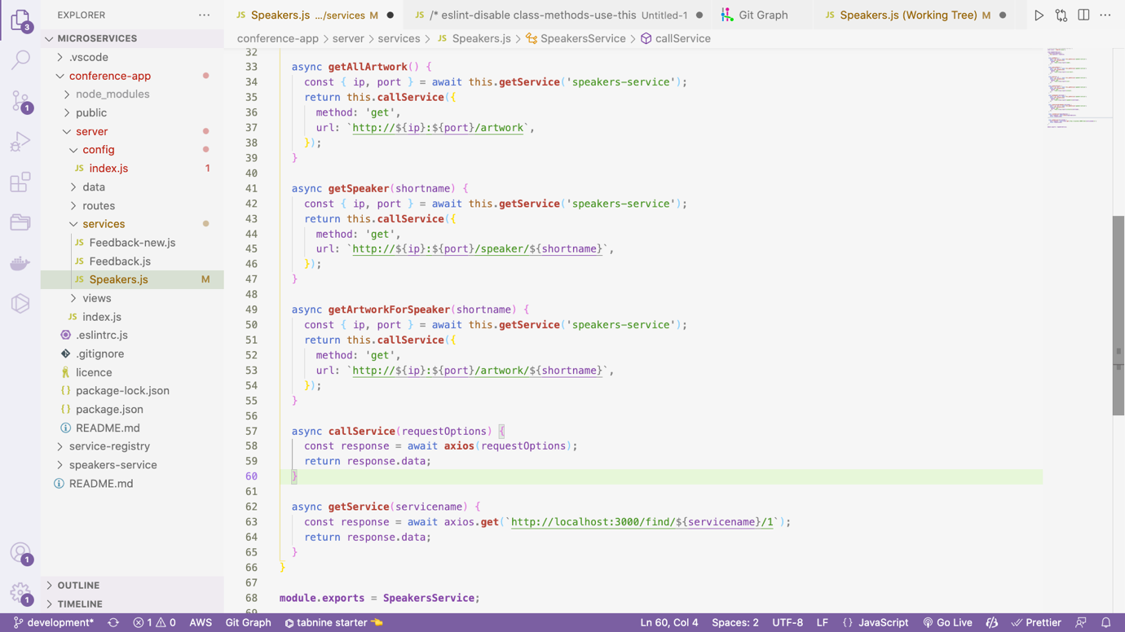

Cleaning up main app

Commit: <https://github.com/AmirMustafa/Conference-app/commit/908902e4e0b56d0755e095b3c45b6b1b69f0943c>

🡪 Here for calling gerService, we are using hard coded url, instead we will now pass from config file

Path: conference-app/server/index.js

const path = **require**('path');

module.exports = {

development: {

sitename: 'Roux Meetups [Development]',

data: {

serviceRegistryUrl: 'http://localhost:3000', // Removed speaker key

serviceVersionIdentifier: '1.x.x',

feedback: path.**join**(__dirname, '../data/feedback.json'),

},

},

production: {

sitename: 'Roux Meetups',

data: {

serviceRegistryUrl: 'http://localhost:3000',

serviceVersionIdentifier: '1.x.x',

feedback: path.**join**(__dirname, '../data/feedback.json'),

},

},

};

Index.js

Path: conference-app/server/index.js

const **express** = **require**('express');

const createError = **require**('http-errors');

const path = **require**('path');

const bodyParser = **require**('body-parser');

const configs = **require**('./config');

const **Speakers** = **require**('./services/Speakers');

const **Feedback** = **require**('./services/Feedback');

const routes = **require**('./routes');

const app = **express**();

const config = configs[app.**get**('env')];

const speakers = new **Speakers**(config.data);

const feedback = new **Feedback**(config.data.feedback);

app.**set**('view engine', 'pug');

if (app.**get**('env') === 'development') {

app.locals.pretty = true;

}

app.**set**('views', path.**join**(__dirname, './views'));

app.locals.title = config.sitename;

app.**use**(**express**.**static**('public'));

app.**use**(bodyParser.**urlencoded**({ extended: true }));

app.**get**('/favicon.ico', (req, res) => res.**sendStatus**(204));

app.**use**(async (req, res, **next**) => {

try {

const names = await speakers.**getNames**();

res.locals.speakerNames = names;

return **next**();

} catch (err) {

return **next**(err);

}

});

app.**use**(

'/',

**routes**({

speakers,

feedback,

}),

);

app.**use**((req, res, **next**) => **next**(**createError**(404, 'File not found')));

*// eslint-disable-next-line no-unused-vars*

app.**use**((err, req, res, next) => {

res.locals.message = err.message;

const status = err.status || 500;

res.locals.status = status;

res.locals.error = req.app.**get**('env') === 'development' ? err : {};

res.**status**(status);

return res.**render**('error');

});

app.**listen**(3009);

module.export = app;

Path: conference-app/server/services/Speakers.js

*/* eslint-disable class-methods-use-this */*

const axios = **require**('axios');

class **SpeakersService** {

constructor({ serviceRegistryUrl, serviceVersionIdentifier }) {

this.serviceRegistryUrl = serviceRegistryUrl;

this.serviceVersionIdentifier = serviceVersionIdentifier;

}

async **getNames**() {

const { ip, port } = await this.**getService**('speakers-service');

return this.**callService**({

method: 'get',

url: `http://${ip}:${port}/names`,

});

}

async **getListShort**() {

const { ip, port } = await this.**getService**('speakers-service');

return this.**callService**({

method: 'get',

url: `http://${ip}:${port}/list-short`,

});

}

async **getList**() {

const { ip, port } = await this.**getService**('speakers-service');

return this.**callService**({

method: 'get',

url: `http://${ip}:${port}/list`,

});

}

async **getAllArtwork**() {

const { ip, port } = await this.**getService**('speakers-service');

return this.**callService**({

method: 'get',

url: `http://${ip}:${port}/artwork`,

});

}

async **getSpeaker**(shortname) {

const { ip, port } = await this.**getService**('speakers-service');

return this.**callService**({

method: 'get',

url: `http://${ip}:${port}/speaker/${shortname}`,

});

}

async **getArtworkForSpeaker**(shortname) {

const { ip, port } = await this.**getService**('speakers-service');

return this.**callService**({

method: 'get',

url: `http://${ip}:${port}/artwork/${shortname}`,

});

}

async **callService**(requestOptions) {

const response = await **axios**(requestOptions);

return response.data;

}

async **getService**(servicename) {

const response = await axios.**get**(`${this.serviceRegistryUrl}/find/${servicename}/${this.serviceVersionIdentifier}`);

return response.data;

}

}

**module**.**exports** = **SpeakersService**;

Moving Images from respective routes:

STEP 1: Cut images/speakers and images/artwork from main app to speaker microservices

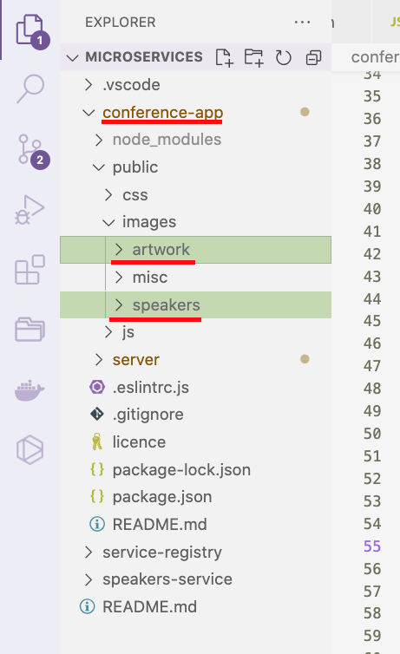

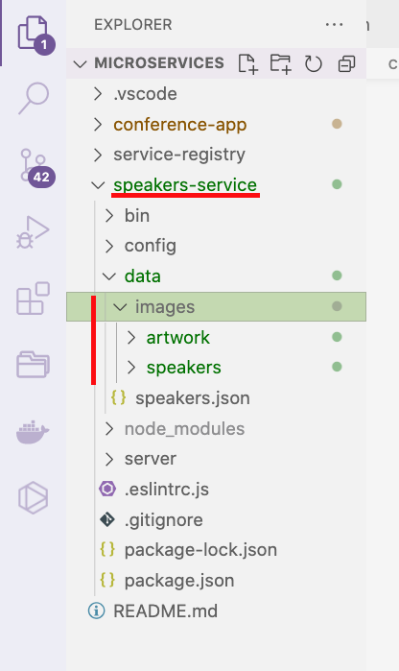

Paste inside speakers microservice: speakers-service/data/images/<paste-both-directories-here>

Goal: Instead of calling from main app, image will render from speakers microservice

1. Speakers Microservice (speakers-service): We will make URL ready

🡪 We can easily render path of image by using express.static command

Path: speakers-service/server/service.js (Speakers Microservice)

service.**use**('/images', **express**.**static**(config.data.images)); *// access images in URL inside this microservices*

Path: speakers-service/config/index.js (Speakers Microservice)

const path = **require**('path');

const **bunyan** = **require**('bunyan');

*// Load package.json*

const pjs = **require**('../package.json');

*// Get some meta info from the package.json*

const { name, version } = pjs;

*// Set up a logger*

const **getLogger** = (serviceName, serviceVersion, level) => **bunyan**.**createLogger**({ name: `${serviceName}:${serviceVersion}`, level });

*// Configuration options for different environments*

module.exports = {

development: {

name,

version,

serviceTimeout: 30,

data: {

images: path.**join**(__dirname, '../data/images'),

speakers: path.**join**(__dirname, '../data/speakers.json'),

},

**log**: () => **getLogger**(name, version, 'debug'),

},

production: {

name,

version,

serviceTimeout: 30,

data: {

images: path.**join**(__dirname, '../data/images'),

speakers: path.**join**(__dirname, '../data/speakers.json'),

},

**log**: () => **getLogger**(name, version, 'info'),

},

test: {

name,

version,

serviceTimeout: 30,

data: {

images: path.**join**(__dirname, '../data/images'),

speakers: path.**join**(__dirname, '../data/speakers.json'),

},

**log**: () => **getLogger**(name, version, 'fatal'),

},

};

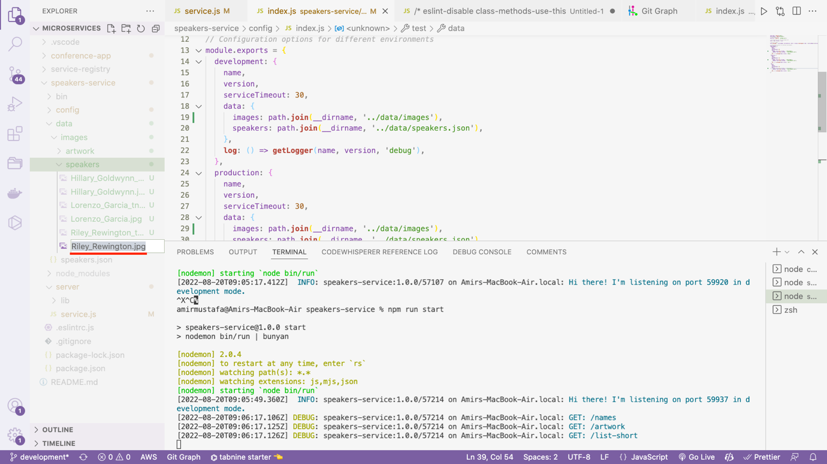

🡪 Restart Speaker’s microservice:

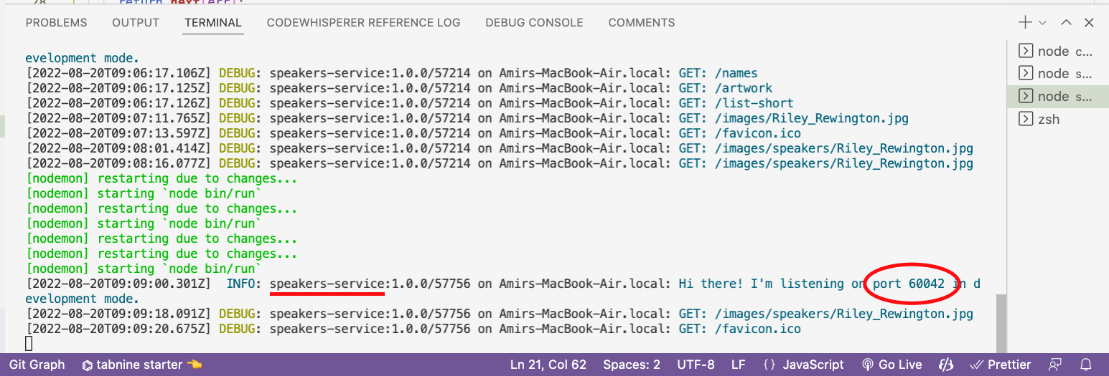

🡪 If we now try to access the image from speaker’s microservice, it renders

<http://localhost:60042/images/speakers/Riley_Rewington.jpg>





🡪 So now image URL is accessible. Work of speaker microservice is done

🡪 Service: Main service (conference-app)

🡪 We already have URL from speakers microservice, we will now access it from conference app

Path: conference-app/server/services/Speakers.js

Frontend:

const axios = **require**('axios');

class **SpeakersService** {

constructor({ serviceRegistryUrl, serviceVersionIdentifier }) {

this.serviceRegistryUrl = serviceRegistryUrl;

this.serviceVersionIdentifier = serviceVersionIdentifier;

}

async **getImage**(path) {

const { ip, port } = await this.**getService**('speakers-service');

return this.**callService**({

method: 'get',

responseType: 'stream',

url: `http://${ip}:${port}/images/${path}`,

});

}

…

…

}

**module**.**exports** = **SpeakersService**;

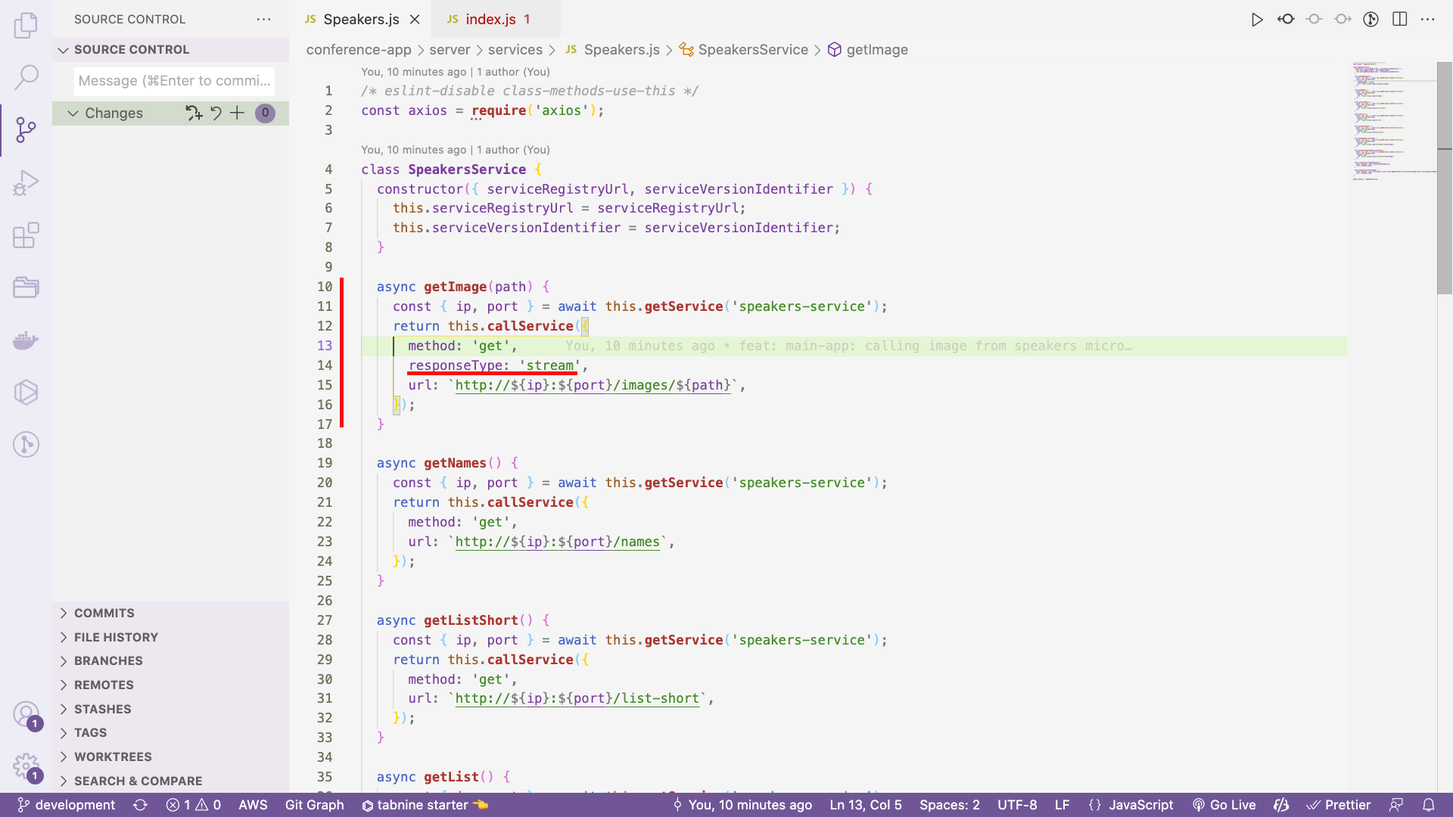

Routes:

Path: conference-app/server/routes/index.js

const **express** = **require**('express');

const router = **express**.**Router**();

const speakersRoute = **require**('./speakers');

const feedbackRoute = **require**('./feedback');

module.exports = (param) => {

const { speakers } = param;

*// Image router*

router.**get**('/images/:imagedirectory/:filename', async (req, res, **next**) => {

try {

const image = await speakers.**getImage**(`${req.params.imagedirectory}/${req.params.filename}`);

return image.**pipe**(res); *// piping because axios sent request is streams - check getImage method*

} catch (err) {

return **next**(err);

}

});

router.**get**('/', async (req, res, **next**) => {

try {

const promises = [];

promises.**push**(speakers.**getListShort**());

promises.**push**(speakers.**getAllArtwork**());

const results = await **Promise**.**all**(promises);

return res.**render**('index', {

page: 'Home',

speakerslist: results[0],

artwork: results[1],

});

} catch (err) {

return **next**(err);

}

});

router.**use**('/speakers', **speakersRoute**(param));

router.**use**('/feedback', **feedbackRoute**(param));

return router;

};

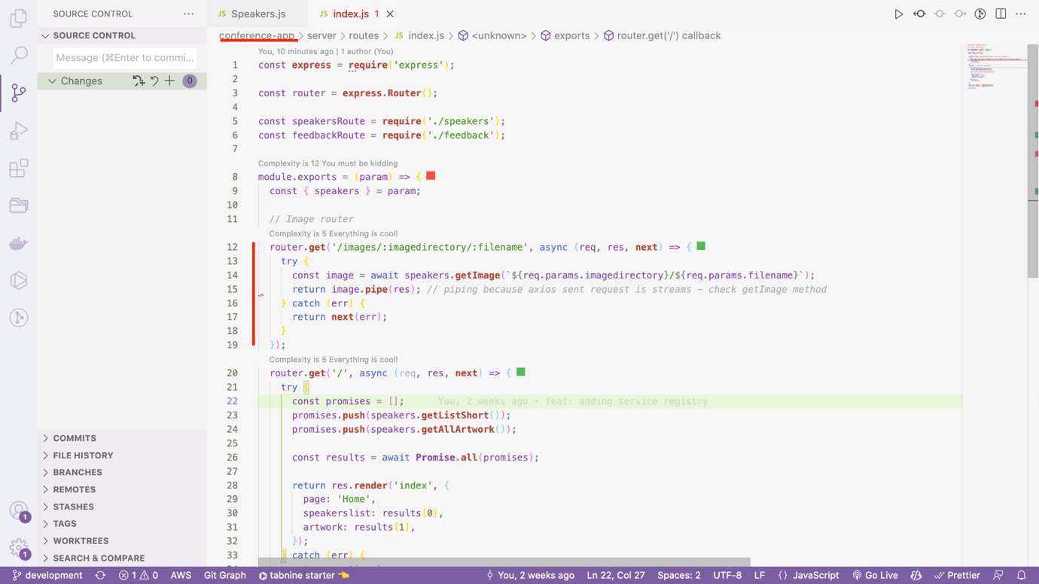

🡪 We have now split up all functionalities related to speakers.

🡪 This service now lives completely on its own and can be tested and extended independently

🡪 This is one of the main points of the microservice architecture.

What happens if service fails?

🡪 Suppose we have developed the service and handed over to the maintenance person.

🡪 Now there a user did small development and deployed

🡪 Assume some issue happens and not working

🡪 So developer was asked to check the problem and found return statement of on speaker microservice was commented

🡪 Uncommenting it will do the fix and application will be up again.

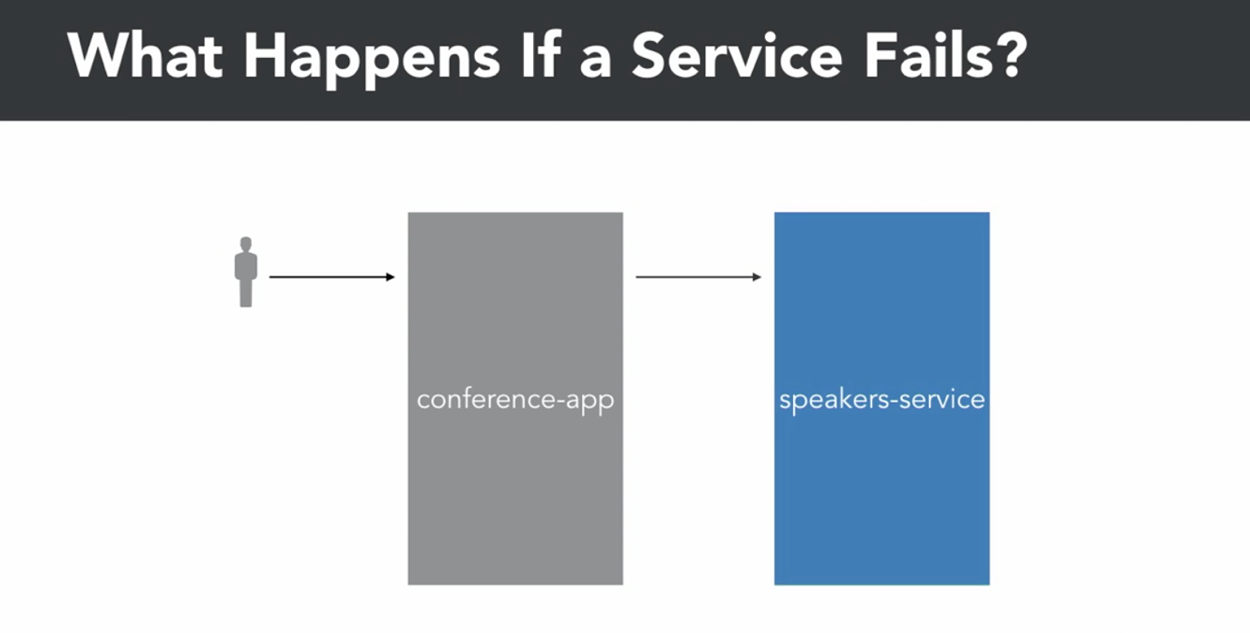

🡪 There can be many request like this and if user refreshes pages problem amplifies

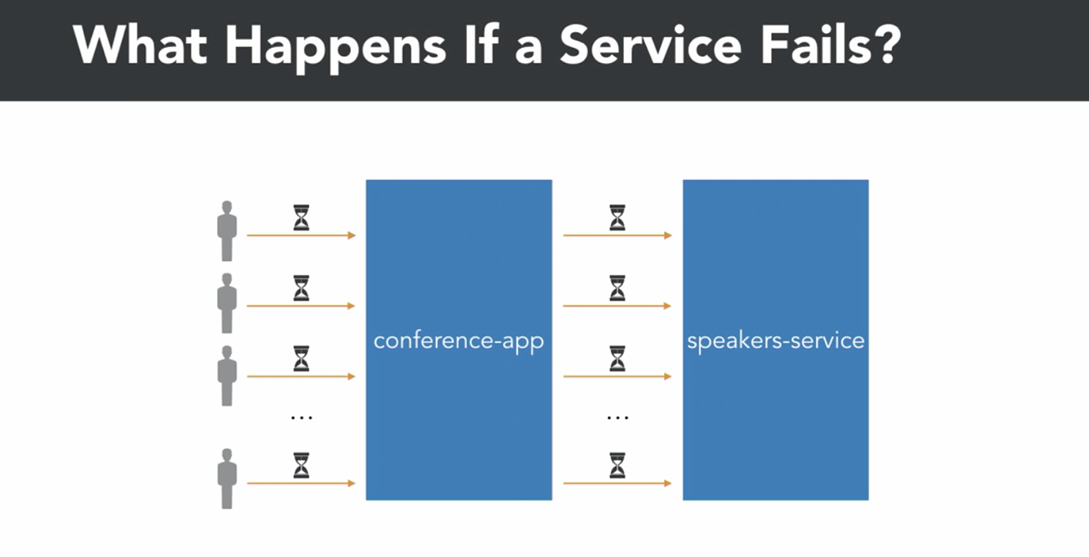

🡪 There has to be some way by which we can handle failure case.

Circuit Breakers:



🡪 We just saw if there are some issue in speaker microservice, the main app goes down loading infinitely.

🡪 One faulty service (microservice) can take down the entire app

🡪 So one way for the app for keep running is using curcit breakers. Let us see how this works.

🡪 Circuit Breakers in software also behave like electric circuit breakers. They can be either open or interrupted

Closed State:

In closed state it will simply allow request to the server.

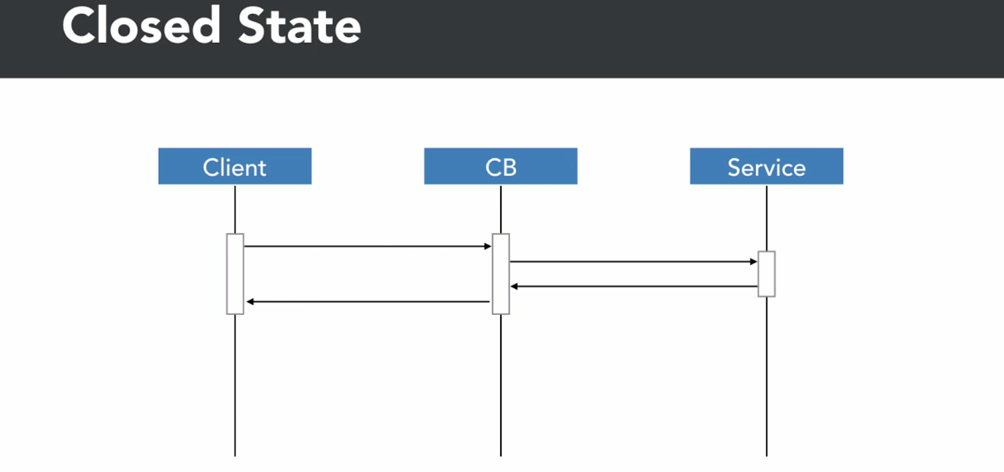

Open State:

🡪 In open state, circuit breaker will not try to connect to the service and will return back to the caller immediately.

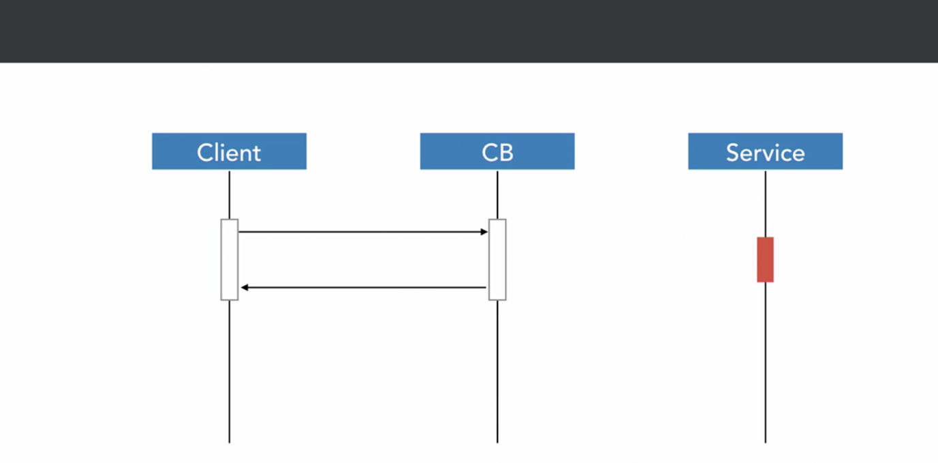

Half Open State:

That we can allow some requests

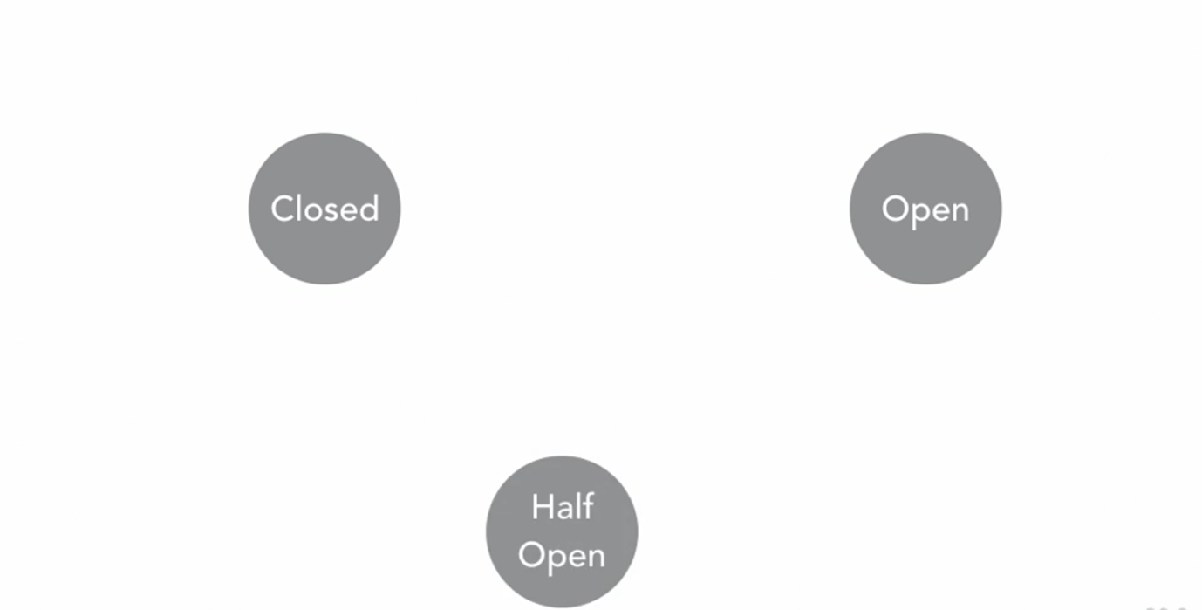

🡪 As long as the request succeeds, the circuit breakers remains closed.

🡪 Also if failure is below accepted number, circuit breaker will stay closed.

🡪 It will just increment the failure count

🡪 If Failure count > accepted failure – circuit breakers state = open.

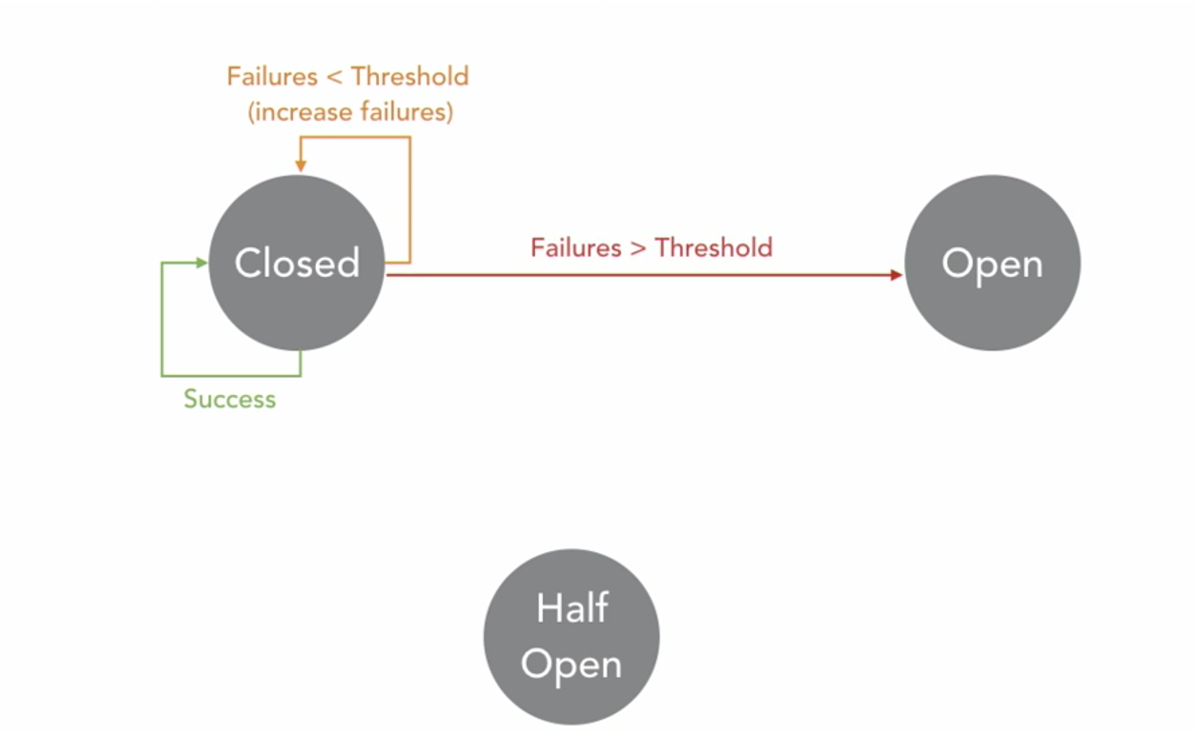

🡪 After a defined cooldown period, we will allow some requests again to go through

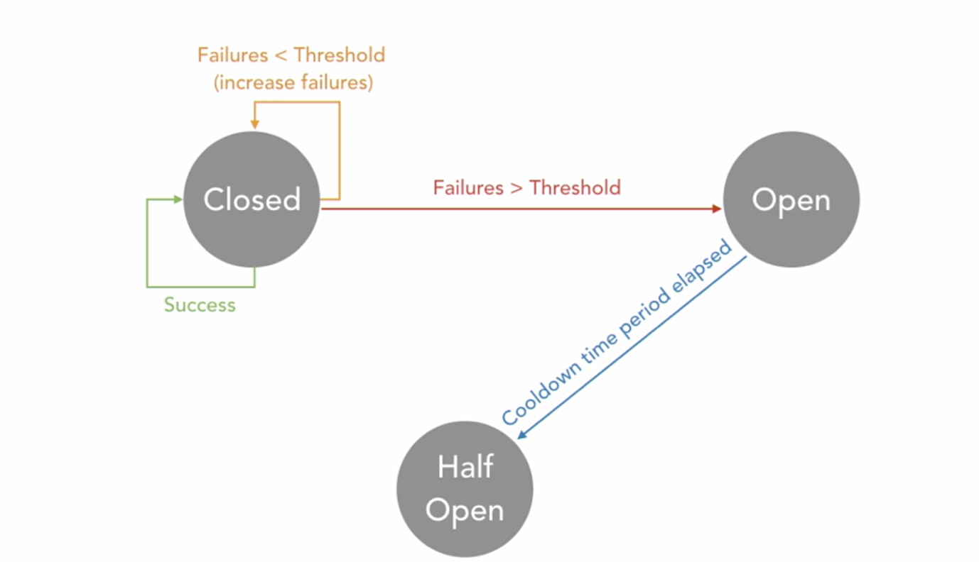

🡪 If this requests succeeds,

circuit breaker = closed state

reset failure count

🡪 If it fails again,

circuit breaker = open state

increase failure count

cooling time – either same or increased

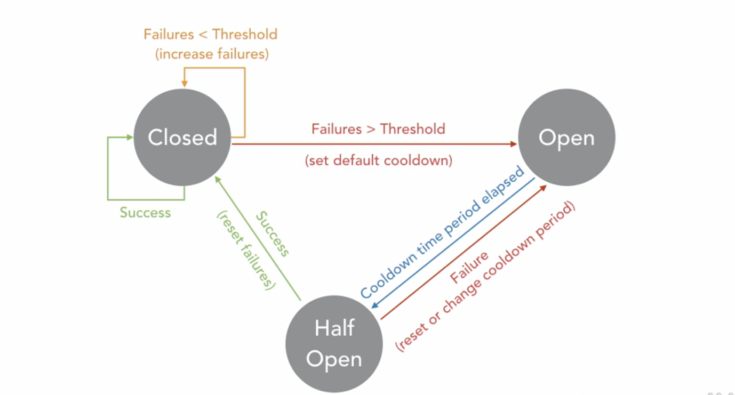

Implementing Circuit Breakers:

🡪 Let us implement circuit breakers in application:

Path: conference-app/server/lib/CircuitBreaker.js

CircuitBreaker.js

const axios = **require**('axios');

class **CircuitBreaker** {

constructor() {

this.states = {};

this.failureThreshold = 5;

this.cooldownPeriod = 10;

this.requestTimeout = 10;

}

**onSuccess**(endpoint) {

this.**initState**(endpoint);

}

**onFailure**(endpoint) {

const state = this.states[endpoint];

state.failures += 1;

if (state.failures >= this.failureThreshold) {

state.circuit = 'OPEN';

state.nextTry = new **Date**() / 1000 + this.cooldownPeriod;

console.**log**(`ALERT! Circuit for ${endpoint} is in state 'OPEN'`);

}

}

*// Can send requests in Circuit's Closed or Half open state, for Open state cannot request*

**canRequest**(endpoint) {

const state = this.states[endpoint];

if (state.circuit === 'CLOSED') return true;

const now = new **Date**() / 1000;

if (state.nextTry <= now) {

state.circuit = 'HALF';

return true;

}

return false;

}

**initState**(endpoint) {

this.states[endpoint] = {

failures: 0,

cooldownPeriod: this.cooldownPeriod,

circuit: 'CLOSED',

nextTry: 0,

};

}

}

**module**.**exports** = **CircuitBreaker**;

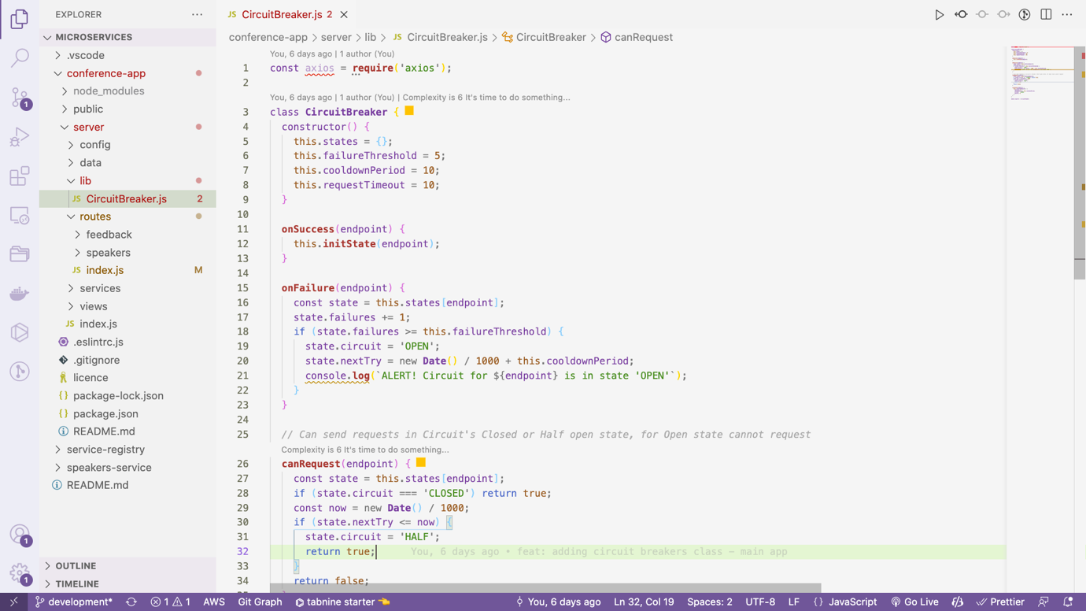

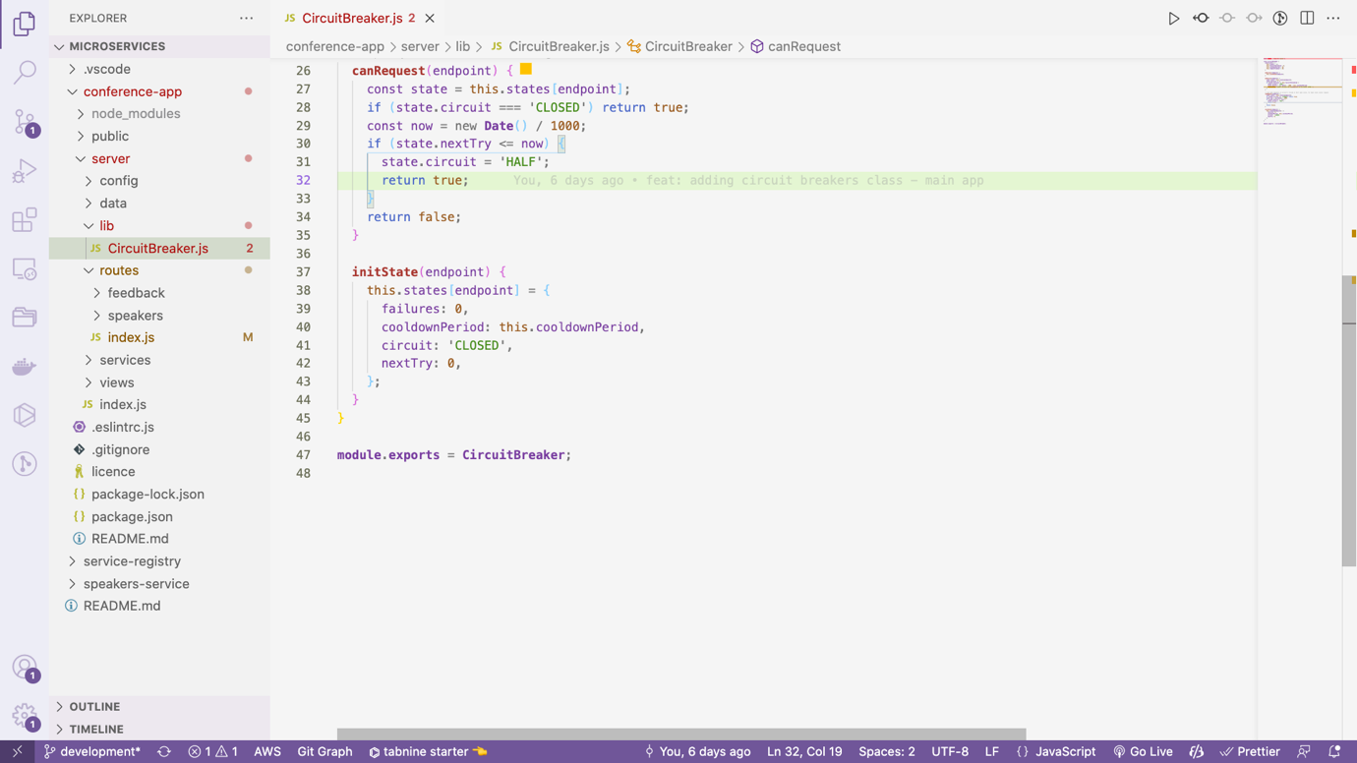

🡪 Now we will invoke circuit breaker in calling service:

Path: conference-app/server/lib/CircuitBreaker.js

const axios = **require**('axios');

class **CircuitBreaker** {

constructor() {

this.states = {};

this.failureThreshold = 5;

this.cooldownPeriod = 10;

this.requestTimeout = 1;

}

**onSuccess**(endpoint) {

this.**initState**(endpoint);

}

**onFailure**(endpoint) {

const state = this.states[endpoint];

state.failures += 1;

if (state.failures >= this.failureThreshold) {

state.circuit = 'OPEN';

state.nextTry = new **Date**() / 1000 + this.cooldownPeriod;

console.**log**(`ALERT! Circuit for ${endpoint} is in state 'OPEN'`);

}

}

async **callService**(requestOptions) {

const endpoint = `${requestOptions.method}:${requestOptions.url}`; *// this checks uniqueness of request*

if (!this.**canRequest**(endpoint)) return false;

*// eslint-disable-next-line no-param-reassign*

requestOptions.timeout = this.requestTimeout * 1000;

try {

const response = await **axios**(requestOptions);

this.**onSuccess**(endpoint);

return response.data;

} catch (err) {

this.**onFailure**(endpoint);

return false;

}

}

*// Can send requests in Circuit's Closed or Half open state, for Open state cannot request*

**canRequest**(endpoint) {

if (!this.states[endpoint]) this.**initState**(endpoint); *// initialize the endpoint if not found*

const state = this.states[endpoint];

if (state.circuit === 'CLOSED') return true;

const now = new **Date**() / 1000;

if (state.nextTry <= now) {

state.circuit = 'HALF';

return true;

}

return false;

}

**initState**(endpoint) {

this.states[endpoint] = {

failures: 0,

cooldownPeriod: this.cooldownPeriod,

circuit: 'CLOSED',

nextTry: 0,

};

}

}

**module**.**exports** = **CircuitBreaker**;

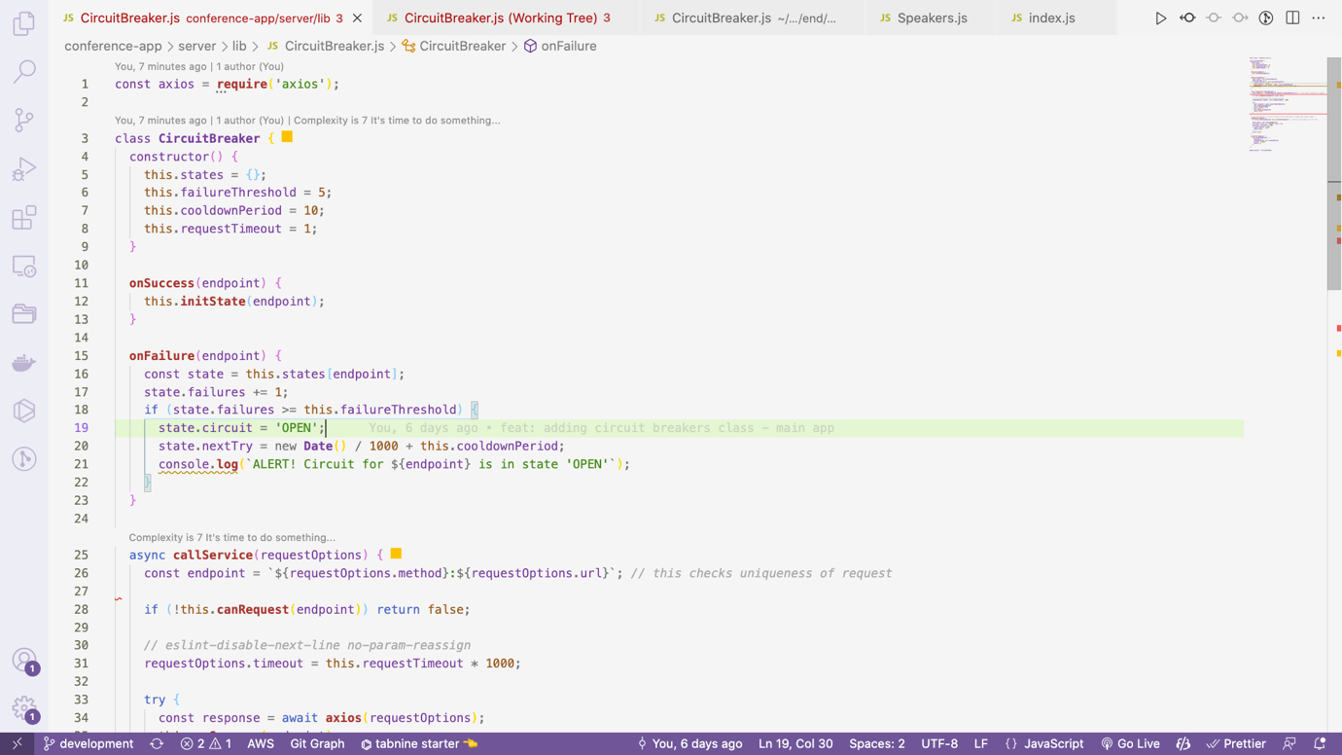

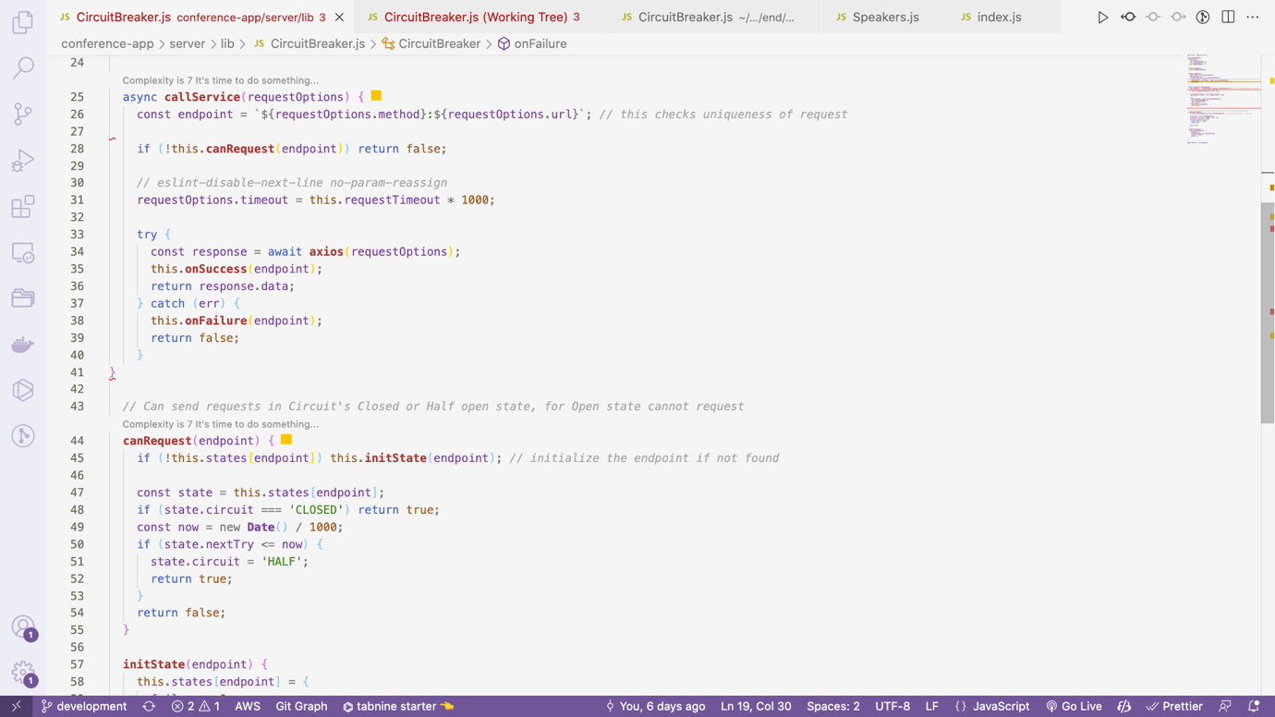

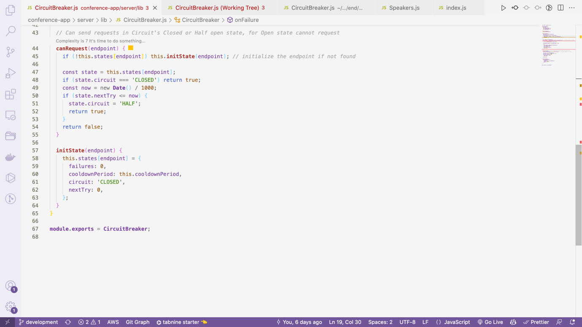

🡪 The next step is to invoke callService method from Speakers.js of conference-app

Path: conference-app/server/services/Speakers.js

*/* eslint-disable class-methods-use-this */*

const axios = **require**('axios');

const **CircuitBreaker** = **require**('../lib/CircuitBreaker');

const circuitBreaker = new **CircuitBreaker**();

class **SpeakersService** {

constructor({ serviceRegistryUrl, serviceVersionIdentifier }) {

this.serviceRegistryUrl = serviceRegistryUrl;

this.serviceVersionIdentifier = serviceVersionIdentifier;

}

async **getImage**(path) {

const { ip, port } = await this.**getService**('speakers-service');

return this.**callService**({

method: 'get',

responseType: 'stream',

url: `http://${ip}:${port}/images/${path}`,

});

}

async **getNames**() {

const { ip, port } = await this.**getService**('speakers-service');

return this.**callService**({

method: 'get',

url: `http://${ip}:${port}/names`,

});

}

async **getListShort**() {

const { ip, port } = await this.**getService**('speakers-service');

return this.**callService**({

method: 'get',

url: `http://${ip}:${port}/list-short`,

});

}

async **getList**() {

const { ip, port } = await this.**getService**('speakers-service');

return this.**callService**({

method: 'get',

url: `http://${ip}:${port}/list`,

});

}

async **getAllArtwork**() {

const { ip, port } = await this.**getService**('speakers-service');

return this.**callService**({

method: 'get',

url: `http://${ip}:${port}/artwork`,

});

}

async **getSpeaker**(shortname) {

const { ip, port } = await this.**getService**('speakers-service');

return this.**callService**({

method: 'get',

url: `http://${ip}:${port}/speaker/${shortname}`,

});

}

async **getArtworkForSpeaker**(shortname) {

const { ip, port } = await this.**getService**('speakers-service');

return this.**callService**({

method: 'get',

url: `http://${ip}:${port}/artwork/${shortname}`,

});

}

async **callService**(requestOptions) {

return circuitBreaker.**callService**(requestOptions);

}

async **getService**(servicename) {

const response = await axios.**get**(`${this.serviceRegistryUrl}/find/${servicename}/${this.serviceVersionIdentifier}`);

return response.data;

}

}

**module**.**exports** = **SpeakersService**;

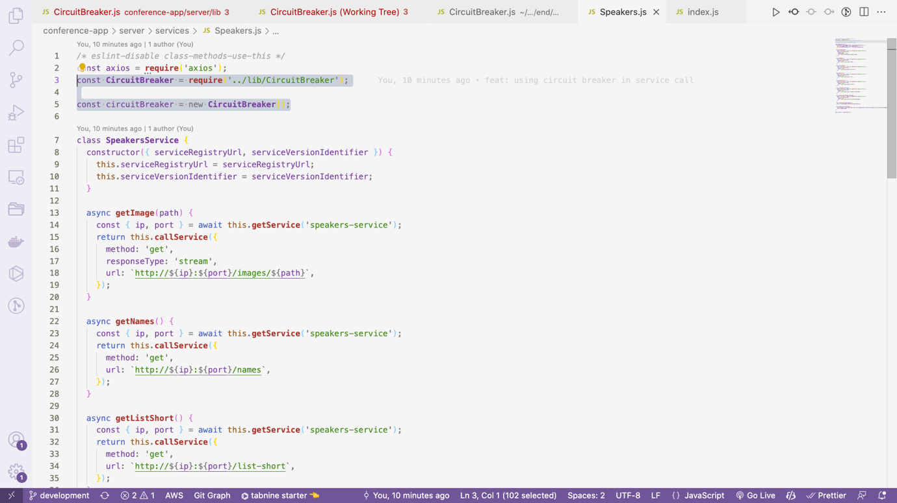

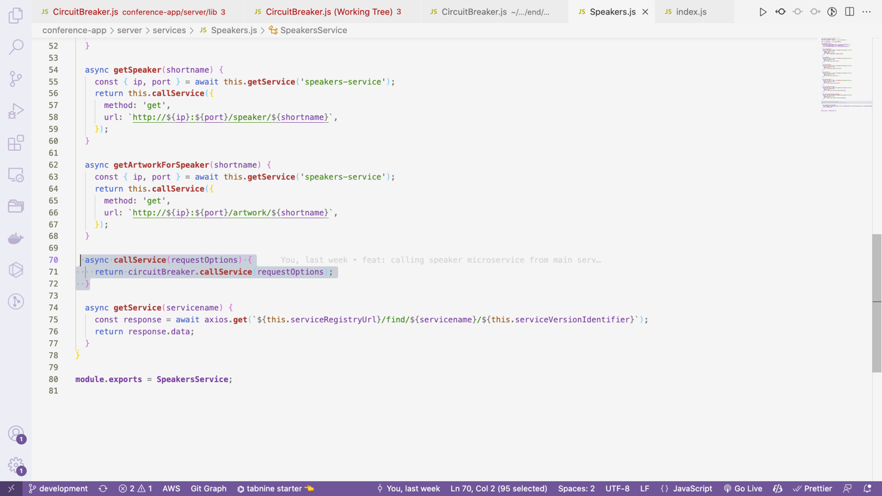

🡪 Clicking All Speaker from dropdown took some time to load

🡪 Still our application did not break, just empty section came

NOTE: For breaking Try commenting the list code from speakers service:

Path: speakers-service/server/service.js

service.**get**('/list', async (req, res, **next**) => {

try {

*// return res.json(await speakers.getList());*

} catch (err) {

return **next**(err);

}

});

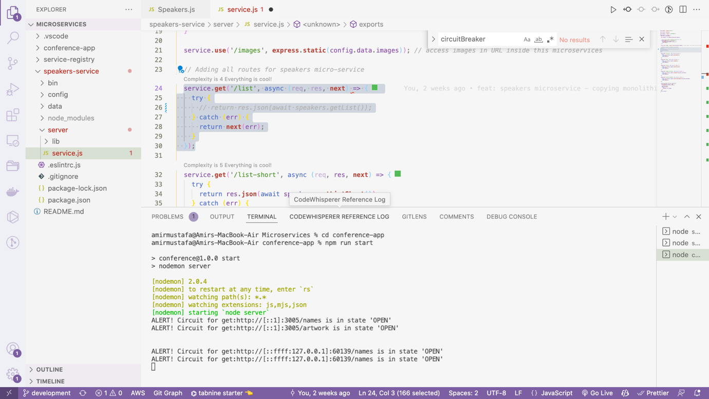



Using Caches to Bridge Outages:

🡪 With Circuit breaker in place whole app will not be down

🡪 Missing service will remain empty. Still, it is the good practice to get data from cache if any server is down by chance

🡪 We will implement caching at the time of calling the service through circuit breaker

*/* eslint-disable class-methods-use-this */*

const axios = **require**('axios');

const **url** = **require**('url');

const **crypto** = **require**('crypto');

const **CircuitBreaker** = **require**('../lib/CircuitBreaker');

const circuitBreaker = new **CircuitBreaker**();

class **SpeakersService** {

constructor({ serviceRegistryUrl, serviceVersionIdentifier }) {

this.serviceRegistryUrl = serviceRegistryUrl;

this.serviceVersionIdentifier = serviceVersionIdentifier;

this.cache = {};

}

async **getImage**(path) {

const { ip, port } = await this.**getService**('speakers-service');

return this.**callService**({

method: 'get',

responseType: 'stream',

url: `http://${ip}:${port}/images/${path}`,

});

}

async **getNames**() {

const { ip, port } = await this.**getService**('speakers-service');

return this.**callService**({

method: 'get',

url: `http://${ip}:${port}/names`,

});

}

async **getListShort**() {

const { ip, port } = await this.**getService**('speakers-service');

return this.**callService**({

method: 'get',

url: `http://${ip}:${port}/list-short`,

});

}

async **getList**() {

const { ip, port } = await this.**getService**('speakers-service');

return this.**callService**({

method: 'get',

url: `http://${ip}:${port}/list`,

});

}

async **getAllArtwork**() {

const { ip, port } = await this.**getService**('speakers-service');

return this.**callService**({

method: 'get',

url: `http://${ip}:${port}/artwork`,

});

}

async **getSpeaker**(shortname) {

const { ip, port } = await this.**getService**('speakers-service');

return this.**callService**({

method: 'get',

url: `http://${ip}:${port}/speaker/${shortname}`,

});

}

async **getArtworkForSpeaker**(shortname) {

const { ip, port } = await this.**getService**('speakers-service');

return this.**callService**({

method: 'get',

url: `http://${ip}:${port}/artwork/${shortname}`,

});

}

async **callService**(requestOptions) {

const servicePath = **url**.**parse**(requestOptions.url).path;

const cacheKey = **crypto**.**createHash**('md5').**update**(requestOptions.method + servicePath).**digest**('hex');

const result = await circuitBreaker.**callService**(requestOptions);

if (!result) {

if (this.cache[cacheKey]) return this.cache[cacheKey];

return false;

}

this.cache[cacheKey] = result;

return result;

}

async **getService**(servicename) {

const response = await axios.**get**(`${this.serviceRegistryUrl}/find/${servicename}/${this.serviceVersionIdentifier}`);

return response.data;

}

}

**module**.**exports** = **SpeakersService**;

Check difference here:

<https://github.com/AmirMustafa/Conference-app/commit/c3fb1010d9d029f6bd8cba58024e0139eed36867>

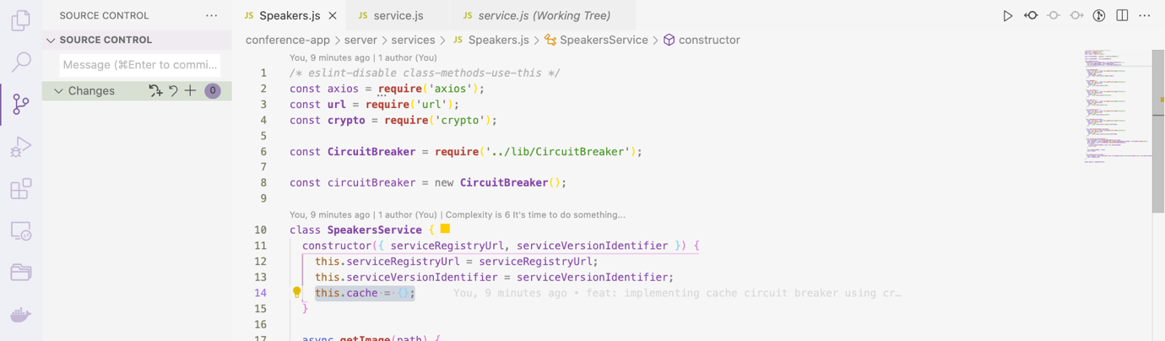

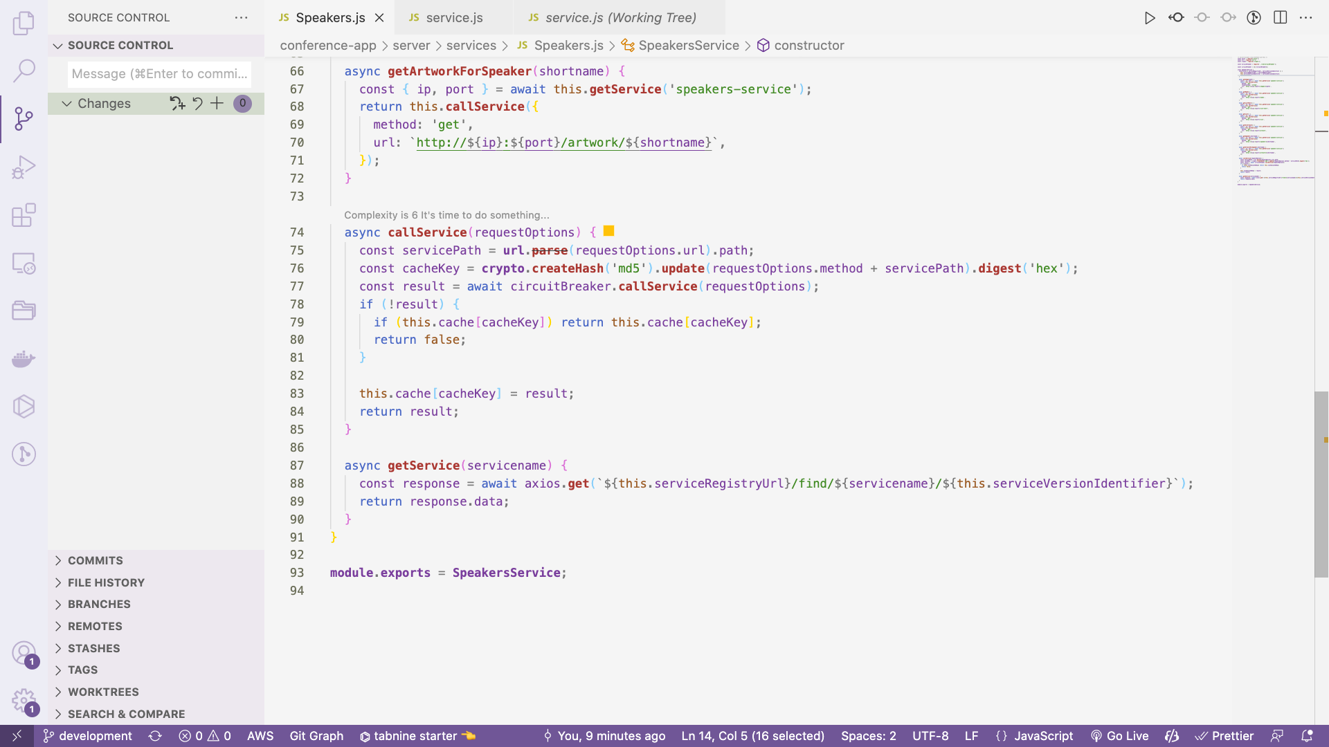

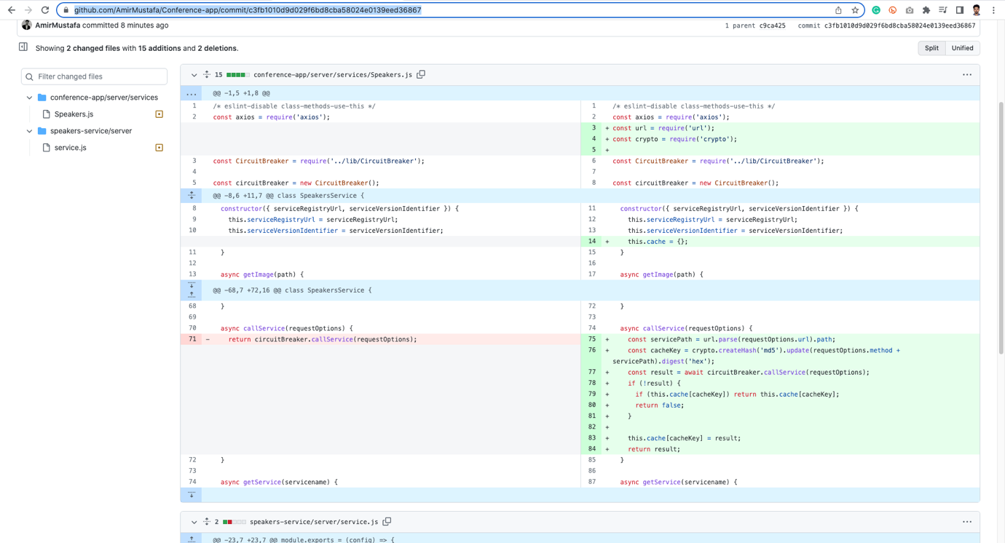

Caching Images:

🡪 If we will comment service image static code, no image will render in the app

Path: speakers-service/server/service.js

*// service.use('/images', express.static(config.data.images)); // access images in URL inside this microservices*

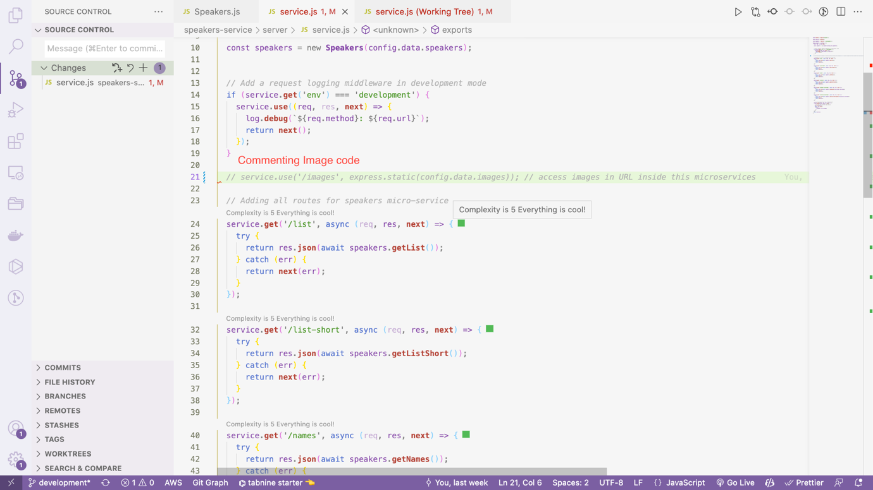



Click – All Speakers from Speakers dropdown



🡪 There should be some caching mechanism for images as well.

STEP 1: Create a directory _imagecacge inside main app (conference app) - in root directory

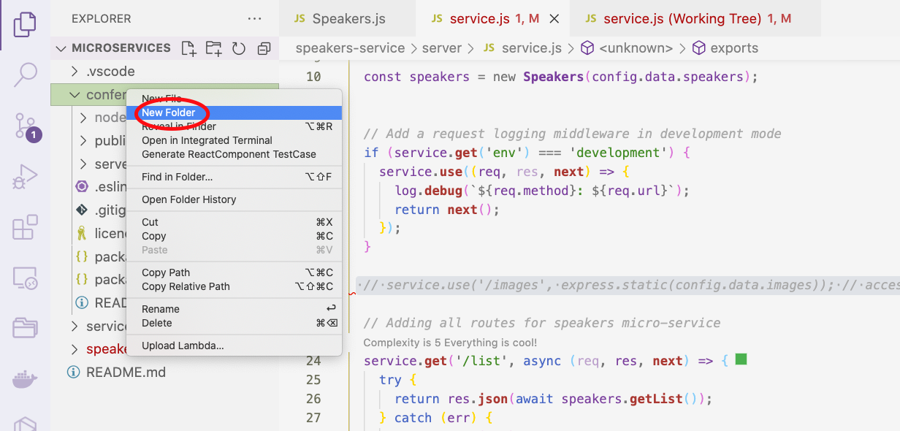

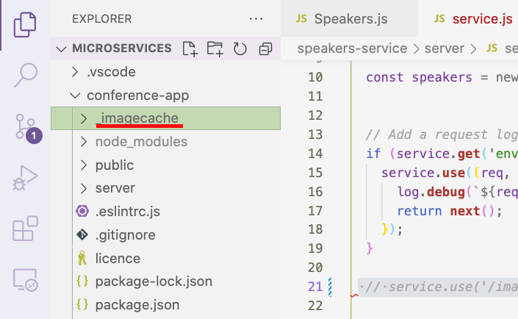

🡪 It is important to note we have streams for getting image

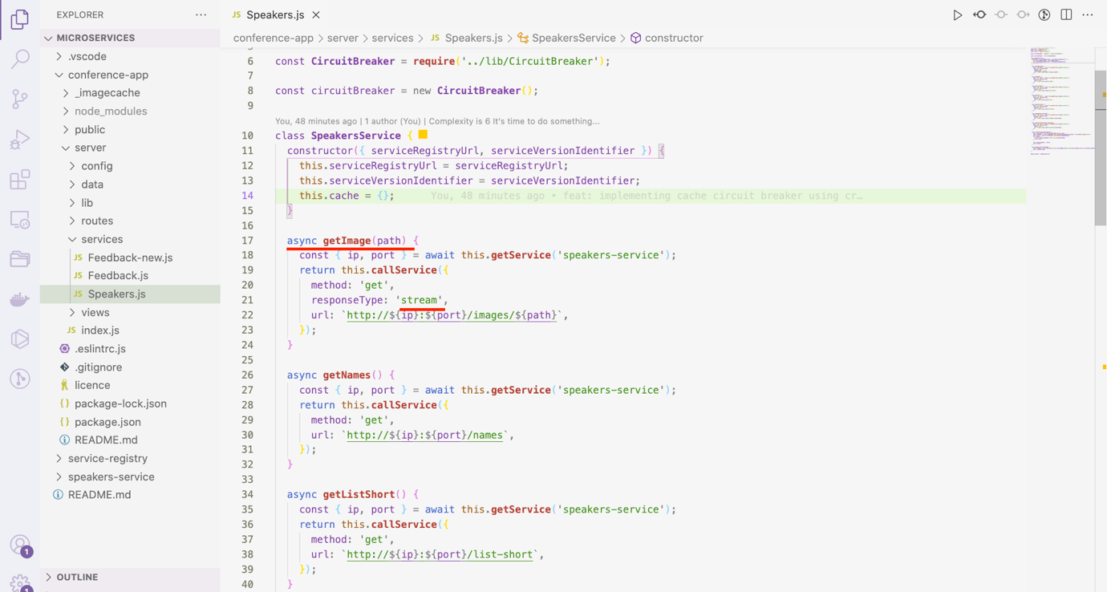

🡪 Check here cached image:

Git Difference:

<https://github.com/AmirMustafa/Conference-app/commit/069f344f7b3c327d95a12a9f82e1ba6ca1ea32c5>

*/* eslint-disable class-methods-use-this */*

const axios = **require**('axios');

const **url** = **require**('url');

const **crypto** = **require**('crypto');

const **fs** = **require**('fs');

const **util** = **require**('util');

const **fsexists** = **util**.**promisify**(**fs**.**exists**);

const **CircuitBreaker** = **require**('../lib/CircuitBreaker');

const circuitBreaker = new **CircuitBreaker**();

class **SpeakersService** {

constructor({ serviceRegistryUrl, serviceVersionIdentifier }) {

this.serviceRegistryUrl = serviceRegistryUrl;

this.serviceVersionIdentifier = serviceVersionIdentifier;

this.cache = {};

}

async **getImage**(path) {

const { ip, port } = await this.**getService**('speakers-service');

return this.**callService**({

method: 'get',

responseType: 'stream',

url: `http://${ip}:${port}/images/${path}`,

});

}

async **getNames**() {

const { ip, port } = await this.**getService**('speakers-service');

return this.**callService**({

method: 'get',

url: `http://${ip}:${port}/names`,

});

}

async **getListShort**() {

const { ip, port } = await this.**getService**('speakers-service');

return this.**callService**({

method: 'get',

url: `http://${ip}:${port}/list-short`,

});

}

async **getList**() {

const { ip, port } = await this.**getService**('speakers-service');

return this.**callService**({

method: 'get',

url: `http://${ip}:${port}/list`,

});

}

async **getAllArtwork**() {

const { ip, port } = await this.**getService**('speakers-service');

return this.**callService**({

method: 'get',

url: `http://${ip}:${port}/artwork`,

});

}

async **getSpeaker**(shortname) {

const { ip, port } = await this.**getService**('speakers-service');

return this.**callService**({

method: 'get',

url: `http://${ip}:${port}/speaker/${shortname}`,

});

}

async **getArtworkForSpeaker**(shortname) {

const { ip, port } = await this.**getService**('speakers-service');

return this.**callService**({

method: 'get',

url: `http://${ip}:${port}/artwork/${shortname}`,

});

}

async **callService**(requestOptions) {

const servicePath = **url**.**parse**(requestOptions.url).path;

const cacheKey = **crypto**.**createHash**('md5').**update**(requestOptions.method + servicePath).**digest**('hex');

let cacheFile = null;

if (requestOptions.responseType && requestOptions.responseType === 'stream') {

cacheFile = `${__dirname}/../../_imagecache/${cacheKey}`;

}

const result = await circuitBreaker.**callService**(requestOptions);

if (!result) {

if (this.cache[cacheKey]) return this.cache[cacheKey];

if (cacheFile) {

const exists = await **fsexists**(cacheFile);

if (exists) return **fs**.**createReadStream**(cacheFile);

}

return false;

}

if (!cacheFile) {

this.cache[cacheKey] = result;

} else {

const ws = **fs**.**createWriteStream**(cacheFile);

result.**pipe**(ws);

}

return result;

}

async **getService**(servicename) {

const response = await axios.**get**(`${this.serviceRegistryUrl}/find/${servicename}/${this.serviceVersionIdentifier}`);

return response.data;

}

}

**module**.**exports** = **SpeakersService**;

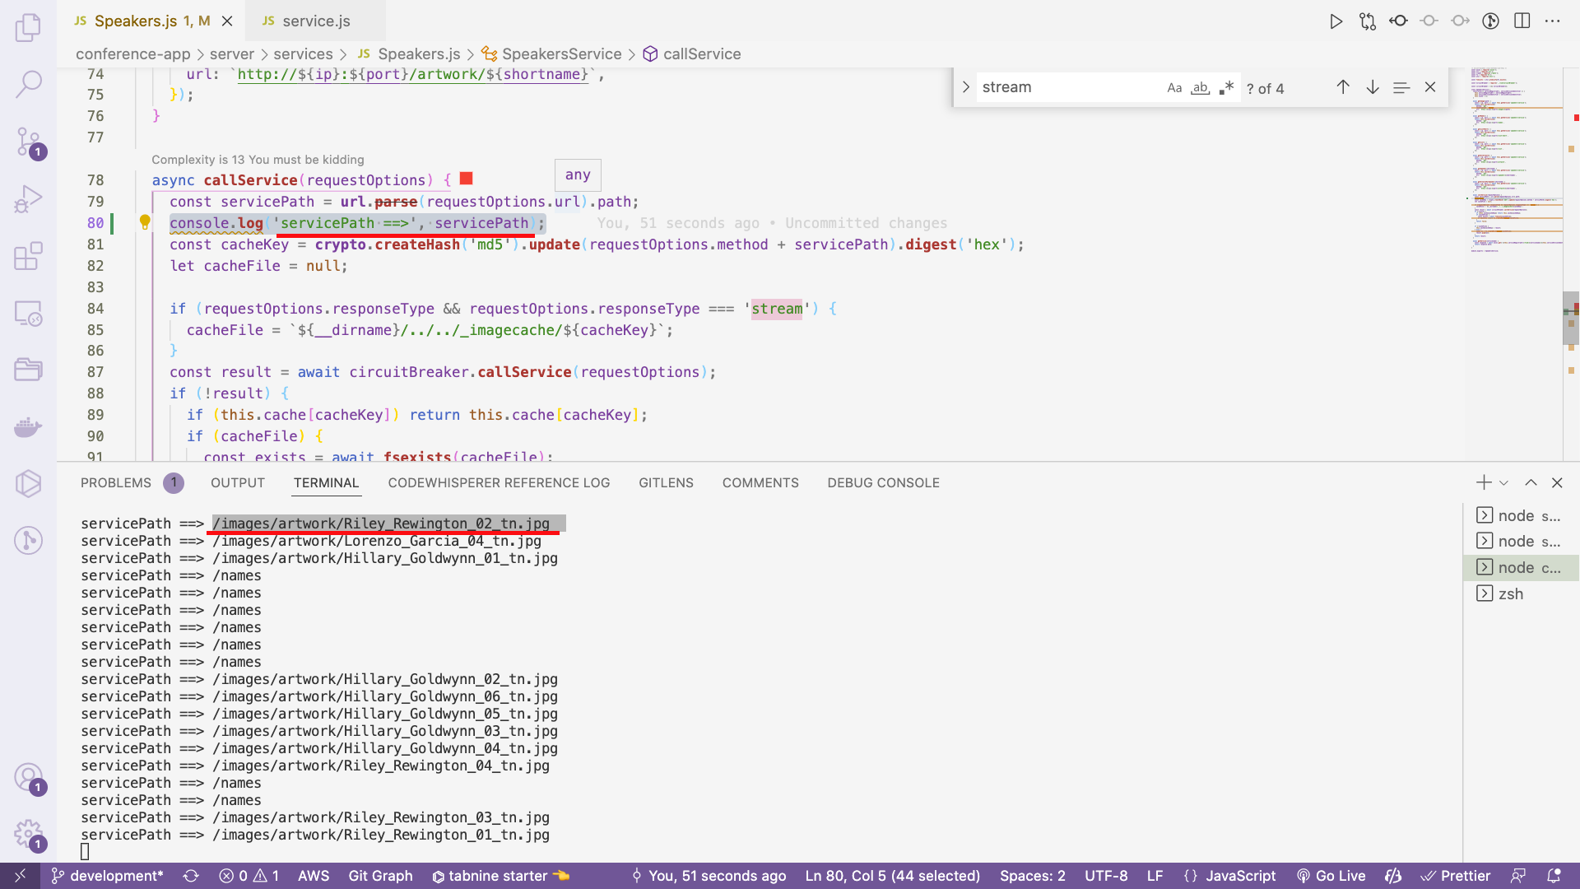

🡪 Calling the file system and promisify it.

🡪Note request type is stream

🡪 We will use createReadStream and createWriteStream for accessing it

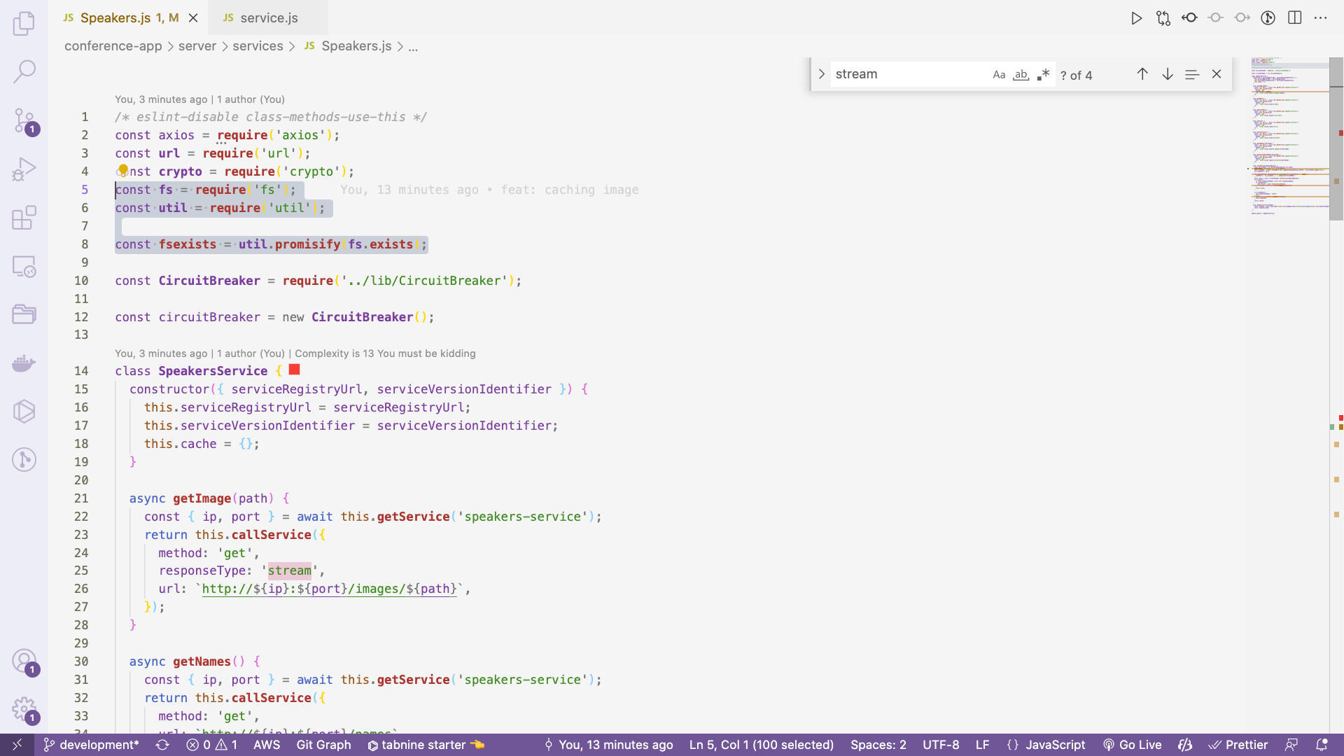

async **callService**(requestOptions) {

const servicePath = **url**.**parse**(requestOptions.url).path;

const cacheKey = **crypto**.**createHash**('md5').**update**(requestOptions.method + servicePath).**digest**('hex');

let cacheFile = null;

if (requestOptions.responseType && requestOptions.responseType === 'stream') {

cacheFile = `${__dirname}/../../_imagecache/${cacheKey}`;

}

const result = await circuitBreaker.**callService**(requestOptions);

if (!result) {

if (this.cache[cacheKey]) return this.cache[cacheKey];

if (cacheFile) {

const exists = await **fsexists**(cacheFile);

if (exists) return **fs**.**createReadStream**(cacheFile);

}

return false;

}

if (!cacheFile) {

this.cache[cacheKey] = result;

} else {

const ws = **fs**.**createWriteStream**(cacheFile);

result.**pipe**(ws);

}

return result;

}

Using Queues with Node.js:

1. Factoring out the feedback service

🡪 Adding base feedback microservice

Commit:

<https://github.com/AmirMustafa/Conference-app/commit/830ee02cedd8deaf46969a23a5117a31c0daaf5b>

🡪 Go inside feedback microservice and install packages

cd feedback-service

Npm install

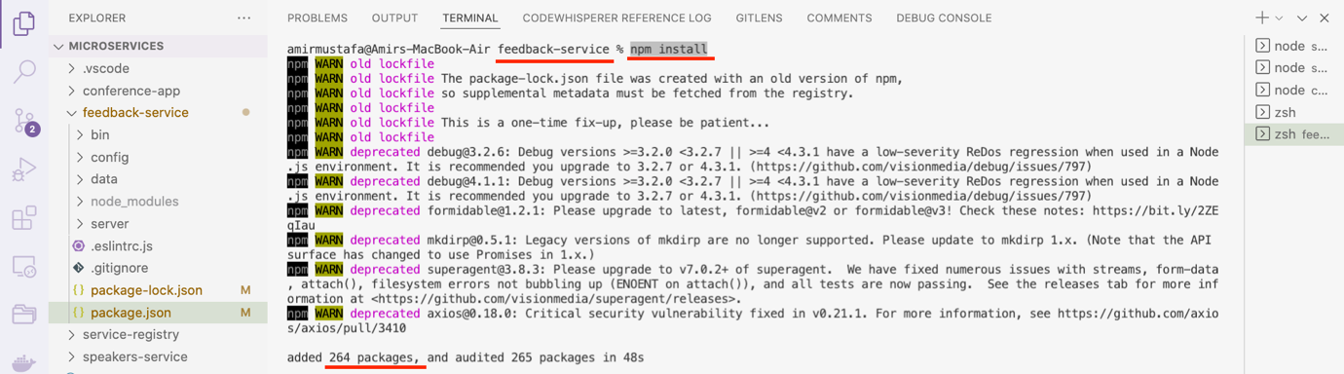

🡪 Run the feedback server using below steps:

cd feedback-service

npm run start

Check code difference here

<https://github.com/AmirMustafa/Conference-app/commit/07ab81789b2a8b9855031ddbc8202f0238c6b03c>

Path: conference-app/server/services/Feedback.js

We are now using axios to access feedback microservice

*/* eslint-disable class-methods-use-this */*

const **url** = **require**('url');

const axios = **require**('axios');

const **crypto** = **require**('crypto');

const **CircuitBreaker** = **require**('../lib/CircuitBreaker');

const circuitBreaker = new **CircuitBreaker**();

class **FeedbackService** {

constructor({ serviceRegistryUrl, serviceVersionIdentifier }) {

this.serviceVersionIdentifier = serviceVersionIdentifier;

this.serviceRegistryUrl = serviceRegistryUrl;

this.cache = {};

}

async **getList**() {

const { ip, port } = await this.**getService**('feedback-service');

return this.**callService**({

method: 'get',

url: `http://${ip}:${port}/list`,

});

}

async **callService**(requestOptions) {

const parsedUrl = **url**.**parse**(requestOptions.url);

const cacheKey = **crypto**.**createHash**('md5').**update**(requestOptions.method + parsedUrl.path).**digest**('hex');

const result = await circuitBreaker.**callService**(requestOptions);

if (!result) {

if (this.cache[cacheKey]) {

return this.cache[cacheKey];

}

return null;

}

this.cache[cacheKey] = result;

this.cache[cacheKey] = result;

return result;

}

async **getService**(servicename) {

const response = await axios.**get**(`${this.serviceRegistryUrl}/find/${servicename}/${this.serviceVersionIdentifier}`);

return response.data;

}

}

**module**.**exports** = **FeedbackService**;

conference-app/server/index.js

const **express** = **require**('express');

const createError = **require**('http-errors');

const path = **require**('path');

const bodyParser = **require**('body-parser');

const configs = **require**('./config');

const **Speakers** = **require**('./services/Speakers');

const **Feedback** = **require**('./services/Feedback');

const routes = **require**('./routes');

const app = **express**();

const config = configs[app.**get**('env')];

const speakers = new **Speakers**(config.data);

const feedback = new **Feedback**(config.data);

STEP 3: Delete feedback.json file from conference-app/data.

This timedata is received from feedback mixroservice app.

🡪 NOTE: 4 servers are running:

Conference-app (main app)

Service registry

Speakers microservice

Feeback microservice

🡪 If we open the URL:

URL: <http://localhost:3009/>



It means Feedback microservice is working

🡪 Click Feedback:

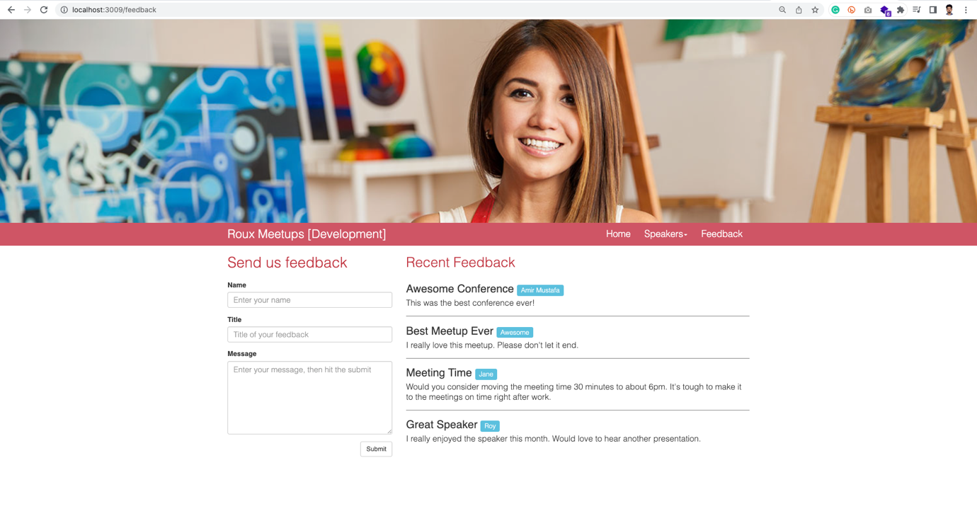

🡪 Let us fill a feedback and click Submit button:

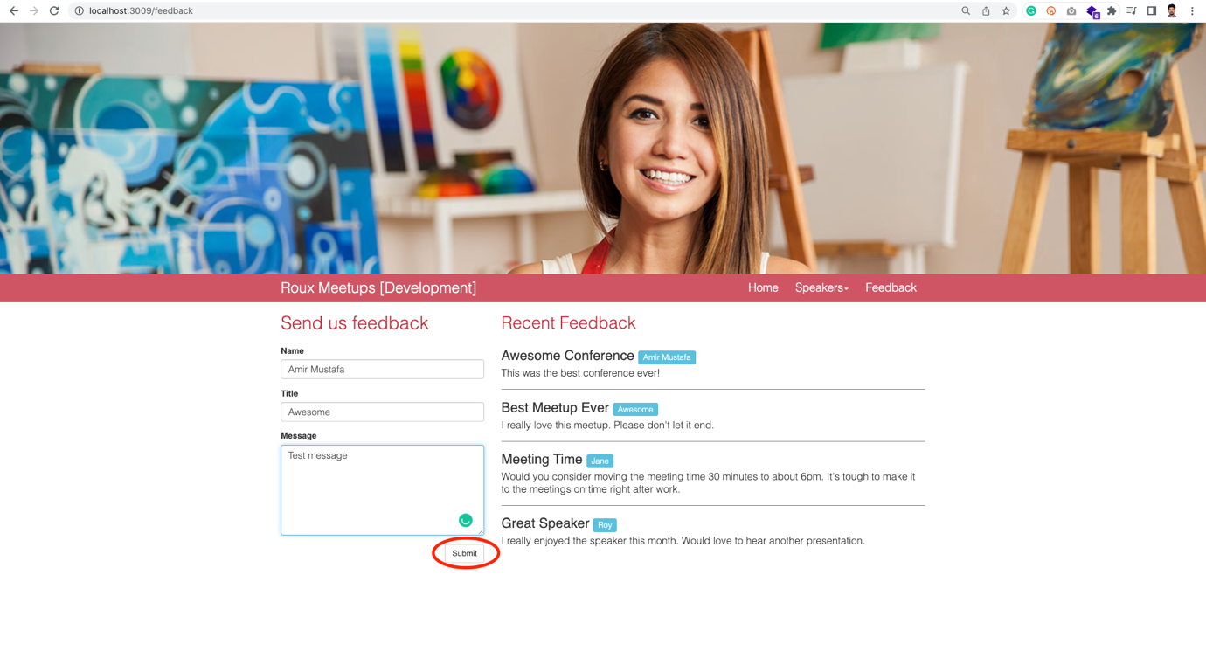

Error comes:

This is expected error. For this we will now implement Queues.

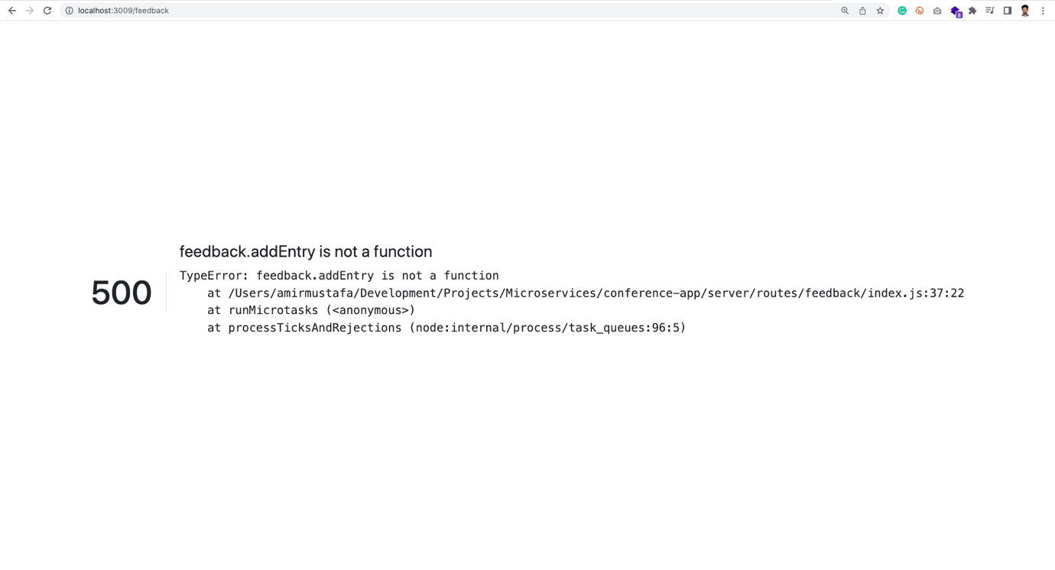

Queues:



🡪 One goal in microservice architecture is to avoid tight coupling

🡪 It’s hard to uncouple request to show data on the website instantly

🡪 But when it comes to posting data to a service – doing that asynchronously through some intermediate service removes any dependency between colour and receiving and service

🡪 Queues are common ways to accomplish that

🡪 The basic principle is very simple, basically they provide a way to publish messages to it.

🡪 So if we have a conference app and feedback app, we can place a queue in between. We can publish those feedback messages to queue

🡪 They will then show up on the queue.

🡪 There can be several messages and everything can end up on the queue

🡪 When the feedback service is available we can they call consume on this queue

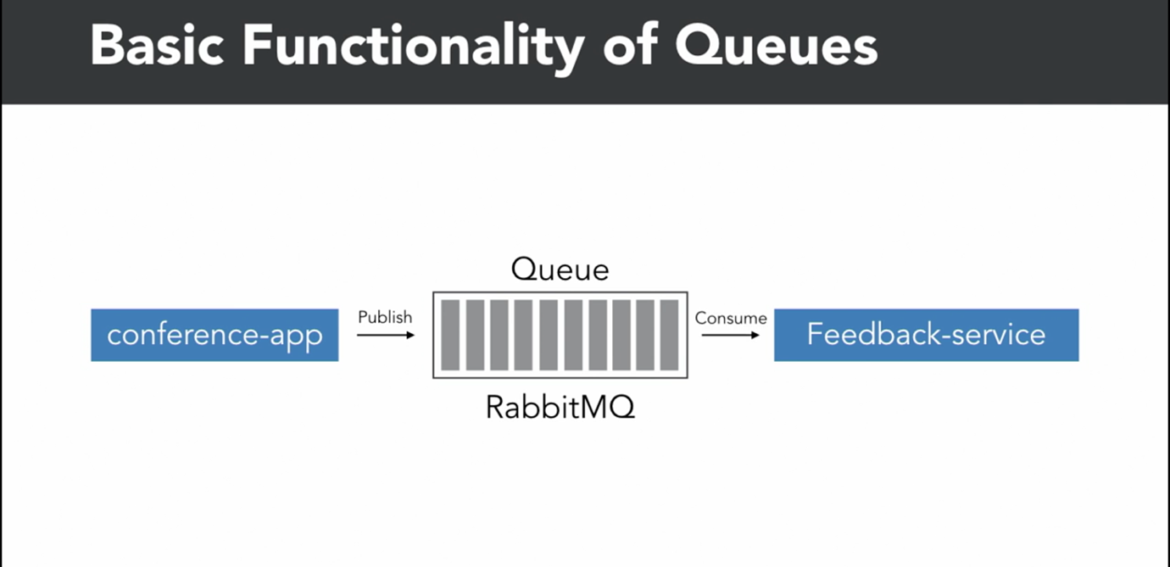

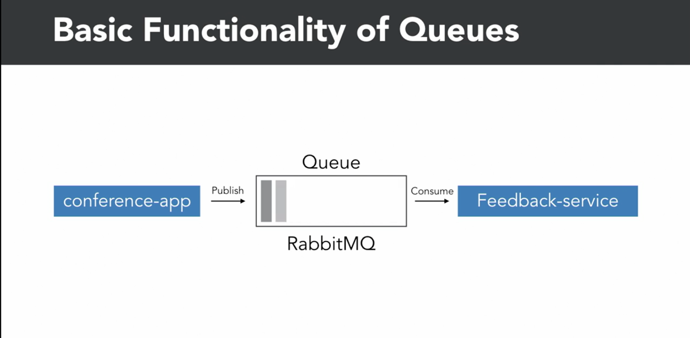

🡪 After it consumed the message, it can acknowledge that it have received the message successfully.

🡪 In this case message will then remove from the queue.

There are several queuing system available. If in Infrastructure provider: AWS, Google or Azure Cloud, it is awesome.

🡪 Here we will be using RabbitMQ to publish and consume messages asynchronously

🡪 Rabbit MQ is available in all OS and available as package for node js

Download and Install RabbitMQ:

🡪 We can install for any OS: <https://www.rabbitmq.com/download.html>

🡪 For MAC machines,

Using Brew: <https://www.rabbitmq.com/install-homebrew.html>

Brew install rabbitmq

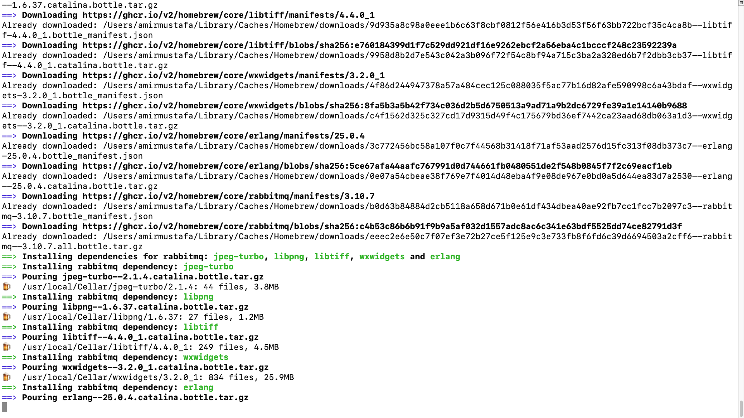

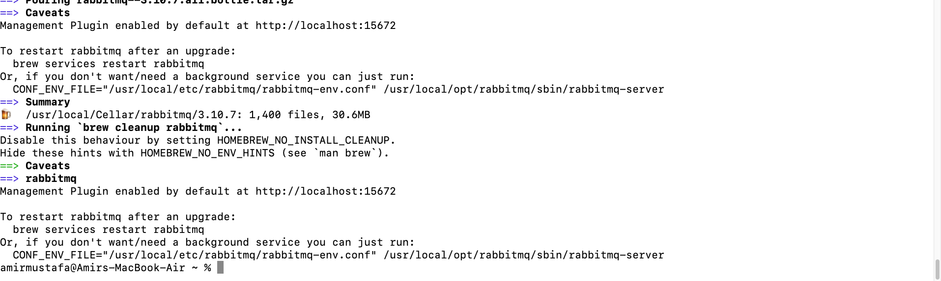

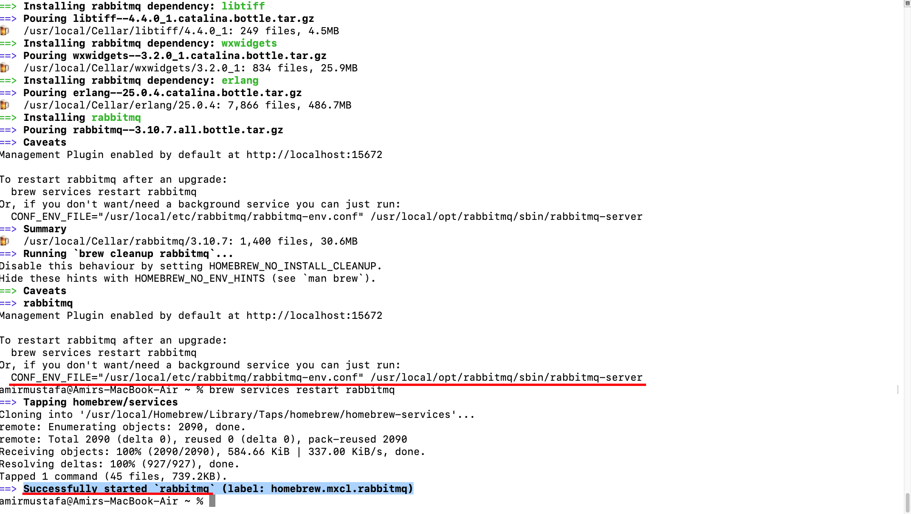

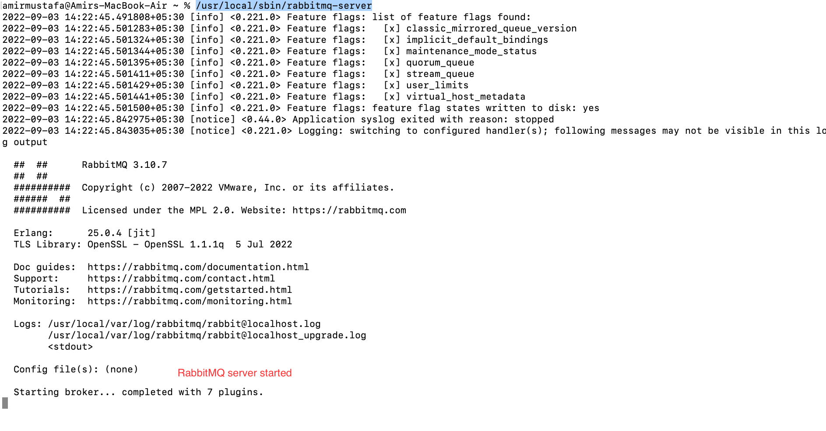

🡪 After install we can start rabbit mq server in two ways:

1. As a service:

brew services restart rabbitmq

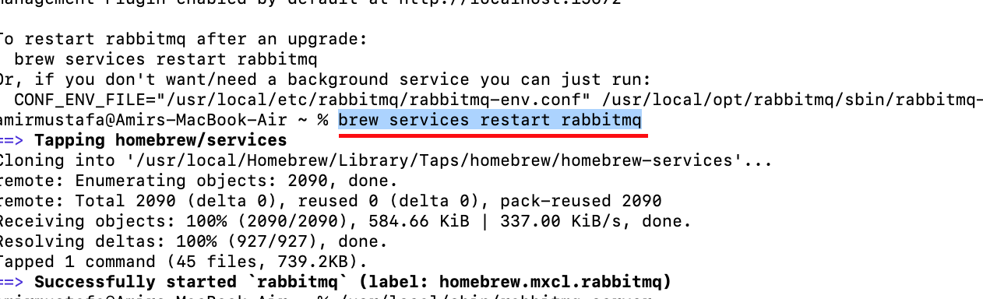

brew services stop rabbitmq



1. As a server: (Let us follow this method)

/usr/local/sbin/rabbitmq-server

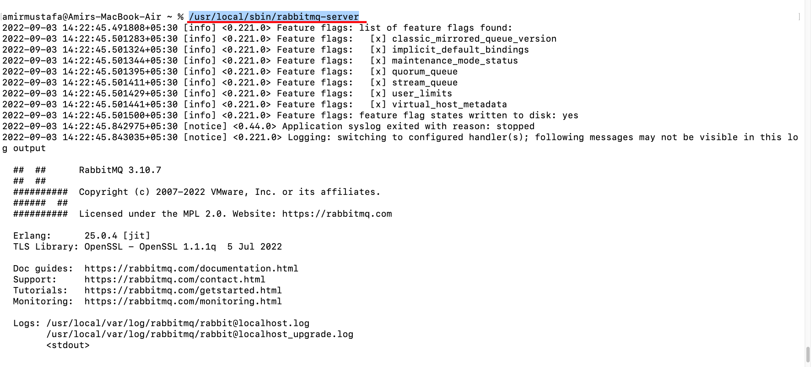

🡪 Rabbit MQ server is up and running

🡪 We now have to implement a method that can send message of feedback to rabbitmq

🡪 For that we have to install node package

npm install –save amqplib

🡪 If we observe Feedback-old.js in conference app (i.e. main app)

Make sure, we should have Rabit MQ server running

Starts Rabbit MQ server

/usr/local/sbin/rabbitmq-server

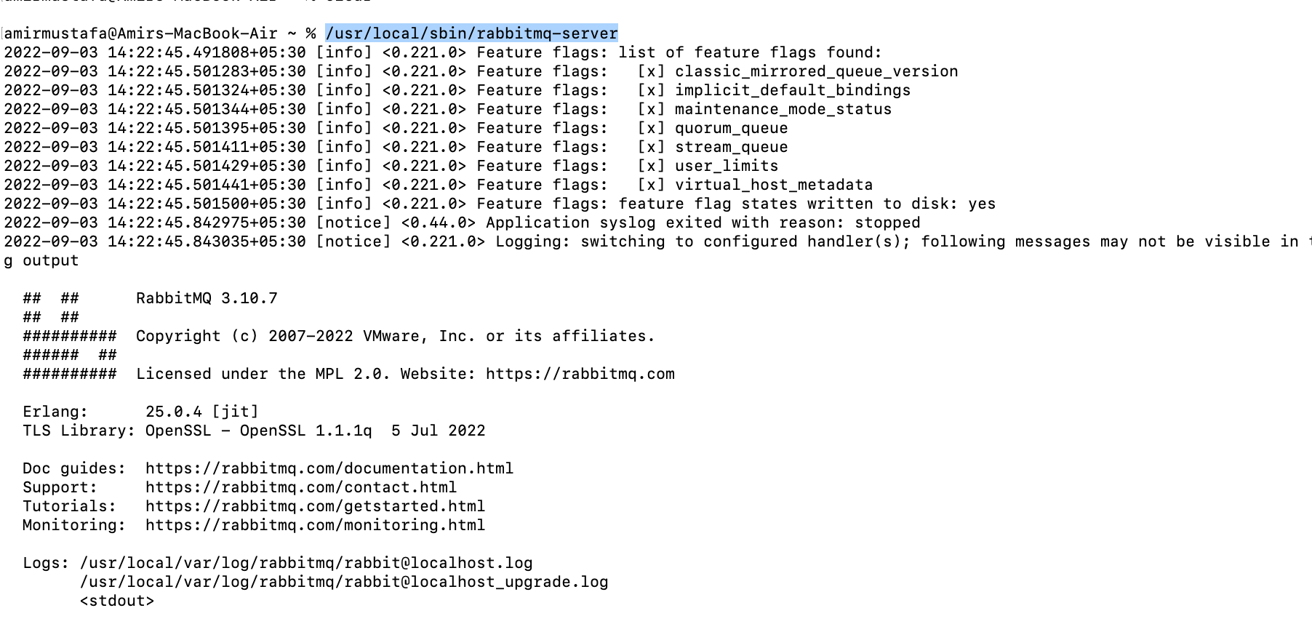

🡪 Previously after filling feedback form and submitting was giving error

OLD File:

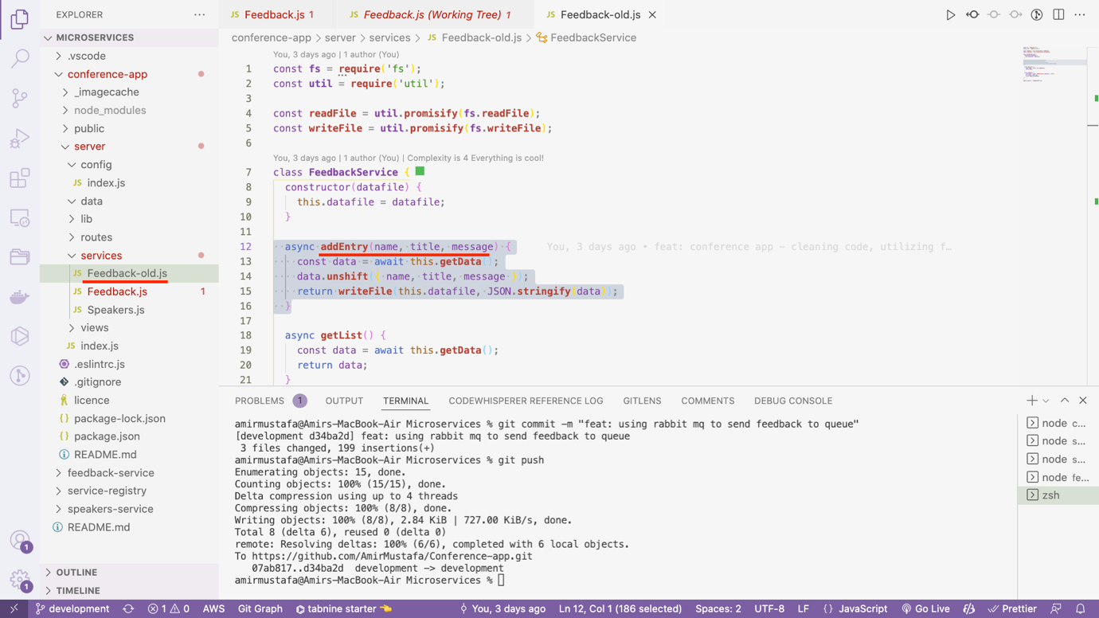

Adding function addEntry:

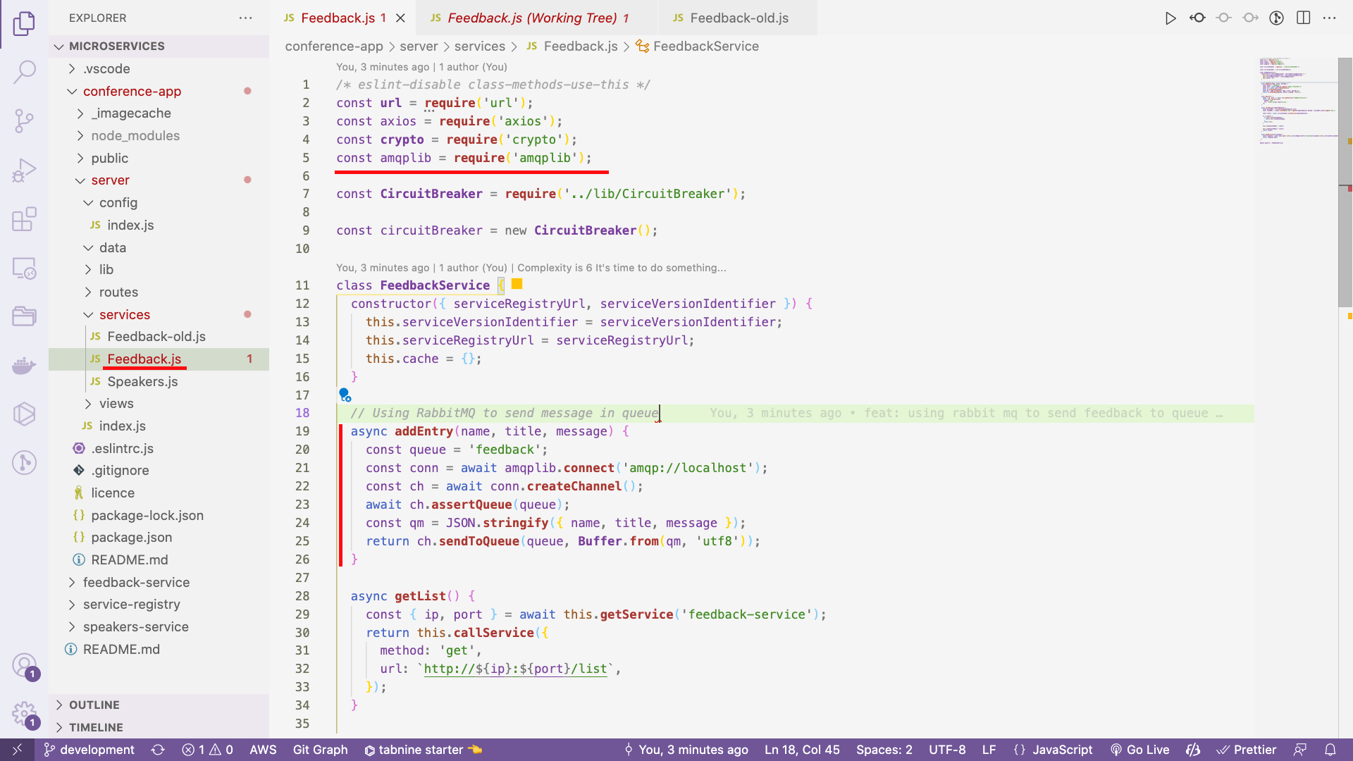

*/* eslint-disable class-methods-use-this */*

const **url** = **require**('url');

const axios = **require**('axios');

const **crypto** = **require**('crypto');

const amqplib = **require**('amqplib'); // Rabbit MQ client

const **CircuitBreaker** = **require**('../lib/CircuitBreaker');

const circuitBreaker = new **CircuitBreaker**();

class **FeedbackService** {

constructor({ serviceRegistryUrl, serviceVersionIdentifier }) {

this.serviceVersionIdentifier = serviceVersionIdentifier;

this.serviceRegistryUrl = serviceRegistryUrl;

this.cache = {};

}

*// Using RabbitMQ to send message in queue*

async **addEntry**(name, title, message) {

const queue = 'feedback';

const conn = await amqplib.**connect**('amqp://localhost');

const ch = await conn.**createChannel**();

await ch.**assertQueue**(queue);

const qm = JSON.**stringify**({ name, title, message });

return ch.**sendToQueue**(queue, **Buffer**.**from**(qm, 'utf8'));

}

async **getList**() {

const { ip, port } = await this.**getService**('feedback-service');

return this.**callService**({

method: 'get',

url: `http://${ip}:${port}/list`,

});

}

async **callService**(requestOptions) {

const parsedUrl = **url**.**parse**(requestOptions.url);

const cacheKey = **crypto**.**createHash**('md5').**update**(requestOptions.method + parsedUrl.path).**digest**('hex');

const result = await circuitBreaker.**callService**(requestOptions);

if (!result) {

if (this.cache[cacheKey]) {

return this.cache[cacheKey];

}

return null;

}

this.cache[cacheKey] = result;

this.cache[cacheKey] = result;

return result;

}

async **getService**(servicename) {

const response = await axios.**get**(`${this.serviceRegistryUrl}/find/${servicename}/${this.serviceVersionIdentifier}`);

return response.data;

}

}

**module**.**exports** = **FeedbackService**;

Consuming data from RabbitMQ queue:

🡪 Now we will consume data in feedback microservice

Npm install –save ampqlib

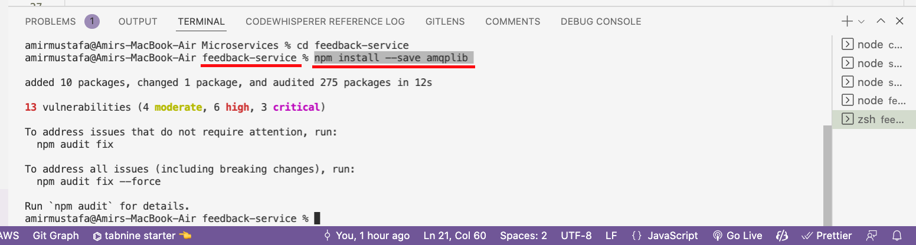

Path: feedback-service/server/service.js

const **express** = **require**('express');

const amqplib = **require**('amqplib');

const **Feedback** = **require**('./lib/Feedback');

const service = **express**();

module.exports = (config) => {

const feedback = new **Feedback**(config.data.feedback);

const log = config.**log**();

const queue = 'feedback';

*// Consuming data from RabbitMQ queue*

amqplib.**connect**('amqp://localhost')

.**then**(conn => conn.**createChannel**())

.**then**(ch => ch.**assertQueue**(queue).**then**(() => ch.**consume**(queue, (msg) => {

if (msg !== null) {

log.**debug**(`Got message ${msg.content.**toString**()}`);

const qm = JSON.**parse**(msg.content.**toString**()); *// Queue message i.e. data*

feedback.**addEntry**(qm.name, qm.title, qm.message)

*// .then(() => ch.ack(msg)); // Let rabbitmq know received message*

}

}))).**catch**(err => log.**fatal**(err));

*// Add a request logging middleware in development mode*

if (service.**get**('env') === 'development') {

service.**use**((req, res, **next**) => {

log.**debug**(`${req.method}: ${req.url}`);

return **next**();

});

}

service.**get**('/list', async (req, res, **next**) => {

try {

return res.**json**(await feedback.**getList**());

} catch (err) {

return **next**(err);

}

});

*// eslint-disable-next-line no-unused-vars*

service.**use**((error, req, res, next) => {

res.**status**(error.status || 500);

*// Log out the error to the console*

log.**error**(error);

return res.**json**({

error: {

message: error.message,

},

});

});

return service;

};

